Grade 7
Visual Arts

Table of Contents

The Aesthetics of Assemblage (AP 1) 1

Finding Beauty in Visual Stories of the Great (American) Migration (CA 1) 7

Creating Inventions like Leonardo da Vinci (HP 6) 10

African Symbolism in Local Architecture (CA 2) 14

Founders of Surrealism (HP 2) 20

Weavers of Louisiana (AP 1) 28

Masks as Carriers of Culture (HP 4) 33

Blue Man Group as Performance Art (AP 4) 39

Mexican Niches (HP 3) 43

Introduction to Animation (HP 5) 47

A Room of One’s Own (CA 3) 53

Cubist Cubed (HP 1) 56

Cuna Indian Molas (AP 5) 60

An Art Vocabulary Scavenger Hunt (CA 4) 65

Empty Bowls (AP 2) 68

Megaliths and Monuments (CA 5) 73

Sculpture as Public Art (AP 2) 79

Glossary 84

Visual Arts Standards and Benchmarks 89

Louisiana Foundation Skills 94

Title The Aesthetics of Assemblage
Time Frame Three 60-minute sessions
Overview Students view and compare images from the works of Jacqueline Bishop. They use this research and their understanding of assemblage to examine the artist’s use of elements and Principles of Design. They examine their understanding of aesthetics and design through a series of sketches. Students render these sketches into a contemporary three-dimensional assemblage.

Standards Aesthetic Perception and Creative Expression

Arts Benchmarks
Use elements and Principles of Design and expanded art vocabulary for responding to the aesthetic qualities of various works. | VA-AP-M1
Demonstrate art methods and techniques in visual representations based on research of imagery. | VA-CE-M1
Use the elements and Principles of Design and art vocabulary to visually express and describe individual ideas. | VA-CE-M3

Foundation Skills Resource Access and Utilization, Linking and Generating Knowledge

Student Understandings

Having investigated the work of Jacqueline Bishop, students understand how artists use found objects, texture, and color to create assemblages. They discuss elements and principles of art employed in assemblages. They apply methods and techniques used in the work of Jacqueline Bishop by creating a contemporary assemblage design.

Vocabulary

assemblage, ecology, aesthetics, sketchbooks

Materials and Equipment

images of the works of Jacqueline Bishop, pencils, rulers, found objects (i.e., leaves, bark, Spanish moss), fishing line, canvas board or heavy white paper, paint brushes, tempera paint, pre-test/post-test assessment measure, split-page notetaking, newspaper, recycled yogurt containers, water containers, sketchbook

Prior Knowledge

Students understand the vocabulary words: composition, form, and space, and can depict visual representations of these words. They understand basic techniques and skills associated with color mixing and paint application.

Sample Lesson

Day 1
Begin the lesson by giving students a pre/post-test assessment. They complete the assessment (5 minutes).

Present Jacqueline Bishop’s Silhouette (2002), Terra (1988-2002), and Orchid Nest (2003).
Using Bishop’s work, introduce motifs characteristic of assemblage works of art such as the use of found objects and the incorporation of color and texture to imply pattern or movement. Facts to share about assemblage include: 1) a definition of assemblage: a composition containing found objects, and 2) general information on the assemblage movement (founded in France in the 1950’s by artist Jean Dubuffet) (10 minutes).

Next, share facts from resources on Jacqueline Bishop. Facts include: Professor Bishop lives in New Orleans, Louisiana. Her primary media are water colors and found objects, such as rocks, twigs and birds’ nests. Her work is exhibited in the Arthur Rogers Gallery, the Tyler Museum of Art and Museum on the Seam. The meaning behind Prof. Bishop’s work is representative of her commitment to ecology. A simple definition of ecology is the study of how things, such as people, plants and animals, relate to each other and to their environment (5 minutes).

In small groups, students continue to view and compare images of Bishop’s work. Students consider the following questions: 1) Which of these works is made from found objects? 2) What found objects do you recognize? 3) Which of these works incorporates the design element texture to depict pattern or movement in the composition? 4) Which of these compositions uses color to depict pattern? 5) What do you think her works say about ecology? Students record these questions and their answers in their sketchbooks (30 minutes).

Students identify a spokesperson for their findings to present their group’s findings to the class (10 minutes).

Day 2
Review information on assemblage, particularly stylistic characteristics including the use of found objects and the incorporation of color and texture to imply pattern or movement. This review includes a brief discussion of the works of Jacqueline Bishop and the ecological meanings behind the works viewed in the previous class (5 minutes).

Students complete the split-page notetaking (view literacy strategy descriptions) to further examine motifs found in assemblage compositions. The split-page notetaking exercise provides students with opportunities to record and display their comprehension using two forms of communication, written and visual representation. Using two methods of communication further reinforces targeted concepts, vocabulary words, and helps each student self-assess changes in his/her personal comprehension throughout the course of the lesson.

Using split-page notetaking, students produce a series of four sketches. They consider ecology, particularly their own personal neighborhoods where they live, and other things, such as plants and animals they share the environment of their neighborhoods with. Sketches assist students in planning an assemblage composition. The final sketch of the exercise is the composition students develop into an assemblage (50 minutes). Students clean up (5 minutes).

Day 3
Open class by reviewing criteria for motif characteristics of Assemblage compositions. Criteria include compositions containing found objects that incorporate color and texture to imply pattern or movement (5 minutes).

Working with found objects, such as bark, Spanish moss or leaves, and tempera paint, students translate their final sketch into their own contemporary assemblage designs. Students make sure to use an ample amount of glue for heavier objects, and to press down on each object for at least 10 seconds when first attaching it to their canvas board or heavy white paper. Consider taping down objects so that they stay in place while drying. Students allow their Assemblage designs to dry flat, as this further assists objects that have been attached with glue to adhere properly to the canvas board or heavy white paper (40 minutes). Students clean up (10 minutes).

Close by having students complete the pre/post-test assessment (5 minutes).

Sample Assessments

Formative
Monitor student performance throughout the art-making process and assist students with individual needs.
Assess group presentations to see if students completed group tasks.
Check to see if students have explored the use of color and texture in written definitions and in sketches.
Check to see if students have explored stylistic characteristics of Assemblage works, including the use of found objects, in their Assemblage designs.

Summative
Evaluate the following:
Pre/post-test for completion and accuracy;
Changes in scores between the pre-test and the post-test and a comparison of these changes;
Split-page Notetaking for completion and accuracy (both written and visual representations);
Assemblage designs for: 1) Completion; 2) Use of color, texture and found objects to explore pattern and movement; 3) Student’s imaginative use of found objects in their compositions; 4) Inventive design; and 5) Craftsmanship.

Resources

The websites listed below offer detailed information on Assemblage:
http://www.wsu.edu/~delahoyd/20th/assemblage.html
http://www.assemblageartists.com/
The website listed below offers detailed information on Jacqueline Bishop:
http://www.loyno.edu/womens.center/jacquelinebishop.html

The website listed below offers detailed information on Jacqueline Bishop and opportunities to view work:
http://www.npr.org/templates/story/story.php?storyId=5238248
This website offers information on the artist and an opportunity to view Bishop’s Silhouette and Terra:
http://www.tylermuseum.org/Bishop_Zeorlin.htm
This website offers an opportunity to view Bishop’s Orchid Nest:
http://www.arthurrogergallery.com/dynamic/artwork_detail.asp?ArtworkID=799

The Aesthetics of Assemblage: Split-page Notetaking Name ____________________

Create a sequence of steps needed to complete an assemblage work of art. Show the steps needed to combine color and texture to create pattern or movement. Compose a written definition on the left and a sketch to visually represent that definition on the right:

 | DEFINITION | SKETCH
First Step
Second Step
Third
Step
Final
Step

The Aesthetics of Assemblage: Pre/Post-Assessment

Name__________________________

Please circle the correct answer

- Pattern is considered an element of design. True or False

- The following images are both examples of pattern. True or False

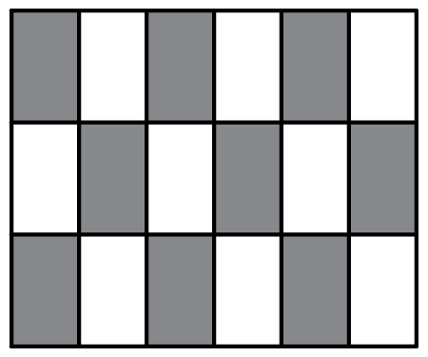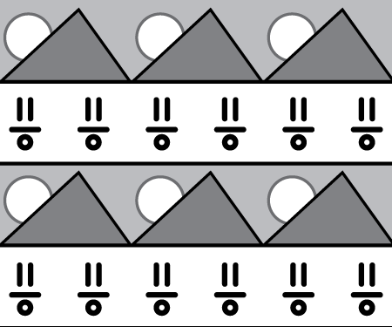

- Assemblage art often uses found objects. True or False

- France was the first area to create the art of assemblage. True or False

- Jacqueline Bishop often incorporates symbols into her designs. True or False

Title Finding Beauty in Visual Stories of the Great (American) Migration
Time Frame Three 60-minute classes
Overview After viewing and discussing paintings from Jacob Lawrence’s Great Migration Series, students work in groups of three to create a series of three small paintings that depict an event in history.

Standards Critical Analysis and Creative Expression

Arts Benchmarks
View works of art and analyze how artists use design elements and principles to achieve an aesthetic effect. | VA-CA-M1
Produce ideas for art productions while engaging in individual and group activities. | VA-CE-M5

Foundation Skills Communication, Linking and Generating Knowledge, Citizenship

Student Understandings

After viewing and listing elements found in Jacob Lawrence’s artwork, students understand how art elements are used to create expression and evoke an aesthetic response. Having studied the contextual and aesthetic attributes of Lawrence’s work and created a narrative painting, students understand how aesthetic elements can be used to create a series of narrative paintings.

Vocabulary

aesthetics, narrative

Materials and Equipment

Internet access or large reproductions of several of Jacob Lawrence’s Great Migration Series paintings, 8 ½ x 11” sheets of heavy weight multi purpose paper, tempera paint, containers of water, paper towels, small and medium sized paint brushes, paint palettes, art journals, pencils

Prior Knowledge

The art elements of line, shape, color, texture and space

Sample Lesson

Day 1
Write the following terms on the board: Aesthetics, Narrative, and The Great Migration and ask students if any of these terms are familiar. Add to student understanding by explaining the following (5 minutes):
Aesthetics is the study of beauty and why certain objects/people are considered beautiful while other things/people are not. Give examples of how this concept changes over time or from society to society. (Such as women binding their feet in China because small feet were considered beautiful or styles of automobiles or hair styles.)
A narrative is the telling of a series of related events
And the Great Migration took place over several decades after the Civil War when African Americans moved from the rural South to the urban North to find new opportunities in the industries and factories located there.

Explain that Jacob Lawrence is an African-American painter who painted a series of works on the Great Migration. Students view several paintings in this series and respond to the narrative and aesthetic aspects of his work (10 minutes).

Read the quotes under the paintings to the students in The First Wave of the Great Migration (1916-1919) Part I and ask the students to interpret what story or narrative the painting communicates. Have students respond to how Lawrence uses the art elements in his paintings. For example, in the first painting of the Migration Series, Part I, the quote under the painting reads, “Around the time of WWI many African-Americans from the South left home and traveled to cities in the North in search of a better life.” Students may observe the mass of people heading toward the city named at the top of the picture plane. The large and bright colored shapes move up the page creating a feeling of movement and excitement. The lack of detail in the people adds to the feeling of a massive crowd of people, and the panels with the crossed lines give the feeling that the mass of people are being squeezed into a very small space.

Assign students into groups of three and select an event from history that they would like to depict in a series of paintings. After the group selects its event, it brainstorms ways to depict this event. Students may need to research this event further. Each group member selects a different aspect or repercussion of the same event and creates several small thumbnail sketches in his/her art journal of how he/she will visually represent this. The group of three views all the sketches and helps each individual group member to select the best design for his/her painting. Each group member paints a different narrative painting about the same historical event (40 minutes).

Each group shares with the entire class its selected event and ideas it used to depict this event visually (5 minutes).

Day 2
Show a new painting from Jacob Lawrence’s Great Migration Series II. Direct students to quickly respond to it by explaining what they think the painting is about and how the art elements help communicate that message (5 minutes).

The students continue to work on their paintings (45 minutes).

After the class has cleaned up, students share problems and ideas they have had as they worked on this project (10 minutes).

Day 3
Ask each group to share what they have completed to date (5 minutes).

Students complete paintings and clean up (40 minutes).

Each group presents its series and explains how it used the art elements in the paintings to communicate the event. Students also share challenges and successes they had completing this series (15 minutes).

Sample Assessments

Formative
Check art journals for thumbnail sketches of group’s historic event.
Observe and monitor activities throughout the lesson. Adjustments and suggestions are provided based on individual needs of students.

Summative
Respond to the students’ presentation and explanation of how they used the art elements in their paintings to communicate their event.
The student’s painting used at least three art elements and the student could clearly identify where and how each one was used to create an aesthetic effect.
The individual paintings are assessed using the following criteria:
The painting communicates something about the chosen topic.
The painting works as a series with the other paintings by members of the same group.
The painting reflects effort.
The painting is complete.

Resources

The following websites contain information and images for this lesson:
http://www.columbia.edu/itc/history/odonnell/w1010/edit/migration/migration.html
http://www.whitney.org/jacoblawrence/art/migration.html

Title Creating Inventions like Leonardo da Vinci
Time Frame Five 60-minute classes
Overview Students view and discuss Leonardo da Vinci’s inventions. They then design and create a model of an invention of their own.

Standards Creative Expression and Historical and Cultural Perspective

Arts Benchmarks
Identify major works of great and influential artists and recognize their achievements. | VA-HP-M6
Maintain a sketchbook or journal and develop a portfolio. | VA-CE-M7
Select and apply media techniques and technology to visually express and communicate. | VA-CE-M2

Foundation Skills Problem Solving, Linking and Generating Knowledge

Student Understandings

Students understand the contributions Da Vinci made to the art world. Through studying Da Vinci’s drawings and creating sketches of their own, they understand the role of the art journal as a place to develop ideas and techniques through drawing. Students also understand the role that brainstorming plays in the conceptual development of an artwork. Having completed a self-assessment, students understand the role that ongoing reflection plays in their development as an artist.

Vocabulary

masterworks, invention, model

Materials and Equipment

Part 1: Internet access, pencils, erasers, stumps, art journals
Part 2: thin strips of wood, tissue paper, string, white glue, wood glue, hot glue, rubber cement, wire, wire cutters, scissors, cardboard and other materials requested by individual students as needed

Prior Knowledge

Students should be familiar with Leonardo da Vinci and his two most famous works. (The Last Supper and Mona Lisa)

Sample Lesson

Day 1

Ask students to share what they know about Leonardo da Vinci. (Have they heard of him? What did he do? When did he live?...) Students view da Vinci’s drawings and complete a questioning the author (or artist) (QtA) (view literacy strategy descriptions) in which they ask Leonardo da Vinci questions about his inventions. (The websites listed in the resources provide information for this session.) Questioning the artist is a variation of questioning the author that enables the teacher to elicit students’ thinking while keeping them focused on an artist’s work. For example, questions might include the following:
The technology to create these designs did not exist during his lifetime (1452 - 1519), so why did he draw them?
What is the purpose of these inventions?
How does the crane work?

When finished, the students present their questions to the class for discussion (20 minutes).

Students design a personal invention in their art journals. The invention must have a written explanation about what it is and how it works. Students record a list of the materials needed to create a model of this invention (30 minutes). Describe the materials available in the classroom, so that they may bring additional materials if needed.

Students share with the class their inventions and why they created them (10 minutes).

Day 2

Students create 3 - D models of their inventions. Materials vary according to the individual invention. Share the rubric with the class; tell them that this will need to be completed for their work to be assessed (20 minutes).

Students create a drawing of a different invention or draw a modification of the invention they drew last class. They write a list of materials they will need to bring to class to create their model of this invention (20 minutes). (The model does not need to work, just resemble the idea.)

Students break into small groups to brainstorm (view literacy strategy descriptions) ways to build models of their inventions as well as identify materials needed. Students identify and collect the needed supplies (15 minutes).

Students share any modifications they plan to make after brainstorming. Remind students to bring materials to the next class so that they may begin work on their model (10 minutes).

Day 3

Describe the materials available in the classroom. Care should be given to explaining the different types of glue and when and how to use them. Remind students of the rubric which must be completed before their work can be scored (10 minutes).

Students have 40 minutes to build a representative model of their invention.

The students clean up, and remind them to bring materials they may have forgotten to the next class. Models are stored in a protected space (10 minutes).

Day 4

Remind students of the rubric and of the available materials. Ask if anyone wants to share a problem or a success that he/she has had (5 minutes).

Students continue to build a model of their invention (45 minutes).

The students clean up. Models are stored in a protected space (10 minutes).

Day 5
Tell the students they must finish their models during the first part of the class; then complete the rubric (5 minutes).

Students complete the model of their invention and fill out the rubric (20 minutes).

Students clean up and then take turns showing the class their inventions and explaining what they are and what they do. Students turn in the rubric and the model of their invention for feedback (30 minutes).

Sample Assessments

Formative
Check that students have drawn ideas and written about these ideas for their invention in their journals.
Check that individual students have a list of supplies they need to build their invention. Check that the students have brought the materials that they need to build a model of their invention.
Observe and monitor activities throughout the lesson. Adjustments and suggestions are provided based on the individual needs of each student.

Summative
Display the models.
Assess the students’ completed inventions for honesty and thoughtful reflection.

Resources

Beattie, D. K. (1997). Assessment in art education. Worchester, MA: Davis Publications.

The following Leonardo da Vinci websites contain information and images:
http://www.elrelojdesol.com/leonardo-da-vinci/gallery-english/index.htm http://www.mos.org/leonardo/
http://www.museoscienza.org/English/Leonardo/

Creating Inventions like Leonardo da Vinci: Rubric for personal inventions

Name_____________________

Directions: Both the teacher and the student complete Part 1 of this rubric assigning up to 5 points for each question. The student completes Part 2 as well.

PART 1
Student Teacher

______ ______ 1. The invention is well thought out and reflects effort on
my part?
Teacher comments:

______ ______ 2. The model of the invention is carefully constructed and
looks similar to my drawing.
Teacher comments:

______ ______ 3. I showed enthusiasm for this project by…

______________________________________________________________________

________________________________________________________________________
Teacher comments:

Total_________30 possible

PART 2
Student Reflections: 5 points each Name_________________

1. I had the following problems with creating a model of my invention:

- I solved problems by…

3. The part of my invention/model that I am the most proud about is…

4. If I were to redesign this model, I would change…

- Leonardo da Vinci’s work was interesting and helpful to me because…

Total: ___________ (25 points possible)
Title African Symbolism in Local Architecture
Time Frame Two 60-minute class periods
Overview Students view and compare images from West African works of art and New Orleans French Quarter wrought iron. They use this research and their understanding of design elements and principles to examine these motifs and the artists’ exploration of culture through a series of sketches. Students render these sketches into a block print that incorporates Adinkra symbols of West Africa.

Standards Critical Analysis and Creative Expression

Arts Benchmark:
Analyze and interpret art images for their symbolic meaning , purpose, and value in place and time. | VA-CA-M2
Demonstrate art methods and techniques in visual representations based on research of imagery. | VA-CE-M1
Develop skills in creating various art forms, including art forms from other cultures. | VA-CE-M4

Foundation Skills Communication, Problem Solving, Linking and Generating Knowledge

Student Understandings

Students understand the role that symbols play in the communication of ideas. They compare and analyze West African symbols evident in Louisiana wrought iron designs. Students apply and expand upon this knowledge by creating block prints that incorporate Adinkra symbols of West Africa.

Vocabulary

symbolize, cultural retention, symmetry, monochromatic, dichromatic, block print

Materials and Equipment

images of West African Adinkra symbols and French Quarter wrought iron, pencils,
brayers, meat trays (recycled), scissors, pencils, water-based ink in the red color family, water-based ink in the green color family (both can be substituted for a mixture of tempera and glue), construction paper, paper plates, newspaper, pre-test/post-test assessment measure, SQPL

Prior Knowledge

Students understand positive and negative space and can depict visual representations of these words. They can identify and visually depict primary colors, secondary colors and complementary colors. They can identify and visually depict tints and shades of red and green.

Sample Lesson

Day 1
Begin the lesson by giving students a pre/post-test assessment. They complete the pre/post-test assessment (5 minutes).

Present reference materials on West African Adinkra symbols as well as images of French Quarter wrought-iron. Introduce motifs characteristic of West African Adinkra symbols, such as the encoding of shapes to communicate social concepts linked to issues of personal and social ethics, attitudes, and beliefs. Adinkra is the Akan word for symbol. The Akan language is spoken by the Akan people of West Africa. Lead a brief discussion on the Akan/Yoruba of West Africa and the history of Louisiana wrought iron, including information linking wrought iron designs found around the French Quarter and other parts of the delta as combinations of “African Retentions” and “European Retentions.” Present images of West African Adinkra symbols and images of Louisiana wrought iron designs (10 minutes). (These images are found in the resources.)

In small groups, students view and compare images of West African Adinkra symbols and images of Louisiana wrought iron designs. Students consider the following questions: 1) What messages do the West African Adinkra symbols communicate? 2) Why are West African Adinkra symbols woven into Louisiana wrought iron? 3) Are West African Adinkra symbols symmetrical or asymmetrical? Students record these questions and their answers in their sketchbooks. Students identify a spokesperson for their findings to present their group’s findings to the class (30 minutes).

Students complete the SQPL (view literacy strategy descriptions) writing exercise to further examine these motifs and produce a series of sketches. The SQPL writing exercise allows students to name and define symbols, record symbol patterns, and record similarities between the West African symbols and other symbols they are already familiar with (15 minutes).

Day 2
Spend five minutes reviewing motifs characteristic of West African Adinkra symbols, such as the encoding of shapes to communicate social concepts linked to issues of personal and social ethics, attitudes, and beliefs.

Using sketches from their SQPL writing as a reference, students choose two Adinkra symbols. Students cut the meat tray into two rectangles. Next, they use pencils to create a recessed area in the meat tray, leaving only their design as the raised area. Students select a monochromatic or dichromatic color scheme using red or green; if monochromatic, they use a single color to create both prints, if dichromatic, they use both red and green. Students use the brayer to apply the water-based ink to each of the meat tray rectangles. If water-based ink is unavailable, a mixture of tempera paint and glue can be substituted for the ink. Mixing tempera paint with the glue creates the required consistency for printmaking. The ink or tempera/glue mixture only fills the raised area of the design matrix. The recessed areas of the design matrix are negative space. Next, students lay the construction paper over the cardboard plate and rub the paper in a circular motion from top to bottom applying thorough and equal pressure throughout. Students then lift the paper and repeat the process with the second color they have chosen. This allows students to translate their two-dimensional sketched representations into monochromatic or dichromatic block prints. Students finish by cleaning up (50 minutes).

Close by having students complete the pre/post-test assessment (5 minutes).

Sample Assessments

Formative
Monitor student performance throughout the art-making process and assist students with individual needs.
Assess group presentations to see if students completed group tasks.
Check to see if students have explored stylistic characteristics of West African Adinkra symbols in block prints.
Check to see if students have explored stylistic characteristics of block prints.

Summative
Evaluate the following:
Pre/post-test for completion and accuracy;
Changes in scores between the pre-test and the post-test and a comparison of these changes;
SQPL writing for completion and accuracy (both written and visual representations);
Block prints for: 1) Completion 2) Use of monochromatic color to explore positive space, negative space, and ground 3) student exploration of West African Adinkra symbols, as well as the incorporation of the stylistic characteristics of these symbols 4) Inventive Adinkra design, and 4) Craftsmanship.

Resources

The websites listed below offer detailed information on Adinkra Symbols of West Africa and opportunities to view Adinkra symbols:
http://www.library.cornell.edu/africana/Writing_Systems/Adinkra_page1.html
http://www.marshall.edu/akanart/adinkracloth.html
This website offers opportunities to view photographs of French Quarter wrought iron work that has Adinkra symbols of West Africa woven into the composition:
http://www.jpas.org/admin/uploads/files/study%20guides/Origin%20of%20Life%20Study%20Guide.pdf
This website offers detailed information on the book by Marcus Christian:
http://www.pelicanpub.com/Press_Release.asp?passval=1589801180
African Symbolism in Local Architecture: SQPL Writing Literacy Strategy

Name: __________________________

Directions:
Read through the handout of Adinkra symbols. Choose five Adinkra symbols from the hand-out. For each one you choose, describe and sketch what you see:

Symbol 1: Description:  What is the name of this Adinkra symbol?  What is the definition of this Adinkra symbol?  What pattern is this Adinkra symbol similar to? | Sketch of symbol 1:

Symbol 2: Description:  What is the name of this Adinkra symbol?  What is the definition of this Adinkra symbol?  What pattern is this Adinkra symbol similar to? | Sketch of symbol 2:

Symbol 3: Description:  What is the name of this Adinkra symbol?  What is the definition of this Adinkra symbol?  What pattern is this Adinkra symbol similar to? | Sketch of symbol 3:

Symbol 4: Description:  What is the name of this Adinkra symbol?  What is the definition of this Adinkra symbol?  What pattern is this Adinkra symbol similar to? | Sketch of symbol 4:

Symbol 5: Description:  What is the name of this Adinkra symbol?  What is the definition of this Adinkra symbol?  What pattern is this Adinkra symbol similar to? | Sketch of symbol 5:

African Symbolism in Local Architecture: Pre/Post-Test Name________________

Please circle the correct answer

- Line is an element of design. True or False

- The following images are both examples of Adinkra Symbols. True or False

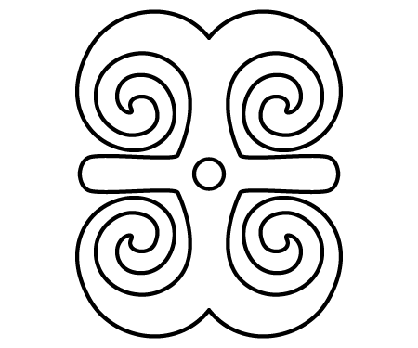

- The art of metalworking began around 3500 B.C. True or False

- Ancient France was the first area to begin the art of metalworking. True or False

- Adinkra symbols are incorporated in the wrought-iron designs found across Louisiana, particularly in New Orleans. True or False

- The Akan people:
Live in China
Live in Spain
Live in West Africa
Live in Australia
All of the above

Title Founders of Surrealism
Time Frame Three 60-minute sessions
Overview Students view and compare images from the work of Max Ernst and Kay Sage. They use this research and their understanding of design elements and principles to examine surrealist motifs through a series of sketches. Students render these sketches into a contemporary surrealist painting.

Standards Creative Expression and Historical and Cultural Perspective

Arts Benchmarks
Understand how works of art cross geographical, political, and historical boundaries. | VA-HP-M2
Demonstrate art methods and techniques in visual representations based on research of imagery. | VA-CE-M1
Use the elements and Principles of Design and art vocabulary to visually express and describe individual ideas. | VA-CE-M3

Foundation Skills Communication, Problem Solving, Linking and Generating Knowledge

Student Understandings

Having viewed and compared the work of surrealist artists Max Ernst and Kay Sage, students identify surrealist artists and their stylistic characteristics. Students are able to incorporate stylistic characteristic of surrealism into surrealist landscapes.

Vocabulary

positive space, negative space, landscape, foreground, background, middle ground, surrealism, assemblage, juxtaposition, motif, perspective, media/medium

Materials and Equipment

images of the works of Max Ernst and Kay Sage, pencils, acrylic or tempera paint, gel mediums, canvas board or heavy white paper, paint brushes, water containers, pre-test/post test assessment measure, Vocabulary Self-Awareness

Prior Knowledge

Students understand the vocabulary words and can identify visual representations of these words. They understand basic techniques and skills associated with color mixing and paint application.

Sample Lesson

Day 1
Begin by giving students the pre/post-test assessment. Students begin by completing the pre/post-test assessment (5 minutes).

Present Max Ernst’s Vox Angelica (1943) and Kay Sage’s J'Ai Vu Trois Cites (1944.) Referring to the artworks, introduce motifs characteristic of surrealist landscapes. Motifs include the skewing of shapes, the twisting of perspective, and the juxtaposition of incongruent objects. Emphasize one example of how positive space, negative space, ground, assemblage, foreground, background, and middle ground are used to create a landscape composition (5 minutes).

Present facts from the reference materials on surrealism as well as artists Max Ernst and Kay Sage. Facts to share on surrealism include: 1) a definition of surrealism (a style where the desire of the artist to make what is unconscious into conscious images so that these images can be examined), and 2) information on when the movement was founded (by André Breton in Paris in 1924). Facts to share on Max Ernst include: 1) where he lived, 2) what his primary media were, and 3) where his work is exhibited. Facts to share on Kay Sage include: 1) where she lived, 2) what her primary media were, and 3) where her work is exhibited (10 minutes).

Lead a brief discussion on the characteristics of surrealism, particularly stylistic characteristics found in surrealist landscapes, (for example, juxtaposing the unexpected – a tree with a cell phone, the ocean with a fork, a mountain top with a tooth brush, etc.). Surrealism focuses on the unconscious, on images the mind creates during sleep. To reinforce understanding of the techniques employed by surrealist artists, point out characteristics of Sage’s work (5 minutes).

In small groups, students continue to view and compare Ernst’s Vox Angelica and Sage’s J'Ai Vu Trois Cites. Students identify additional examples of surrealist motifs in each work, as well as discuss Ernst and Sage’s use of positive space, negative space, ground, assemblage (particularly assemblage as it relates to compositions created from the assembling of a diverse and apparent incongruous, miscellaneous grouping of forms or objects), foreground, background, and middle ground (25 minutes).

Close by having a spokesperson from each group report his/her group’s findings to the class (10 minutes).

Day 2
Students complete the vocabulary self-awareness (view literacy strategy descriptions) exercise to further examine surrealist motifs, such as the skewing of shapes, the twisting of perspective, the juxtaposing of incongruent objects, as well as the incorporation of these stylistic characteristics found in surrealist landscapes; vocabulary self-awareness includes opportunities for a series of sketches and assists students with their understandings of knowing what it is they don’t know. They record and communicate their comprehension of targeted vocabulary words and self-assess changes in their personal comprehension throughout the course of the lesson (35 minutes).

Working with acrylic or tempera paints, students begin to translate their two-dimensional sketches from their vocabulary self-awareness exercise into a contemporary surrealist landscape (15 minutes).

Students clean up (10 minutes).

Day 3
Open class by spending five minutes reviewing criteria for motif characteristics of surrealist paintings. Criteria include skewing of shapes, the twisting of perspective, and the juxtaposing of incongruent objects, as well as use of positive space, negative space, ground, assemblage, foreground, background, and middle ground in landscape compositions (5 minutes).

Students complete their surrealist painting (40 minutes).

Students clean up (10 minutes).

Close by having students complete the pre/post-test assessment (5 minutes).

Sample Assessments

Formative
Monitor student performance throughout the art-making process and assist students with individual needs.
Assess group presentations to see if students completed group tasks.
Check to see if students have explored the use of positive space, negative space, ground, assemblage, foreground, background, and middle ground in written definitions and in sketches.
Check to see if students have explored stylistic characteristics of surrealist landscapes in sketches.

Summative
Evaluate the following:
Pre/post-test for completion and accuracy;
Changes in scores between the pre-test and the post-test and a comparison of these changes;
Vocabulary Self-Awareness for completion and accuracy (both written and visual representations);
Landscape paintings using the following criteria:
Student exhibits imaginative use of positive space, negative space, ground, assemblage, foreground, background, and middle ground in his/her landscape compositions;
Student exploration of the skewing of shapes, the twisting of perspective, the juxtaposing of incongruent objects, as well as the incorporation of these stylistic characteristics to complete their surrealistic landscapes.

Resources

Suther, J. D. (1997). A house of her own: Kay Sage, solitary surrealist. University of Nebraska Press.

The websites listed below offer detailed information on painter Max Ernst and opportunities to view his work. (Websites should be previewed by the teacher. Some images may not be suitable for some students.)
http://www.mcs.csuhayward.edu/~malek/Ernst.html
http://www.metmuseum.org/special/Max_Ernst/images.asp
Images of Kay Sage’s work can be viewed at the following websites:
http://www.artcyclopedia.com/artists/sage_kay.html http://www.aaa.si.edu/collectionsonline/sagekay/
Kay Sage’s work can also be found in collections at the Art Institute of Chicago and the Museum of Modern Art, New York.

Founders of Realism: Vocabulary Self-Awareness

Name_____________________

Please rate your understanding of each vocabulary word using the rating scale below; then draw a sketch of the word and write a definition.

Rating categories:
+ means “I understand the meaning of this word very well”
? means “limited or not quite sure what this word means”
- means “don’t know this word at all”

Word | + | ? | - | Example | Definition
Positive space

Negative space

Foreground

Background

Landscape

Assemblage

Collage

Foreground
Background
Middle ground
Surrealism

Founders of Surrealism: Pre/Post-Test

Name_____________________

Please circle the correct answer.

1. Elements of Design include line contrast. True or False

2. Max Ernst and Kay Sage were both:

Cubists
Surrealist
Modern Primativists
Abstract Expressionists

3. The seven Principles of Design include pattern and rhythm. True or False

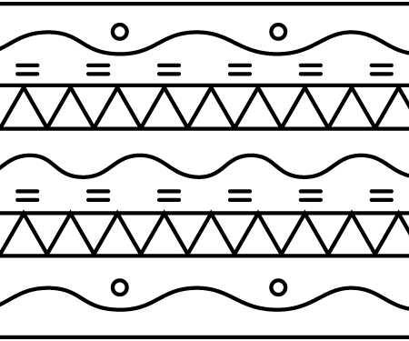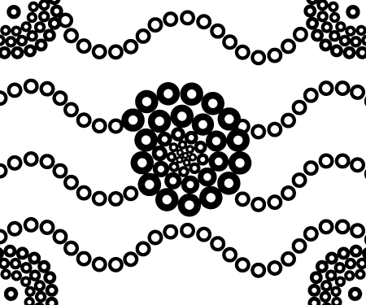

4. Landscapes always show scenes from indoors. True or False

5. Landscapes can include sunsets. True or False
Title Weavers of Louisiana
Time Frame Three 60-minute sessions
Overview Students view and compare images of traditional basket weavings created by the Chitimacha. They use this research and their understanding of design elements and principles to examine motifs from these weavings through a series of sketches. Students render these sketches into a contemporary weaving.

Standards Aesthetic Perception and Creative Expression

Arts Benchmarks
Use elements and Principles of Design and expanded art vocabulary for responding to the aesthetic qualities of various works. | VA-AP-M1
Demonstrate art methods and techniques in visual representations based on research of imagery. | VA-CE-M1
Develop skills in creating various art forms, including art form from other cultures. | VA-CE-M4

Foundation Skills Communication, Problem Solving, Linking and Generating Knowledge

Student Understandings

Having viewed and compared basket weavings created by the Chitimacha, a Native American group indigenous to Louisiana, students identify stylistic characteristics of Chitimacha weaving. They incorporate stylistic characteristics into their own two-dimensional weavings.

Vocabulary

Chitimacha, basketry, warp, weft

Materials and Equipment

images of the works of Chitimacha basket weavers, map of Louisiana parishes, pencils,
clear tape, colored pencils (red, black and yellow), sketchbooks, graph paper, single hole-punch, construction paper (red, black and yellow), gel mediums, canvas board or heavy white paper

Prior Knowledge

Students understand positive and negative space and can depict visual representations of these words. They identify and visually depict form, as well as balance, pattern and rhythm.
Sample Lesson

Day 1
Begin by giving the pre/post-test assessment. Students complete the assessment (5 minutes).

Present images of Chitimacha basket weaving. While referring to works, provide a very brief introduction of motifs characteristic of Chitimacha basket weaving. Motifs include: repeating patterns, such as “the snake” (the teche), mouse tracks, bull’s eye or worm track, a tri-chromatic color scheme (yellow, red and black), and repeated use of color to create emphasis, rhythm and movement. Emphasize one example of each motif characteristic of Chitimacha basket weaving (5 minutes).

Present facts from the reference materials on the Chitimacha. Facts to share include: 1) a definition of basket weaving (the use of strips, the weft, to weave in and out of the warp), 2) what the Chitimacha use to make baskets with and how they make them, and 3) information on the Chitimacha (including a map of Louisiana parishes). Traditional Chitimacha baskets are woven from sugar cane. The sugar cane must be collected, stripped and then peeled. To create the traditional tri-chromatic color scheme (yellow, red and black,) natural materials are used to dye the cane. Facts to share on the Chitimacha include: 1) where they live (The Chitimacha live in south Louisiana, in St. Mary Parish, along Bayou Teche), 2) what their primary media are, and 3) where their work is exhibited.

Lead a brief discussion on the characteristics of Chitimacha basket weaving, particularly stylistic characteristics found in Chitimacha basket weaving, (for example, repeating patterns, a tri-chromatic color scheme, and the repeated use of emphasis, rhythm and movement.) Point out several additional patterns, including bow tie, dots, perch, little trout, turtle with a necktie, and rabbit’s teeth. To reinforce understanding of the techniques employed by Chitimacha weavers, point out these characteristics in several additional examples (15 minutes).

In groups of three, students continue to view and compare images of Chitimacha basket weaving and review reference materials on this Louisiana culture and its basket weaving techniques (reference materials include several maps of Louisiana parishes.) Students identify additional examples of Chitimacha basket weaving motifs, as well as discuss information on the Chitimacha. Students also look for and identify additional weaving patterns not discussed earlier. Students record their findings in their sketch books (25 minutes).

In closing, a spokesperson from each group reports the group’s findings to the class (10 minutes).

Day 2
To further examine Chitimacha motifs, such as repeating patterns, a tri-chromatic color scheme, and the repeated use of emphasis, rhythm and movement, using reference materials from the previous class and the findings recorded in their sketchbooks, students select one new image of a Chitimacha weaving pattern. A chosen image can include any one of the weaving patterns in the reference materials previously examined in the large group, or any the student identified and recorded in his/her sketchbook in smaller work groups. One example of a pattern students can choose would be “the snake” (the teche), mouse tracks, bull’s eye, worm track, bow tie, dots, perch, little trout, turtle with a necktie or rabbit’s teeth (5 minutes).

Using graph paper and colored pencils, students plot out the pattern of their chosen design. This gives students an opportunity to record and communicate their comprehension of targeted vocabulary words visually. Students use the remaining class time to begin to translate their two-dimensional graph plots from their graph paper into a contemporary weaving. Working with construction paper, students transfer the pattern plotted on the graph paper to the construction paper. Students lay the graph paper on top of the construction paper. Students tape the graph paper to the construction paper. To transfer the plotted weaving pattern, following the colored pattern, students use their pencils to gently poke a hole through the graph paper and the construction paper (see figures a-f).

Students poke holes to follow the weaving patterns they have selected. To create a pattern for weaving over and under, students leave small spaces, at least 1/4 of an inch, as they poke holes to create the weaving patterns. This is the first step of creating the warp for the weaving. Next, students use a hole-punch to complete the warp. Students punch out the holes they have created by poking through the construction paper with their pencils. The warp is the weaving space into which strips are woven. Next students cut construction paper to act as the weft-- the strips are woven into the warp. Strips are small—a maximum of ¼ inch. Students store their warp and the pieces of construction paper they have cut into the weft for the following class.

Students clean up (5 minutes)

Day 3
Open class by reviewing criteria for motif characteristics of Chitimacha basket weaving. Criteria include repeating patterns, a tri-chromatic color scheme, and the repeated use of emphasis, rhythm and movement. Art-making criteria include the successful use of strips (the weft) to create the pattern in the warp (5 minutes).

Demonstrate the weaving techniques for the students. They continue to work on their Chitimacha weavings (45 minutes).

Students clean up (5 minutes).

Close by having students complete the pre/post-test assessment (5 minutes).

Sample Assessments

Formative
Monitor student performance throughout the art-making process and assist students with individual needs.
Assess group presentations to see if students completed group tasks.
Check to see if students have explored the use of repeating patterns, a tri-chromatic color scheme, and regular employment of emphasis, movement and rhythm in sketches and in graph paper plot designs.

Summative
Evaluate the following:
Pre/post-test for completion and accuracy;
Changes in scores between the pre-test and the post-test and a comparison of these changes;
Chitimacha-inspired weavings using the following criteria:
Student shows imaginative use of a tri-chromatic color scheme (yellow, red and black,);
Student explores the traditional Chitimacha patterns, including “the snake” (the teche), mouse tracks, bull’s eye, worm track, bow tie, dots, perch, little trout, turtle with a necktie or rabbit’s teeth, as well as the incorporation of these traditional patterns in their completed weavings;
Student demonstrates the successful application of the weaving process.

Resources

The website listed below offers detailed information on Chitimacha history:
http://www.chitimacha.gov/tribal_about_history.htm
The website listed below offers detailed information on the history of Chitimacha basket weaving and Images of baskets:
http://hometown.aol.com/chitimacha/chitimachabaskets.html
http://lsm.crt.state.la.us/cabildo/cab2.htm
http://www.support-native-american-art.com/southeast-baskets.html
The website listed below offers a detailed map of Louisiana parishes:
http://quickfacts.census.gov/qfd/maps/louisiana_map.html
The website listed below offers several detailed maps of Louisiana parishes:
http://www.lib.utexas.edu/maps/states/louisiana.gif

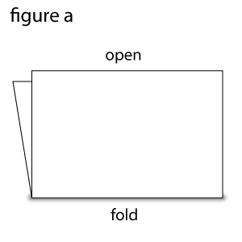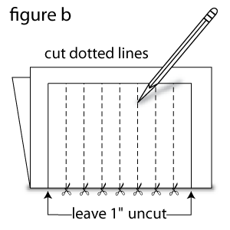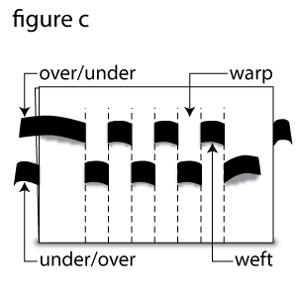
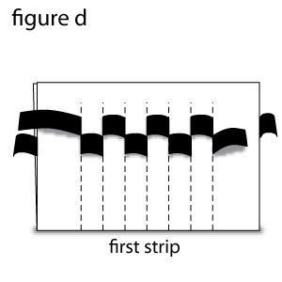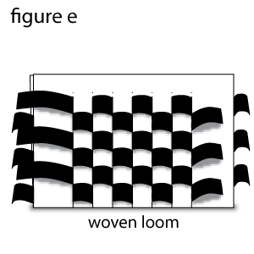
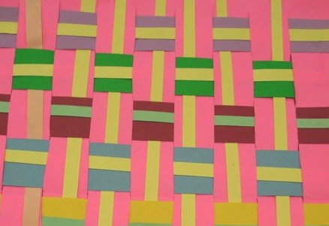
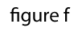
Sample Assessment Weavers of Louisiana: Pre/post-Assessment

Please circle the correct answer Name__________________________

- Elements of Design include pattern. True or False

- These images are both examples of pattern. True or False?

- The piece of thread, strip of basket material or paper strip used to weave is called the weft. True or False

- The Chitimacha live in:

- Terrebonne Parish
- Plaquemines Parish
- St. Mary Parish
- St. James Parish
- Catahoula Parish

- The Chitimacha are known for their pottery. True or False

- The Chitimacha live :

- in central Louisiana
- in North East Louisiana
- in South Louisiana
- in North West Louisiana

Title Masks as Carriers of Culture
Time Frame Six 60-minute classes
Overview Students research and present information learned about the use of masks from different cultures. They create their own masks inspired by their research.

Standards Creative Expression and Historical and Cultural Perspective

Arts Benchmarks
Distinguish media and techniques used to create works of art throughout history. | VA-HP-M4
Demonstrate art methods and techniques in visual representations based on research of imagery. | VA-CE-M1
Develop skills in creating various art forms, including art forms from other cultures. | VA-CE-M4

Foundation Skills Resource Access and Utilization, Linking and Generating Knowledge

Student Understandings

Having studied masks from diverse cultures, students understand the purpose of masks, materials used to create masks, how masks are used in rituals, and how the environment influences the making and use of masks. They understand how a variety of materials can be used to construct a three-dimensional form.

Materials and Equipment

Access to library and Internet resources, papier-mâché, paper, school glue, scissors, feathers, cloth, fake fur, thread, needles, sea shells, hot glue gun and glue, beads, yarn and other materials deemed necessary by the students’ research.

Prior Knowledge

Students are familiar with ways to research selected topics.

Sample Lesson

Day 1
Inform the students that they are studying the role and use of masks in different cultures and then making a mask that reflects the culture they selected. List several cultures on the board for the students to choose from (suggested cultures include Northwest Coast American Indians, Southwest American Indians, Inuit, Mayan, Chinese, and South Louisiana (Mardi Gras). Students sign up for the culture of their choice (10 minutes).

Students research their selected culture by answering questions on the handouts listed after the resources (provide resource books in the classroom or take the students to the library or computer lab). Students sharing the same culture can work together and share what they learned through their research. Any additional questions or relevant information can be added to improve the students’ understanding of the masks of their selected culture (45 minutes).

Tell students what materials will be available for art-making. Students turn in completed handouts; if students are not finished they may complete it as homework (5 minutes).

Day 2
Inform the students that using their research from the last class, they will create a mask inspired by their selected culture. Distribute their research (5 minutes).

Students create a mask inspired by their research. They begin by drawing several sketches of ideas for a mask design in their art journals and making notes of materials they would like to use to create these masks. They should select materials and subjects based on what they learned during their research. If their masks are carved from wood, they use a different medium. Once the sketches are complete, discuss with the group what materials it needs and how to use them (45 minutes). (All members of the same group should use similar media and materials.)

Students temporarily attach their research into their art journals so it doesn’t get lost and then put their journals away (5 minutes).

Day 3
Remind the students they are to make a mask that reflects the culture they have studied. Review the rubric with the students so they know how their work is scored (5 minutes).

Students begin working on their masks. Demonstrate or help individual groups if they selected a medium for their masks that they have not used before (40 minutes).

Students clean up their areas and store their masks where they can dry. Ask students to identify the media and techniques they used and compare that to historical artworks previously studied in their learning logs (10 minutes).

Day 4
Quickly review the second rubric with the students to remind them how their work is scored. Show them an example of a “1” and a “5” (5 minutes).

Students continue working on their masks (40 minutes).

Students clean up their areas and store their masks where they can dry. Ask students to describe the media and techniques that they used to create their masks in their learning logs (10 minutes).

Day 5

Quickly review the rubric with the students to remind them how their work is scored (5 minutes).

Students continue working on their masks (40 minutes).

Students clean up their areas and store their masks where they can dry. Ask students to describe how the methods and techniques that they used compare to the art forms of the culture they are modeling in their learning logs (10 minutes).

Day 6

Students present their masks to the class today. They have about 15 minutes to put any finishing touches on their masks and then they do the following: (write these on the board to help students remember)
1. Show reproductions of masks from the culture you researched to the class.
2. Describe the culture that inspired your mask, and share information you learned about that culture. (This may be done in groups or individually.)
3. Make a small sign which identifies the culture that inspired your mask.
4. Turn in the identifying sign with your completed research and your mask. (Display the masks, using the students’ signs to identify the cultures.)

Students complete their masks, clean up and get ready to present their mask to the class (15 minutes).

Students present their masks to the class, using their research to respond to numbers 1 and 2 listed on the board. All students studying the same culture should present together (30 minutes).

Students turn in their masks, the identifying sign and completed research (5 minutes).

Sample Assessments

Formative
Check to see if the student has done the following:

completed the research about masks from his/her selected culture;
selected and collected appropriate materials for his/her mask; and
created practice sketch.
Observe and monitor activities throughout the lesson. Adjustments and suggestions are provided based on individual needs of students.

Summative

Evaluate the students’ individual presentations.
Assess masks based on craftsmanship and connections between the culture studied and the mask created.

Resources

The following websites may assist students in doing research for their art product:
http://www.andrew.cmu.edu/course/60-105/finals/Cumming_M/'cumming_m.html
http://www.germantownbulldogs.org/indians/southwest.html
http://sorrel.humboldt.edu/~rwj1/esk.html
http://www.native-languages.org/masks.htm
http://www.ucalgary.ca/~dmjacobs/edts325/masks/inuit.html
http://www.tribalarts.com/feature/riordan/index.html
http://www.latinamericanstudies.org/mayan-masks.htm
http://www.llc.ed.ac.uk/cinema-china/king_maskmaking.html
http://www.paulnoll.com/China/Opera/index.html
http://www.einaudi.cornell.edu/curriculum/monkey/opera/
http://cti.itc.virginia.edu/~bcr/African_Mask.html
http://www.artyfactory.com/africanmasks/index.htm
http://www.novareinna.com/festive/mardi.html
http://www.novareinna.com/festive/mardi.html
http://www.lsue.edu/acadgate/mardmain.htm

Masks from Many Cultures - Crystal Productions video

Masks as Carriers of Culture: Research Worksheet Name_________________

After selecting a culture, study at least two reproductions of masks to help you complete the following:

Name of Culture___________________________

Why were the masks created? How were they used by that culture?

Describe the ritual or ceremony that uses these masks. (Is it a religious ceremony, a celebration of an event, a rite of passage, etc.?)

Draw sketches of designs, patterns and/or symbols used by the culture.

Describe the colors, shapes, and textures that you see in the masks.

What influenced the details of the mask? Does the mask depict an animal, a person, or a spirit? What does the mask maker do to achieve this effect?

What materials are used to make the masks? Where did the mask maker find these materials?

Masks as Carriers of Culture: Assessment rubric for student mask

Name of student_____________________________

Assign a number of 1-5 to the following criteria. Each criterion is worth a total of 5 points.

______The mask reflects effort and is well-constructed.

______The mask design was influenced by the selected culture. (The student should explain this connection during their presentation.)

_____ The student turned in the completed research questions worksheet.

_____ The student’s research was thorough, accurate, and clearly presented.

_____The student used appropriate materials for his/her mask.

_____The student stayed on task and cleaned up at the end of each class period.

Total________ (30 points possible)

Title Blue Man Group as Performance Art
Time Frame One 60-minute class
Overview After investigating the performance of the Blue Man Group, students create a storyboard for a new performance piece.

Standards Aesthetic Perception and Creative Expression

Arts Benchmarks
Demonstrate awareness of various new ideas, possibilities, options, and situations pertaining to the art world. | VA-AP-M4
Produce ideas for art productions while engaging in individual and group activities. | VA-CE-M5
Maintain a sketchbook or journal and develop a portfolio. | VA-CE-M7

Foundation Skills Communication, Problem Solving, Resource Access and Utilization

Student Understandings

After studying the Blue Man Group, students understand how performance can serve as an innovative art form. Having created a storyboard representing their own performance art work, students understand one way in which performance art works can be designed and created.

Vocabulary

performance art, storyboard

Materials and Equipment

Internet access or printed images, copies of Blue Man Group’s newspaper review, sketchbook/journal, pencil, - Storyboard for Blue Man Group Adventure

Prior Knowledge

Elements of art (color, value, line, shape, form, texture and space) and Principles of Design (movement, unity, variety, balance, emphasis, contrast, proportion, and pattern)

Sample Lesson

Begin by inviting students to respond to the term “performance art” in their sketchbooks. Students share their ideas with the rest of the class. Using student responses and the Artlex definition for performance art, a definition is devised for this new option in the art world.
A student reads the definition aloud.
Performance art - Art in which works in any of a variety of media are executed premeditated before a live audience. Although this might appear to be theater, theatrical performances present illusions of events, while performance art presents actual events as art. (10 minutes)

Next, students are introduced to the Blue Man Group by displaying one image of the performance art group and by having students listen /read the following excerpts from Christopher Hoile’s article. This review in hard copy may also be given to the students (5 minutes).

After listening to the reading of the article, students quickly jot down surprises learned about performance art in their sketchbook/journals (5 minutes).

Next, students view a video clip of the group performing. Immediately following the video clip, students describe first impressions in their sketchbook/journals. Pose the following questions:
What was your first impression after viewing the clip?
What connections do you see between art and performance?
How can you describe the Blue Man Group using the elements and principles of art?

Students visit Blue Man Group website to view video clip of different aspects of the show. This inspirational clip guides the students’ art-making task (10 minutes).

To demonstrate awareness of various new ideas, possibilities, options, and situations pertaining to the art world, in groups of three, students create a storyboard for another Blue Man Group episode or a performance art piece of their own design. Students are given the definition of storyboard (www.artlex.com) as well as the handout for storyboarding (20 minutes).

Storyboard - A series of simple pictures that depict the important changes of scene and action in a planned film or video production. In the production of an animated film, for example, a series of sketches, comparable to a comic strip, outline the narration of a scene — its visual and auditory changes. Traditionally, these drawings are tacked to a bulletin board, arranged, re-arranged and replaced as the story takes shape. Early rough storyboard drawings are thumbnail sketches, while more detailed drawings are called "finished" or "final storyboard panels."

In closing, student groups may volunteer to share their storyboards of their performance art piece with the whole class (10 minutes).

Extension
As a whole class, students select one of the groups’ performance art pieces to produce. The whole class then divides tasks and each student participates in the production.
Sample Assessments

Formative
Observe, monitor, and assist activities throughout the lesson (reflective description of Blue Man Group’s performance art, list of performance art possibilities, sketchbook or learning log entries of personal reflection, group storyboard for a performance art piece). Adjustments and suggestions are provided based on individual needs of students

Resources

Christopher Holie’s review was found at http://www.stage-door.org/reviews/BlueManGroup.htm.

The following websites contain information and images for this lesson:
www.artlex.com
http://www.stage-door.org/reviews/BlueManGroup.htm
http://www.blueman.com/
http://music.barnesandnoble.com/features/interview.asp?NID=684328
http://www.starpulse.com/Music/Blue_Man_Group/Pictures/

Storyboard for a Blue Man Group Adventure or a Performance Adventure of Your Design.

Name______________________________

Directions: Brainstorm your ideas with your group. Use a graphic organizer on the back of this paper to record ideas.
In the squares below, sketch your adventure actions and use the lines below to describe each event.
___________________________________________________________________________________________________
___________________________________________________________________________________________________
___________________________________________________________________________________________________
___________________________________________________________________________________________________
___________________________________________________________________________________________________
___________________________________________________________________________________________________
Title Mexican Niches
Time Frame Four 60-minute classes
Overview After viewing images of the Mexican culture’s celebrations, students create a Mexican niche.

Standards Creative Expression and Historical and Cultural Perspective

Arts Benchmarks
Understand the meaning and significance of ideas, themes, and messages  in works of art from the past and present. | VA-HP-M3
Develop skills in creating various art forms, including art forms from other cultures. | VA-CE-M4
Maintain a sketchbook or journal and develop a portfolio. | VA-CE-M7

Foundation Skills Problem Solving, Resource Access and Utilization, Linking and Generating Knowledge

Student Understandings
Having viewed and discussed the ways artists have depicted recurrent themes (birth, war, family, identity) or events, students create a three-dimensional niche communicating their view of a theme or event (Day of the Dead). They understand how cultures express important events or themes inherent through works of art. Students understand how to create three-dimensional works of art by using found materials and recognize the importance of sketching as a planning tool for finished works of art.

Vocabulary

niche (small box with a scene inside),retablo, scoring

Materials and Equipment

computer, projector, 8.5”x11” paper, scissors, glue, Crayola Model Magic, pencil, markers, construction paper, sketchbooks

Prior Knowledge

Students have basic understanding of the following concepts -origami paper folding, foreground, and background.

Sample Lesson

Day 1
Introduce Mexico’s celebration of the Day of the Dead, El Dia de los Muertos, a piece of living history where Aztec and Spanish cultures have collided. Once a year, families honor their deceased relatives by decorating their graves and constructing ofrendas (altars) in their homes.
View images of the tradition on the Internet (see resources) or have printed images for students to investigate. Show students images of niches (small boxes), scenes with calacas, (skeletons) pointing out that the skeletons in these small boxes are generally realistic, (such as a dentist, a football player, a musician, an artist, or celebrity etc.) (15 minutes).

Explain that each student is creating a niche. Using their sketchbooks, students begin by brainstorming (view literacy strategy descriptions) with a partner about the topic of their niche. Have student pairs discuss the following questions (15 minutes).
Whom do I want to honor?
How do we honor our deceased? What symbols and imagery are used?
How does this Mexican tradition differ from ours?

Next, each student draws a preliminary sketch of his/her niche complete with foreground and background, the skeleton being the foreground. Students include visual characteristics representative of Mexican design in these works such as use of color, patterns, and symbols (15 minutes).

After students have completed the sketches, allow students to volunteer to hang and discuss their drawings. Make sure to point out images or symbols characteristic of Mexican niches (10 minutes).

Close by having students write three ideas they would like to develop in their sketchbooks for the next day. Finally, students write down on a small piece of paper a question they have. Collect the exit slips and review them prior to the next class (5 minutes).

Day 2
Open class by reviewing students’ tasks and explaining the criteria that are used to assess their niches. Niches are scored by looking for the following details:
Successful construction of origami box
Inclusion of all required elements (box, background, skeleton, doors, title triangle)
Inclusion of any visual qualities representative of Mexican design (5 minutes)

To begin creating their niche, students review sketches and research and create an origami box. Demonstrate the creation of an origami box.
Take 8.5” x 11” paper and cut off 2 inches, creating an 8.5” x 8.5” piece of paper.
Use the attached website to create the box, http://www.origami-instructions.com/origami-box.html.
Stand the box on one edge, and cut (from another piece of paper) a square to fit at the back of the box (3” x 3”); this is used to create the background and then glued in place (10 minutes).
Next, on the small square paper, students create a scene or the background for their chosen calacas for the niche and glue it in place. Then students use Crayola Model Magic to construct a small skeleton complete with appropriate costume and glue it into place within the box (40 minutes). Students describe their scene or background in their sketchbook journals and clean up the work station (5 minutes).

Day 3
Open by asking students to share issues that they are confronting during the construction of their niche. This allows the teacher to offer suggestions to the whole group (5 minutes).

Students continue to create their niche. Now that their skeleton has air dried (1 day), students can use markers to add detail.

Next, students, create doors for the niche by cutting a 3” x 9” piece of construction paper and then wrapping it around the box to create doors, scoring it appropriately for a snug fit, and gluing in place. Doors may be decorated and/or cut out.

For the top of the niche, students cut out a triangle including a tab at the base for gluing to the box. This may be used for the niche’s title. See image after resources (50 minutes). After they clean up the work stations, students discuss any difficulties they are experiencing as a group (5 minutes).

Day 4
Open by reminding students of the criteria used to assess the niches (5 minutes). Students continue to work on niches (50 minutes). Students write how they are expressing their artistic idea in their sketchbook journals and clean up the work station (5 minutes).

Day 5
Students complete niches (30 minutes). Display niches (10 minutes).

In sketchbook journals, have students reflect on their art-making and the Mexican tradition of honoring their deceased, Day of the Dead, by writing five sentences about what they have learned (5 minutes). Clean up (5 minutes).

Extensions
On the back, students may write about the skeleton or an artist could be used at the topic of the niche.

Sample Assessments

Formative
Observe and monitor activities throughout the lesson, discussion, sketchbook and niche-making. Adjustments and suggestions are provided based on individual needs of students.

Summative
Evaluate the niche using the following criteria:
Successful construction of origami box,
Inclusion of all required elements (box, background, skeleton, doors, title triangle),
Inclusion of any visual qualities representative of Mexican design,
Completion of Journal entry.

Resources

Lowery, L. (2004). Day of the dead. Minneapolis, MN: Carolrhoda Books.

The Day of the Dead is actually celebrated over a three-day period - from October 31 through November 2 - when families all over Mexico honor their deceased by decorating graves and building altars (ofrendas) in their homes. The ofrendas are a unique expression by each family, displaying photographs of the dead relative or loved ones, sweets, flowers, candles, and favorite possessions of the departed. The following websites contain additional information and images on the occasion:
http://www.azcentral.com/ent/dead/teachers/teacherpacket_edited.pdf
http://www.dayofthedead.com/
http://www.azcentral.com/ent/dead/
http://www.inside-mexico.com/featuredead.htm
http://www.mexonline.com/features/daydead-oaxaca.htm
http://www.mexonline.com/jose-guadalupe-posada.htm
http://www.thefolkartgallery.com/retablo.htm

Retablo

Title Introduction to Animation
Time Frame Three 60-minute sessions
Overview The students view works of Pixar Animation Studios and discuss the roles of the artist in computer animation. They use this research and their understanding of design elements and principles to create flipbooks composed of a series of sketches that illustrate movement.

Standards Creative Expression and Historical and Cultural Perspective

Arts Benchmarks
Describe and compare careers in visual arts and the role and status of the artist in various cultures and time periods. | VA-HP-M5
Demonstrate art methods and techniques in visual representations based on research of imagery. | VA-CE-M1
Produce ideas for art productions while engaging in individual and group activities. | VA-CE-M5

Foundation Skills Communication, Problem Solving

Student Understandings

Students explore the artist’s role in animation. The focus is on computer animation and the works of Pixar Animation Studios. They assume the role of animators and create original flipbooks depicting motion.

Vocabulary

animation, frame, flipbook, sequence

Materials and Equipment

images of the works of Pixar Animation Studios, pencils, colored pencils, sketchbooks,
small (3 x 5 inch) sketchbooks or pads of small (3 x 5 inch) non-ruled index cards, pre/post-test assessment measure

Prior Knowledge

Students understand basic techniques and skills associated with the application of Elements of Design such as line, color, and space, and can combine them to depict design principles such as pattern, movement, and rhythm.
Sample Lesson

Day 1
Begin by giving the pre/post-test assessment. Students complete the assessment (5 minutes).

Introduce motifs characteristic of animation. A simple definition of animation is the art of bringing a visual composition to life. A simple explanation of motifs characteristic of video animation is that the animation’s sequences of on-going motion are assembled one step at a time through a series of individual frames. Beginning with individual panels, or frames, animation assembles these individual images into a sequence of motion. In a finished sequence, a flower may look like it has gone from bud to bloom, a person may look like he/she has run from one place to another, or a house may look like it was built. A flipbook is a simplified version of animation in which each page of the book represents an individual frame or step in the sequence of motion. The sequence is the amount of steps or frames it takes to complete the motion from start to finish (10 minutes).

Next, present handouts of reference materials on Pixar Animation Studios (see resources). In groups of three, students view and compare images from the work of Pixar Animation Studios. Students identify motifs in each work, as well as the artists’ use of design elements, such as line, color, and space, and the combination of these elements to depict design principles, such as pattern, movement, and rhythm. Students consider and record the following questions in their sketchbooks: 1) How have the artists used line color? 2) How have the artists used space? 3) What might the first step in the sequence of movement be? 4) What might the final step in the sequence of movement be? Students record their responses in their sketchbooks (35 minutes).

Finally, a spokesperson for each group reports his/her group’s findings to the class (10 minutes).

Day 2
Open class by reviewing newly learned terminology related to animation (such as animation’s sequences of on-going motion are assembled one step at a time through a series of individual frames). Direct students to fold a piece of paper from left to right. The students sketch a series of ten frames to create a sequence of motion. In the left column, they will provide dialogue to be animated (10 minutes).

Students produce a series of sketches. This assists students by enabling them to record and display their comprehension using two methods of communication, written text and corresponding visual representations. Using two methods, written text and corresponding visual representations, reinforces targeted concepts, vocabulary words, and allows students to self-assess changes in their personal comprehension throughout the course of the lesson (30 minutes).

Next, using their sketchbooks and using line and space to illustrate movement, students expand the split-page notetaking exercise to begin to create flip books composed of a series of sketches. Using pencil and colored pencil, and small (3 x 5 inch) sketchbooks or pads of small (3 x 5 inch) non-ruled index cards, they create a minimum of 30 sketches. Each sketch needs to be simple as it depicts a very small change in design from the sketch that precedes it. Viewed all together by flipping the pages of the sketchbook or book of index cards, the sketches as a whole depict a sequence of movement, such as a flower blooming, a person running or swimming or a house being constructed (15 minutes).

Students clean up (5 minutes).

Day 3
Open class by reviewing newly learned terminology related to animation and the creation of flipbooks. A flipbook is a simplified version of animation in which each page of the book represents an individual frame or step in the sequence of motion. The sequence is the amount of steps or frames it takes to complete the motion from start to finish (5 minutes).

Using their sketchbooks, and using line and space to illustrate movement, students continue to expand the exercise to create flipbooks composed of a series of sketches. Using pencil and colored pencil, and small (3 x 5 inch) sketchbooks or pads of small (3 x 5 inch) non-ruled index cards, students continue creating a minimum of 30 sketches. Each sketch needs to be simple as it depicts a very small change in design from the sketch that precedes it. Viewed all together by flipping the pages of the sketchbook or book of index cards, the sketches as a whole depict a sequence of movement, such as a flower blooming, a person running or swimming or a house being constructed (45 minutes). Students clean up (5 minutes).
Close by having students complete the pre/post-test assessment (5 minutes).

Sample Assessments

Formative
Monitor student performance throughout the art-making process and assist students with individual needs.
Assess group presentations to see if students completed group tasks.
Check to see if students have used line, color and space to depict pattern, movement, and rhythm in each individual sketch.
Students write the similarities and differences of a traditional artist and an animator in their sketchbook journals.

Summative
Evaluate the following:
Pre/post-test for completion and accuracy;
Comparison of changes in scores between the pre-test and the post-test;
Flipbook sequences for: 1) Completion, 2) Use of individual panels to convey a sequence of motion, 3) Inventive design, and 4) Craftsmanship.

Resources

The websites listed below offer detailed information on Pixar Animation Studios and opportunities to view its work:
http://www.pixar.com/
http://www.moma.org/exhibitions/2005/pixar.html
http://disney.go.com/disneyvideos/animatedfilms/cars/

Introduction to Animation Name_____________________________

Describe the sequence and sketch the sequence:
One frame at a time, create a sequence of motion. For each frame, write about what is happening in the left square. Create a sketch of each frame on the right.

First Frame: | Sketch the first frame of the sequence:
Second Frame: | Sketch the next frame of the sequence:
Third Frame: | Sketch the next frame of the sequence:
Fourth Frame: | Sketch the next frame of the sequence:
Fifth Frame: | Sketch the next frame of the sequence:
Sixth Frame: | Sketch the next frame of the sequence:
Seventh Frame: | Sketch the next frame of the sequence:
Eight Frame: | Sketch the next frame of the sequence:
Ninth Frame: | Sketch the next frame of the sequence:
Final Frame: | Sketch the final frame of the sequence:

Introduction to Animation Name_____________________________

Directions: Please circle the correct answer

- Elements of Design include movement. True or False

- The following images are graphic representations that are examples of movement.
True or False

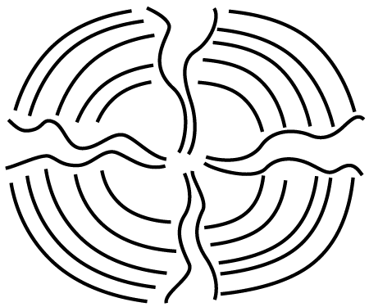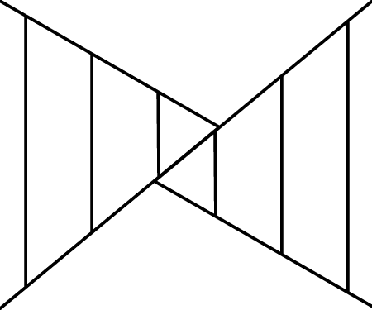

- Animation can be computer-generated or drawn. True or False

- Principles of Design include: rhythm, pattern, and balance. True or False

- Line is a design element that can be used to create the design principle of contrast.
True or False

Title A Room of One’s Own
Time Frame Two 60-minute classes
Overview After viewing and discussing the interiors of the Palace of Versailles, the Robie House, and contemporary interiors, students create a colored pencil drawing of a room of one’s own.

Standards Critical Analysis and Creative Expression

Arts Benchmarks
Express and justify aesthetic judgments about the created (built)  environment. | VA-CA-M3
Select and apply media techniques, and technology to visually express and communicate. | VA-CE-M2

Foundation Skills Resource Access and Utilization, Linking and Generating Knowledge

Student Understandings

Having viewed, listed, and discussed characteristics found in historical and contemporary interiors, students express and justify aesthetic judgments about built environments. They understand how colored pencils can be used to create a one-point perspective drawing of a built environment (“room of one’s own”).

Vocabulary

orthogonal line – lines to the vanishing point

Materials and Equipment

Internet access, magazines (Pottery Barn, West Elm, etc.) rulers, pencils, easers, learning log, sketchbook, 9” x 12” paper, colored pencils

Prior Knowledge

Students have had basic experience drawing one-point perspective and blending colored pencils to create shades and tints.

Sample Lesson

Day 1
Open by introducing bedroom interiors of the past, i.e. Versailles’ queen’s chamber (circa 1661) and Frank Lloyd Wright’s Robie House bedroom (circa 1910) using visual means, either prints or projections.

Next, in their sketchbook/learning logs (view literacy strategy descriptions), students create three vertical columns by folding a page. Make headings for the first two columns, Versailles’ queen’s chamber, Wright’s Robie House bedroom and in the third column, “room of one’s own.” Students begin by listing attributes found in Versailles’ queen’s chamber and the Robie House. In groups of three, students reflect upon their lists using the following questions:
What is found in each of these rooms?
Why do these rooms look so different?
What type of ornamentation, color scheme, and details are used? Why? (20 minutes)

In the third column of their page, students list items they think would be found in the perfect “room of one’s own.” Using magazines/catalogues such as Pottery Barn and West Elm, students explore possibilities for designing a contemporary bedroom and adding items to their lists (10 minutes).

This list and the design information are now used to create a one-point perspective drawing of the perfect “room of one’s own” on 9” x 12” paper. Review one point perspective: all lines are vertical, horizontal or orthogonal lines (lines to the vanishing point). Demonstrate basic procedure.

Students work in pencil to create this drawing including at least five items from their lists (25 minutes). In closing, students are invited to share their progress with the class (5 minutes).

Day 2
In groups of three, students review the one-point perspective drawing process and check one another’s drawing for correctness, meaning all lines are either vertical, horizontal or orthogonal lines (to the vanishing point) (5 minutes).

Then, students continue to work on their bedroom design drawing, completing it in colored pencil. Encourage students to develop tints and shades in their color scheme and to add depth to the drawing (45 minutes).

As a culminating activity, students exhibit their drawings and observe the similarities and differences on personal design preferences in a gallery walk simulation. In their sketchbook or learning logs, students comment on their work or a selected classmate’s work. Aesthetic comments should include justifications (10 minutes).

Sample Assessments

Formative
Observe, monitor and assist activities throughout the lesson (three column attributes list, one-point perspective of bedroom). Adjustments and suggestions are provided based on individual needs of students.

Summative
Completion of students’ three-column list
Completion of students’ journal responses to finished artwork
Personally designed bedrooms, drawings for incorporation of interior design characteristics, use of one-point perspective techniques, and use of colored pencils to create tints and shades and develop depth.

Resources

The following websites contain images and information for this lesson:
http://www.gowright.org/robiehouse/robiehouse.html
http://www.greatbuildings.com/buildings/Chateau_de_Versailles.html
http://www.olejarz.com/arted/perspective/index.html
Title Cubists Cubed
Time Frame Three 60-minute sessions
Overview Students create a Cubist-inspired painting.

Standards Creative Expression and Historical and Cultural Perspective

Arts Benchmarks
Identify and classify work of arts by their subject, style, culture and time period. | VA-HP-M1
Demonstrate art methods and techniques in visual representations based on research of imagery. | VA-CE-M1
Use the elements and Principles of Design and art vocabulary to visually express and describe individual ideas. | VA-CE-M3

Foundation Skills Problem Solving, Resource Access and Utilization, Linking and Generating Knowledge

Student Understandings

Having viewed the works of Cubist artists, students identify and discuss characteristics of the Cubist style of painting. Having created a Cubist-inspired painting, students understand how art elements can be used to create a Cubist painting.

Vocabulary

Cubism, color scheme, abstraction

Materials and Equipment

Cubists Cubed (handout), 11”x17” paper, pencil, ruler, magazines, tracing paper, permanent marker, acrylic or tempera paint, water containers, Internet access or prints

Prior Knowledge

Students have basic understanding of the elements of art and drawing objects. They have used acrylic or tempera paint.

Sample Lesson

Open by displaying the following Cubist art works: Georges Braque, Still Life: Le Jour, 1929), a figurative work; Diego Rivera, Sailor at Lunch, 1914; and Max Weber, cityscape, Rush Hour, New York, 1915.
Introduce Cubism to students using the Artlex.com description as a guide.
Cubism - One of the most influential art movements (1907-1914) of the twentieth century, Cubism was begun by Pablo Picasso (Spanish, 1882 - 1973) and Georges Braque (French, 1882 - 1963) in 1907. They were greatly inspired by African sculpture, by painters Paul Cézanne (French, 1839-1906) and Georges Seurat (French, 1859-1891), and by the Fauves. In Cubism the subject matter is broken up, studied, and reassembled in an abstracted form. Picasso and Braque initiated the movement when they followed the advice of Paul Cézanne, who in 1904 said artists should treat nature "in terms of the cylinder, the sphere and the cone." Braque and Picasso's similar compositions are broken into planes with open edges, sliding into each other while denying all depth. Color is reduced to a gray-tan cameo, applied uniformly in small brushstrokes creating vibrations of light (Artlex, 2008).

Next, using the handout, Cubists Cubed, students write their own observations of the images listed. After studying each artwork, students record their observations of line, shape, and color in the provided squares. Upon completion, students select three of these observations to reflect their art-making in the Cubist style (20 minutes).

Recalling the above definition of Cubism, lead a discussion with the following:
Did the artists follow Paul Cezanne’s advice, treating nature as cylinder, sphere and cone?
Describe how one of the artists has abstracted the subject matter.
Each artist has reduced objects into geometric shapes; name an object that they can still be recognized.
How is line used in each painting?
Describe the color schemes used by the artists.
Is repetition, a principle of design, important to these works? (20 minutes)

After students have completed the handout, explain that they are creating a Cubist-inspired painting using what they have learned about Cubist art. The Cubist painting will be scored for completion and representation of Cubist style (abstraction of images, use of line, shape, and color).

Students select a magazine picture for their subject matter. Students place the tracing paper on top of the magazine picture and create a preliminary drawing/sketch by tracing geometric shapes that make up the composition. Referencing their Cubists Cubed and the lesson’s featured artworks (above), students study their own abstracted compositions and make alterations using repetition or subtractions to the composition. This drawing can also be used for color studies; it can be copied on a copy machine, and different color schemes may be applied with crayon or colored pencil (20 minutes).

Close the lessons by displaying students’ Cubist drawings for a short in-process critique (10 minutes).

Day 2
Open session by displaying one Cubist work and reviewing characteristics of the Cubist style. Remind the students that they are to create a Cubist-inspired painting using the abstracted sketches students completed on day 1 (5 minutes).
After completing the abstracted sketch, students transfer their compositions to 11”x17” paper using pencils. Once the image is transferred, students outline the drawing using permanent marker. Application of acrylic or tempera paint completes the work for today (50 minutes). Clean up (5 minutes).

Day 3
Open by reminding students how their Cubist works are scored. Take questions related to student progress and offer suggestions for continued work (5 minutes).

Students continue to work on their paintings (40 minutes).

Once the paintings are completed, students clean up their areas. Students present their works to the class, describing the one element that shaped their Cubist style and their favorite part of this art-making process (15 minutes).

Sample Assessments

Formative
Note students’ participation during the class discussion of Cubist art work.
Check that students are using a Cubist style in their preliminary drawing.
Observe and monitor activities throughout the lesson. Adjustments and suggestions are provided based on individual needs of students.

Summative
Completion of students’ Cubism Cubed
The Cubist painting is scored for completion and representation of Cubist style (abstraction of images, use of line, shape, and color).
The student’s presentation of his/her artwork draws upon details of Cubism.

Resources

For information and images about Cubism and its artists, visit the following websites:
www.artlex.com
http://www.tate.org.uk/collections/glossary/definition.jsp?entryId=80
http://www.nga.gov/cgi-bin/pimage?46283+0+0 (Georges Braque, Still Life: Le Jour)
http://www.nga.gov/exhibitions/2004/rivera/210-021.htm (Diego Rivera, Sailor at Lunch)
http://www.nga.gov/cgi-bin/pimage?51803+0+0 (Max Weber, Rush Hour, New York)
Cubists Cubed

Name___________________________

Instructions: View three different Cubist artworks; write three observations about each artwork.
Use any three of these statements to construct your Cubist style artwork.

LINE SHAPE COLOR

Artist

Title

Year

Artist

Title

Year

Artist

Title

Year

Title Cuna Indian Molas
Time Frame Three 60-minute classes
Overview Students learn about the Cuna (Kuna) Indians of the San Blas Islands off the coast of Panama and the molas they create. They create similar designs out of construction paper. Upon completion of these designs, students reflect on whether molas are works of art, a craft or simply clothes.

Standards Aesthetic Perception and Creative Expression

Arts Benchmarks
Discuss the question “What is art?” and express intuitive reactions and personal responses to various works. | VA-AP-M5
Demonstrate art methods and techniques in visual representations based on research of imagery. | VA-CE-M1

Foundation Skills Problem Solving, Resource Access and Utilization, Linking and Generating Knowledge

Student Understandings

Having viewed, studied, and reflected on Cuna Indian mola designs, students understand how designs and works of art are valued in other countries for beauty and craftsmanship. Having created a mola, students better understand how construction paper can be used to simulate the design characteristic of molas.

Vocabulary

mola, craft, fine art

Materials and Equipment

Access to the Internet or reproductions of molas, a large map of Panama which shows the San Blas Islands, art journals, pencils, multi-colored construction paper (cut into 8” x 5” sheets, enough for four or five sheets per student), cutting mats, glue (rubber cement is best, but glue sticks work, too), X-Acto knives and newspaper

Prior Knowledge

Students have a working understanding of the art elements and Principles of Design. Students should know how to safely use cutting boards and X-Acto knives. If using white glue, students need to be reminded to use very small dots of glue.

Sample Lesson

Day 1
Display several images of molas and a map of the eastern coast of Panama and write the following vocabulary words on the board: mola, San Blas Islands, Cuna (Kuna) Indians, matriarchal society. Introduce students to the Cuna culture and molas and provide a brief history (15 minutes).
The San Blas Islands are located off the Caribbean coast of Panama. Can everyone find them? (A student may come up and point to the islands.) The Cuna lived on the mainland of Panama until Spanish explorers defeated them for control of the mainland. After their defeat, the Cuna set out in canoes for the San Blas Islands which offered a safe haven. The Cuna have lived on these islands since that time.

For centuries Cuna men have traveled back to the mainland of Panama every day to tend their fields and collect water and firewood for their families on the islands. They fish the Caribbean for sharks and manta rays to sell or other sea life to eat.

Cuna woman wear shirts with designs that tell stories about their lives. The women sew the colorful shirts, or molas, which add to the overall adornment of the women. A mola, which is the name of the blouse they wear, has a panel that is made of several different colored pieces of fabric that are sewn into a design. These designs depict nature, dreams, daily events, traditions and legends of the Cuna.

The Cuna society revolves around women, and the birth of a girl is cause for celebration and gifts. When a young Cuna girl is ready to marry, the man of her choice is brought to her home where he lives with his wife and mother-in-law. Property is passed from mother to child. Women bring money and prestige to their families by making molas.

Around the world, people carefully preserve and hang the panels of the mola as works of art. But to the Cuna, these panels are part of their clothing and can be found on both the front and back of their shirts.

Show reproductions of mola panels. Students observe the use of color, line, shape, rhythm and movement in these designs. Guide this discussion by asking the following questions:
Describe the kinds of colors you see. (Are they bright, dull, pastels, primary colors, secondary colors, tints or shades?)
Does one color dominate the work?
What kinds of lines do you see? (Are the lines straight, curved, zigzag, broken, thick or thin?)
What kind of line dominates the work?
What kinds of shapes can you find in the mola?
Is there one type of shape that dominates the work?
Rhythm is the repeating of an element to create a visual beat. What elements (lines, shape and color) are repeated, and where are they on the mola?
Are the “visual beats” even or does the rhythm change?
Movement is created when your eye has a path to follow. What leads your eyes around the mola?
What do you look at first? Then, where does your eye go?
Can you find a visual path which is directed by colors or shapes or lines?

Show the PowerPoint for this lesson, which demonstrates the processes of cutting a mola panel design. Present the rubric for the mola panels. Students design three different molas in their art journals. Each design should be about one of the following: nature, dreams, daily events, traditions and/or legends. Each design must include four different colors. Designs should create rhythm by repeating a color, a shape or a similar type of line in several different parts of the mola. The mola designs should also create movement by directing the viewer’s eye around the mola. The student should think about the first place the viewer’s eyes look. Where do they go next, and what leads the viewer to this? Again, lines, shapes, and colors help create this visual path (40 minutes).

Once the designs are complete, the student selects the strongest one for their mola. The top color is selected, and using an X-Acto knife and cutting mat, the student carefully cuts out the largest shapes of the design. The cutout paper is then glued to a different color of construction paper and the design is cut out again, leaving some of the new color showing and adding details (see the PowerPoint). This procedure is repeated two or three more times until the final color is glued to the panel and the work is complete. This may take two or three days depending on the complexity of the design.

Collect the X-Acto knives and the cutting mats. Paper molas are stored in a safe place until the next class period (5 minutes).

Day 2
Show the PowerPoint and the rubric (after the resources) to the class and review the procedures and assessment criteria for the mola panels (5 minutes).

The students continue to work on their mola panels (50 minutes).

Collect the X-Acto knives and the cutting mats. Paper molas are stored in a safe place until the next class period (5 minutes).

Day 3
Show the PowerPoint and the rubric to the class and review the procedures and assessment criteria for the mola panels (5 minutes).

Students complete mola panels and clean up their work areas (25 minutes).

Reflection and self assessment
Students complete the rubric and turn it in to the teacher. Ask students their opinion about whether molas are works of art, a craft or simply clothes in their sketchbook journal (25 minutes).

Students hang their mola panels on the bulletin board and then share their thoughts about whether these mola panels are art or craft (5 minutes).

Sample Assessments

Formative
Check student art journals for completion of mola panel designs
Observe and monitor activities throughout the lesson. Adjustments and suggestions are provided based on the individual needs of each student.

Summative
Check the rubric for completeness
Assess the mola using the same criteria the student used, awarding between one and five points for each criteria in numbers 1-6 in the rubric
Assess the students’ responses to question #8 on the rubric. Does the student completely and thoughtfully answer the question using complete sentences and supporting his/her answer?

Resources

Presilla, M. (1996). Mola: Cuna life s and art. New York: Henry Holt and Company.
PowerPoint with a demonstration of the product is available at the Department’s website.
http://www.louisianaschools.net/lde/saa/2883.html

Information and images about molas may be found at the following websites:
http://www.galenfrysinger.com/mola_panama.htm
http://www.nmai.si.edu/exhibitions/the_art_of_being_kuna/
http://www.panart.com/mola1_02.html

Student/Teacher Assessment of Mola Panels Name______________________

Study your mola and circle the correct answer.

1. The mola panel design is about one or more of the following: (circle your theme)
Nature
Dreams
Daily events
Traditions
Legends
Teacher comments:

2. The mola panel depicts a minimum of four different colors. Yes or No
Teacher comments:

3. The mola panel is neatly cut. Yes or No
Teacher comments:

4. The mola panel is neatly glued. Yes or No
Teacher comments:

5. The mola panel creates rhythm. Yes or No
Explain: Rhythm is created by…
Teacher comments:

6. The mola panel creates movement. Yes or No
Explain: Movement is created by…

Teacher comments:

7. Do you think the Cuna molas are works of art or simply clothing? Explain why.
Use complete sentences

Teacher Assessment

Award between one and five points for every criteria listed in numbers 1 – 6. ________(30 possible points)
If question #7 is answered completely and thoughtfully, award 10 points. If the question is not complete or the student did not reflect thoughtfully on his/her response or support his/her ideas, award from 9 - 0 points for this. ______

Grand Total________ (40 points possible)
Title/Topic An Art Vocabulary Scavenger Hunt
Time Frame One 60-minute class
Overview Students describe two different works of art using art vocabulary and present this information to the class.

Standards Critical Analysis and Creative Expression

Arts Benchmarks
Critique works of art using expanded art vocabulary. | VA-CA-M4
Maintain a sketchbook or journal and develop a portfolio. | VA-CE-M7

Foundation Skills Communication, Resource Access and Utilization, Linking and Generating Knowledge

Student Understandings

After completing a visual scavenger hunt (ex: students are given a list of art vocabulary and are asked to describe how that vocabulary is represented in a work of art) of a famous work of art, students understand the many ways that artists employ visual devices to create a work of art.

Vocabulary

harmony, variety, balance, proportion, emphasis, rhythm, movement, unity, credit line, medium

Materials and Equipment

art textbooks or any books with art reproductions, or one reproduction of a masterwork for every three students in the class, a large reproduction of a masterwork or access to the Internet and a projection system, art journals, colored pencils

Prior Knowledge

Students are familiar with the art elements of line, shape, color, texture and space and they are able to use them in a written context.

Sample Lesson

Day 1
Display a reproduction of a masterwork in front of the room. A suggestion is Franz Marc’s The Large Blue Horses. Demonstrate the credit line and explain the information provided. Have students complete a small drawing of the work in their art journals using colored pencils to help them study the work in more detail (20 minutes).

Write the following vocabulary, listed below in italics, on the board while the students are drawing the masterwork. Explain the new vocabulary using The Large Blue Horses to illustrate each principle of design. Using another reproduction (teacher’s choice), students take turns orally describing how the artist used the art principles listed on the board. Going back to Marc’s painting, the students write in their journals next to their drawing of The Large Blue Horses, how Marc used five different principles (of their choice) in this painting.

Vocabulary - harmony, variety, balance, proportion, emphasis, rhythm, movement, unity, media

Group Activity
Assign the class into groups of three. Each group selects a masterwork (from the textbook or a reproduction on line or from individual cards or posters). Following a group discussion of the selected artwork, students each complete the handout. They must attach the handout in their individual art journals (30 minutes).

Each group presents its work to the class and acts as Professor Know-It-All (view literacy strategy descriptions) about that work. The class may ask questions about the work using the handout as a guide (10 minutes).

Sample Assessments

Formative
Check art journals for completed drawings of the masterwork.
Check art journals for a list of five terms most applicable to The Large Blue Horses and written explanations.
Ongoing observation and monitoring of activities take place throughout the lesson. Adjustments and suggestions are provided based on individual needs of students.

Summative
Check the handout for correct use and understanding of the vocabulary.
Evaluate the presentation for participation and correct use of vocabulary.

Resources

Mittler, G. & Ragans, R. (1999). Understanding art. Woodland Hills, CA: Glencoe/McGraw-Hill.
Information and images about Franz Marc’s The Large Blue Horses may be found at http://www.knowitall.org/artopia/painting/artcritic/painting/paintingtemplate.cfm?artID=16.
(Go to “more options” and click on “full screen” scroll down to the painting.)
Art Vocabulary Scavenger Hunt

Names of group members ______________________________________________________________
________________________________________________________________

Write the credit line for the masterwork you selected.
Title of the work: (underlined)

Artist:
Medium:
Date:
Size:

Study the masterwork and notice the ways the following Principles of Design are used. Then, write complete, descriptive sentences about your selected masterwork using the following terms:

harmony

variety

balance

proportion

emphasis

rhythm

movement

unity
Title Empty Bowls
Time Frame Four 60-minute class periods
Overview Students create clay pottery bowls as a service project to benefit organization(s) of their choice to help combat hunger.

Standards Aesthetic Perception and Creative Expression

Arts Benchmarks
Describe the use and value of the visual arts in daily life, the workplace, and the community. | VA-AP-M6
Select and apply media, techniques and technology to visually express and communicate. | VA-CE-M2

Foundation Skills Communication, Resource Access and Utilization, Citizenship

Student Understandings

Students help eliminate hunger by creating ceramic bowls and holding a fund raiser to raise awareness and money for organizations that combat hunger.

Vocabulary

green ware, bisque ware, glaze ware, kneading, slab, coil, scoring, slip, texture, underglaze, gloss glaze, foot

Materials and Equipment
Internet, clay, lead-free glazes, needle tools, a variety of textures to press into the clay, foot, plastic cups, paper towels, slip, kiln, poster board, markers, supplies for a community dinner of soup and bread

Prior Knowledge

Students have a beginning understanding of the properties of clay (clay shrinks as it dries) and the importance of wedging (if any air pockets exist in the clay, air bubbles will expand during the firing and cause the clay piece to explode or break).

Sample Lesson

Day 1
Open by explaining the concept behind the Empty Bowls project.
Empty Bowls was started by a Michigan art teacher who wanted to help his students raise money for a food drive. He and his students made ceramic bowls and then served a simple meal of soup and bread (see emptybowls.net website below) for a cost of $10.00 to community members. The money raised was then donated to an organization to help combat hunger. Guests attending the meal kept the handmade ceramic bowls as a reminder of all the empty bowls in the world.

Next, share the rubric (below) with the class so that it knows the criteria for making the bowls and how the bowl is scored. Students use the rubric as a guide for the construction of their bowls (10 minutes).

Demonstrate how to knead the clay, how to create a slab, and how to create a variety of textures on both sides of the slab, how to drape the slab to make a bowl, how to create a foot for the bowl using a coil, and how to attach the foot by scoring and adding slip. Demonstrate how to work with clay for the students. Give them a block of clay and instruct them to create a bowl.

The slab should be about ¼ to ½ inch thick and draped over the bottom of an upside down, large, fat plastic cup (I use 16 oz. cottage cheese or margarine containers) that has been covered with a paper towel. This creates the main bowl section. Students need to score and add slip to the coil and to the bottom of the bowl in order for the foot to become securely attached. Remind students that as the clay dries it shrinks, so they should not press the clay tightly onto the cup. Also, students need to be reminded that this bowl is for soup and must be big enough to hold the soup. Students should put their initials on the bottom of the bowl. Once the clay is firm, but before it dries, remove the clay from the cup (45 minutes).

Students clean up their area and place the slab bowls on a shelf to dry. Remind the students why the bowls are being made (10 minutes).

Day 2
Students are reminded about the goal of this project and how their creative bowls help feed the hungry (5 minutes).

Students are given another block of clay to knead and then create another bowl. Bowls are decorated on both sides with a variety of textures, and a foot should be attached on the bottom of the bowl. Students need to be reminded that this bowl is for soup and must be big enough to hold the soup. Students should put their initials on the bottom of the bowl. The second bowl should be placed on a shelf to dry (45 minutes).

Students clean up their area and place the bowls on a shelf to dry. Ask the students to explain why the bowls are being made (10 minutes).

Day 3
The students and the teacher discuss the fundraising dinner part of the Empty Bowls Project. Many jobs need to be completed, and the class makes a list of what each student is responsible for (25 minutes).

Some of the jobs to be assigned include the following:
Location-where will the event be held?
Cooking – what are served and who will prepare it?
Supplies – what supplies are needed to serve the meal?
(Ingredients for the soup, spoons, napkins, drinks, bread, salt and pepper, butter)
Cleaning – the bowls must be washed before food can be served in them.
Publicity – how will people learn about this event?
Serving the meal – who will serve the meal?
Traffic flow – where will people enter, pay, get a bowl of soup, bread, spoon, etc.
Clean-up – who will help with bussing the tables, emptying trash and cleaning the room?
(Have a jobs chart for students to sign-up.)
Who will receive the donations from the event? While this may be any organization which helps eliminate hunger, students may want to select a local food bank or an international relief agency.

Students sign-up for jobs and work in small groups to define their roles, make lists of tasks that need to be done, and begin accomplishing these tasks (for example, the publicity groups may work on posters to promote the Empty Bowls Project) (30 minutes). (Prior approval from the principal may be necessary before students interact with the public.)

Students clean-up and take posters to hang around the school and the community (5 minutes).

Day 4
Open by explaining to students that they are glazing their pottery. In order for the bowl to be food-safe, each bowl must be glazed. Students are told that after the green ware dries, it is fired in a kiln. The fired clay is called bisque ware. (At this point, the teacher has bisque-fired the bowls, and they are ready for glazing.) Students are shown how they can use an underglaze to make the textures stand out by applying the under-glaze and then wiping off the underglaze with a damp sponge. Students are also told they can paint areas of color with the underglaze (15 minutes).

Students then glaze bisque-fired pieces to add color and designs to the bowls. Students cover the bowls with three coats of gloss glaze over the underglaze making sure to wipe the bottoms so that the bowls do not stick to the kiln shelf (50 minutes).

Students clean-up glaze and sign-up for jobs for Empty Bowls Night (10 minutes).
The bowls are fired again in a kiln, and the finished bowls are ready for Empty Bowls Night.

Sample Assessments

Formative
Observe and monitor activities throughout the lesson. Adjustments and suggestions are provided based on individual needs of students.

Summative
Students complete the Empty Bowls Night Assessment (before and after Empty Bowls Night, rubric #2)
Assign points for the students’ answers to the Empty Bowls Night Assessment (#2)
Assess the bowls according to rubric #1.

Resources

For more information about the Empty Bowls project, visit the following website.
http://www.emptybowls.net/EmptyBowlsProject.htm

 ---------------------------Separate for ready use--------------------------------------

Empty Bowls Project: Teacher Assessment of Bowls Name_____________________

Awards points for the criteria listed below (each student may earn up to 5 points for each).

_____The bowls are decorated on both sides with a variety of textures.

_____A coil is used to create a foot on the bottom of each bowl.

_____The foot is securely attached.

_____The bowls are big enough to hold at least one cup of soup.

_____The student put his/her initials on the bottom of each bowl.

_____The bowls are painted with an underglaze and then are covered with three coats of gloss glaze.

_____The student put effort and energy into making the bowls.

Total___________(35 points possible)
Empty Bowls Night Assessment Name__________________________________

The student completes questions #1 and #2 before Empty Bowls Night. The student completes questions # 3 and #4 after Empty Bowls Night. Assign a value for each of your answers up to the total possible listed next to the question.

Students answer the following before Empty Bowls Night:

1. Describe how this project demonstrates the value of the visual arts in daily life or the community. (10 points)

1. How many bowls did you create for this event? (10 points)

2. Draw a small sketch of each one. (6 points)

Students complete the following after Empty Bowls Night:

3. What else did you do to help Empty Bowls Night become a reality? (20 points)

4. What did you learn from this project? (4 points)

Teacher comments:

Total ____________(50 possible)
Title Megaliths and Monuments
Time Frame Three 60-minute sessions
Overview Students view and compare images of Stonehenge. They use this research and their understanding of design elements and principles to examine motifs related to these megalithic monuments through a series of sketches. Students render these sketches into their own circular sculpture formation.

Standards Critical Analysis and Creative Expression

Arts Benchmarks
Develop interpretations about works of art and give supporting reasons. | VA-CA-M5
Demonstrate art methods and techniques in visual representations based on research of imagery. | VA-CE-M1
Produce ideas for art productions while engaging in individual and group activities. | VA-CE-M5

Foundation Skills Communication, Problem Solving, Linking and Generating Knowledge

Student Understandings

Students have an understanding of the meaning behind the creation of Stonehenge. Having viewed and explored questions related to the meaning of Stonehenge, they understand how interpretations are constructed. Students have an understanding of how techniques, methods, and materials (found objects) can be used to create sculpture.

Vocabulary

megalith, assemblage, monument

Materials and Equipment

images of Stonehenge, pencils, sketch books, 12” x 12” cardboard squares, found objects (including chunks of cardboard, rocks, bark, pine cones and sticks), liquid glue, pre-test/post-test assessment measure

Prior Knowledge

Students understand positive and negative space, and can depict visual representations of these words. They can identify and visually depict form and balance.
Sample Lesson

Day 1
Begin by giving the pre/post-test assessment. Students complete assessment (5 minutes).

Present information and images on Stonehenge (see resources). Information to share on Stonehenge includes: 1) the formations at Stonehenge were constructed over thousands of years, 2) construction occurred in three phases, and 3) all construction involved found objects. In art, found objects, such as rocks, are objects found in nature or other things not usually thought of as art supplies used by the artist(s) to create an art work. At Stonehenge, the final phase of construction, or Phase III, involved the placement of megaliths at specific intervals. The term “megalith” literally means “large stone” and denotes monuments assembled from these large rocks. Referring to the artworks, briefly introduce motifs characteristic of monuments, such as a monument can be a tomb, a stone, a building, or anything erected to honor or remember the past; a monument can be erected to honor an individual person, a place or an event. Also, point out examples of how positive space, negative space, ground, assemblage, foreground, background, and middle ground are used to create each of Stonehenge’s three phases of composition (15 minutes).

In groups of three, students continue viewing and comparing images of Stonehenge’s three phases. Using their sketchbooks, students record and consider the following questions: 1) How did the artist use form? 2) How did the artist incorporate positive space, negative space and ground in each phase of the monuments? 3) How did the artist use foreground, background, and middle ground to create each phase of the monument? Students record their responses to these questions in their sketchbooks (20 minutes).

Close by having a group spokesperson present the group’s findings to the class (10 minutes).

Day 2
Open class by reviewing facts learned about Stonehenge in prior session. Students refer to their sketchbooks to reflect on questions and answers from the pervious class period (5 minutes). Students complete the handout to further understand Stonehenge (20 minutes).

Students use found objects, such as chunks of cardboard, rocks, bark, pine cones and sticks to create a circular sculpture formation. With these materials in mind, students produce a series of three 7” x 7” sketches to design a found-object circular sculpture formation (30 minutes).

Students clean up (5 minutes).

Day 3
Prepare a table with found objects, such as chunks of cardboard, rocks, bark, pine cones and sticks, and 12” x 12” cardboard squares.

Students pick one sketch from the three they completed during class on day 2. Students translate their sketches into their own found-object circular sculpture formations. To translate their designs, students go up one at a time to the table prepared with 12” x 12” cardboard squares and found objects and select one 12” x 12” cardboard square and materials, such as chunks of cardboard, rocks, bark, pine cones and sticks. Students attach their found objects to the 12” x 12” cardboard squares. Students use an ample amount of glue for each object and hold the object in place for at least ten seconds to help the object adhere to the cardboard. By creating their own found-object sculpture formations, students understand the stylistic characteristics of monuments (45 minutes).

Students clean up (10 minutes).

Close by having students complete the pre/post-test assessment (5 minutes).

Sample Assessments

Formative
Monitor student performance throughout the art-making process and assist students with individual needs.
Assess group presentations to see if students completed group tasks.
Check to see if students have explored the use of space, form, perspective, foreground, background, and middle ground in written definitions and in sketches.
Check to see if students have explored stylistic characteristics of monuments in sketches.

Summative
Evaluate the following:
Pre/post-test for completion and accuracy;
Changes in scores between the pre-test and the post-test and a comparison of these changes;
Questioning the Artist for completion and accuracy (both written and visual representations);
Sketches for imaginative use of form, foreground, background, and middle ground;
Circular sculpture formations for imaginative use of form, foreground, background, and middle ground their found-object and completion

Resources

The websites listed below offer detailed information on Stonehenge and opportunities to view this work:
http://witcombe.sbc.edu/earthmysteries/EMStonehenge.html
http://www.activemind.com/Mysterious/Topics/Stonehenge/
http://www.britannia.com/history/h7.html
Megaliths and Monuments Name__________________

Directions: Explore Stonehenge further by answering the following questions.

Initiate discussion | What stories are the artists trying to tell?  What messages are found in Stonehenge at Phase I?  What messages are found in Stonehenge at Phase II?  What messages are found in the megalith stone formations of Stonehenge Phase III?
Focus on artist’s message | What do the forms mean?  Why did the prehistoric artists choose those particular forms?

Link Information | Does the style of design from Phase I, II and III connect?  What are some similarities?  What are some differences?
Identify difficulties in the way the found objects (stones) are put together | Do the images in the formations at Stonehenge make sense? How do you know?  What do we need to better understand the messages in Phase I?  What do we need to better understand the messages in Phase II?  What do we need to better understand the messages in Phase III?
Refer to works of all three phases to distinguish assumptions from actual observation | Did the artists tell us that?  Did the artists give us the answer to that?

Megaliths and Monuments: Pre/Post-Test

Name__________________________

Please circle or write in the correct answer

- Elements of Design include space. True or False

- These images are both examples of space. True or False



- Artists often use symbols to communicate information about ways of life and cultural values. True or False

- A monument can be a tomb, a stone, a building, or anything erected to honor or remember the past. True or False

- Symbols can be used to communicate what is unique about a person, place or an event. True or False

- A megalith is a large tree. True or False

- Stonehenge had five phases of construction. True or False

- Stonehenge was built only with rocks. True or False

- An example of a found object is _____________________
Title Sculpture as Public Art
Time Frame One 60-minute class
Overview Students investigate and describe two Public art sculptures from Louisiana’s Percent for Art program: Steve Kline’s Steps on Floating Water (SLU’s Cate Education Building, Hammond Louisiana) and Howard Kalish’s One Plant, Many Flowers (Claiborne Building, Baton Rouge, Louisiana). Students develop personal opinions based on acquired information.

Standards Aesthetic Perception and Creative Expression

Arts Benchmarks
Recognize that concepts of beauty differ by culture and that taste varies from person to person. | VA-AP-M2
Describe the use and value of the visual arts in daily life, the workplace, and the community. | VA-AP-M6
Maintain a sketchbook or journal and develop a portfolio. | VA-CE-M7

Foundation Skills Communication, Resource Access and Utilization, Citizenship

Student Understandings

Having investigated and compared two Public Art sculptures, students construct and share opinions based on acquired information. Students recognize that taste varies from person to person.

Vocabulary

public art, taste

Materials and Equipment

Internet access or printed images, sketchbook/journal, pencil

Prior Knowledge

Students have introductory knowledge of the elements of art and the Principles of Design.

Sample Lesson

Introduce students to the term “public art.”
Public art is a mirror that reflects the environment, cultural values, and artistic vitality of a community in which it exists. At its best, public art is more than just art installed in public places. It is a broadly based process of dialogue, involvement, and participation involving all segments of a community. Public Art enhances the quality of life for citizens by encouraging a heightened sense of place, enhancing a community's prestige, and enlivening the visual quality of the built environment (CRT, 2008).

Next, ask students if they know of any Public Art in their own community. What is it? Where is it located within the community? How does the work reflect the community?

Provide information on a program called Louisiana Percent for Art. Students view the program’s mission from the website.
Established in 1999, the Percent for Art Legislation stipulates that for every state building with a construction budget of $2 million dollars or more, one percent are used for the creation of artwork for the building and its grounds.
The purpose of the Percent for Art law is to provide the citizens of Louisiana with an improved public environment through works of high quality. This law adds visibility to the cultural heritage of the state and its people.
The overall goals of the program are to create a world-class collection of public art for Louisiana citizens and to attract visitors to the state; create economic opportunities for Louisiana public art artists; and train public art artists in Louisiana to develop into a more successfully competitive cultural industry in and out of state (10 minutes) (CRT, 2008).

Next, students view two sculptures from Louisiana’s Percent for Art program: Steve Kline’s Steps on Floating Water, 2008 (SLU’s Cate Education Building, Hammond Louisiana) and Howard Kalish’s One Plant, Many Flowers, 2005 (Claiborne Building, Baton Rouge, Louisiana). This can be done online at the Percent for Art Completed Projects’ webpage, or from printed images. Students study the works, read artists’ description of the works, and create sketches of the works in their sketchbook/journals.

Students write an opinionnaire (view literacy strategy descriptions) next to their sketches. They construct personal opinions (deriving from their taste) based on acquired information gleaned from visual and written sources (35 minutes).

In closing, students share their taste or opinion of the sculptures with the whole class. Student listeners record other students’ differing ideas by listing the student’s name and preference (Stine or Kalish) in their sketchbook/journal. At the end of this share time, students write if their opinions have changed or not, reflecting on a specific reason that may have come from another student’s response (15 minutes).

Sample Assessments

Formative
Observe, monitor and assist activities throughout the lesson (sketchbook/journal entries of sculptures’ sketches and opinionnaire comparisons, list of group opinions and ideas). Adjustments and suggestions are provided based on individual needs of students

Resources

The Louisiana Division of the Arts has images for this lesson on its website:
http://www.crt.state.la.us/arts/PercentForArtFAQ.shtml,
http://www.crt.state.la.us/arts/WhatisPublicArt.shtml, http://www.crt.state.la.us/arts/PercentForArtCompletedProjects.shtml

The following images were used by permission of Division of the Arts.
Southeastern Louisiana University Teacher Education Center, Hammond, 2008
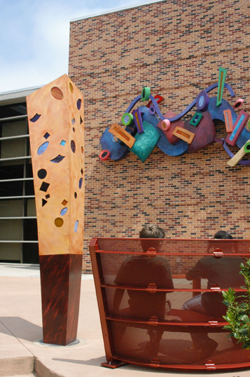
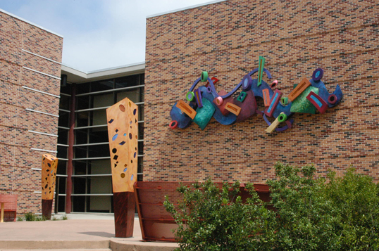
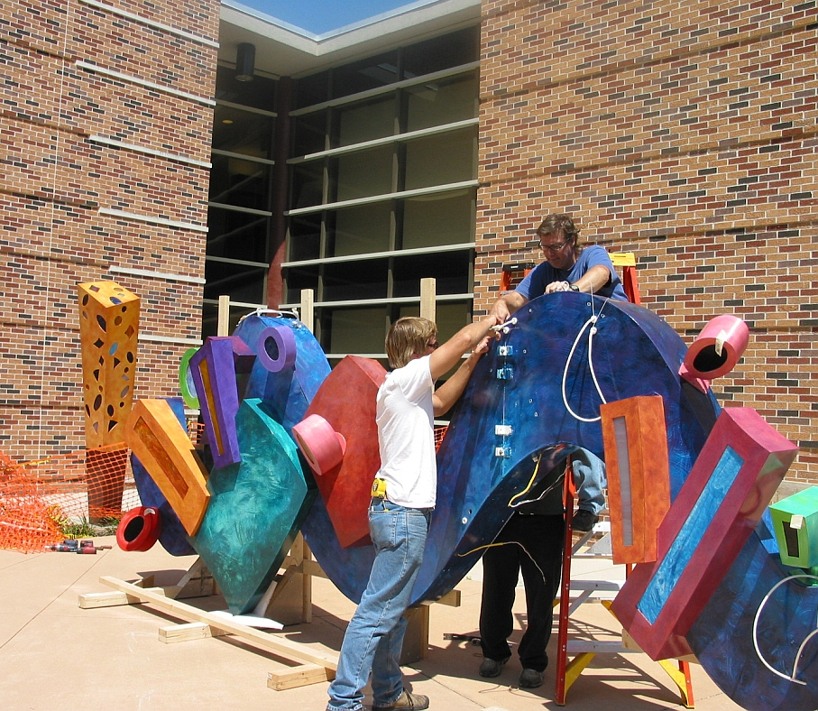
Kline, Steve
Steps on Floating Water

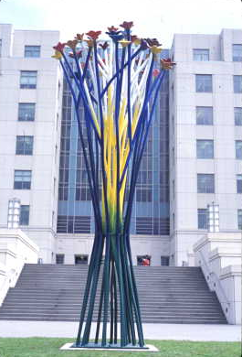
Claiborne Building 2005
Kalish, Howard
One Plant, Many Flowers
Sculpture, 18' x 7' x 6' colorful steel beams form the stalks of human-like blooms at the top.

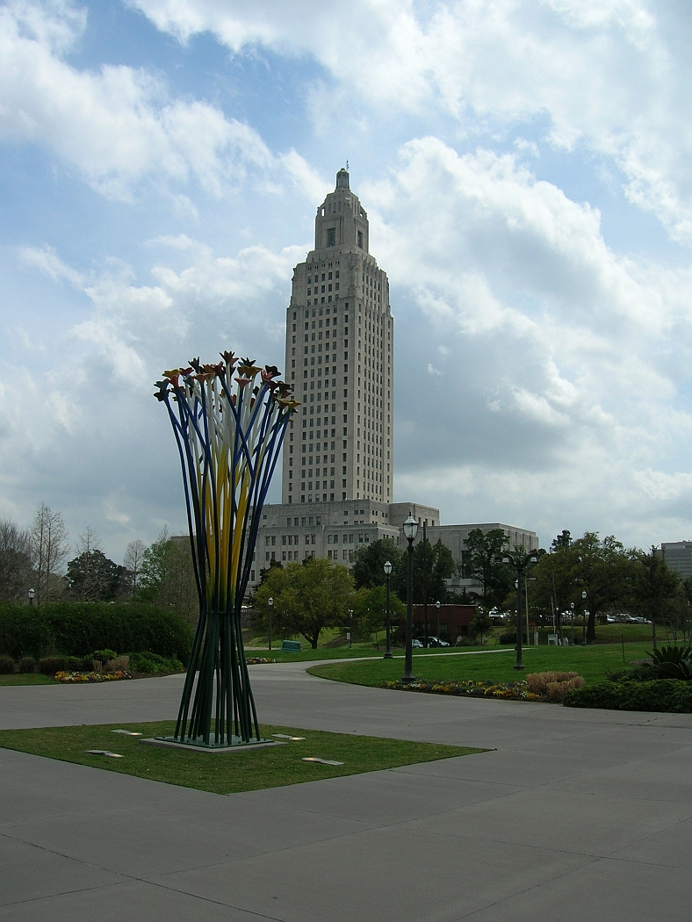
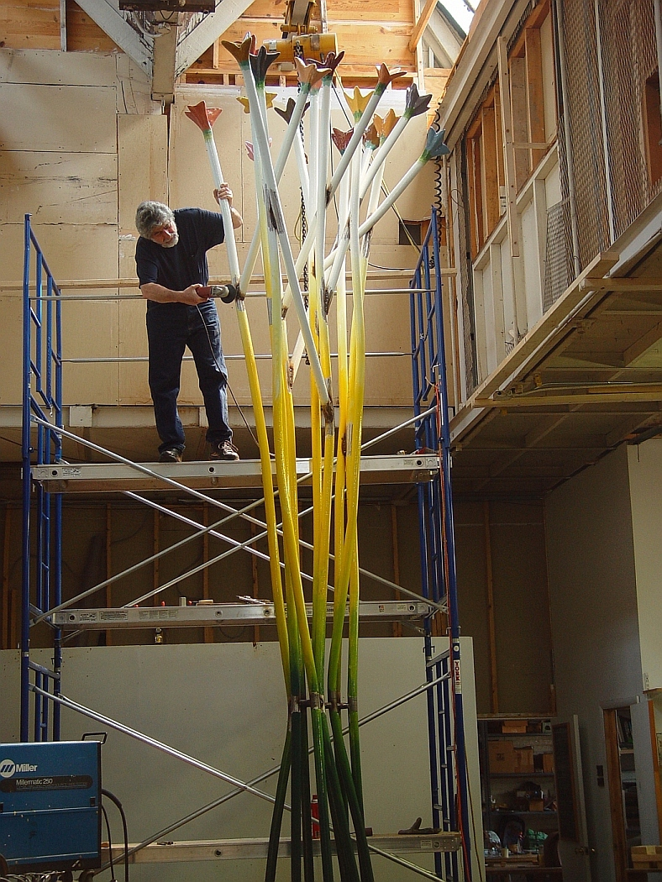
Photos used with permission from Percent for Arts Program.
Comparing Public Art Sculptures

Name __________________________

Investigate and compare two contemporary pieces of public art, Steve Kline’s Steps on Floating Water (SLU’s Cate Education Building, Hammond Louisiana) and Howard Kalish’s One Plant, Many Flowers (Claiborne Building, Baton Rouge, Louisiana)

Describe each work using the Elements of Art (color, value, line, shape, form, texture and space) and Principles of Design (movement, unity, variety, balance, emphasis, contrast, proportion, and pattern) in your descriptions.

Finally, select which work best fits your taste and explain why.

Artist, sculpture  Architecture  Location | Steve Kline’s Steps on Floating Water SLU’s Cate Education Building, Hammond, Louisiana | Howard Kalish’s One Plant, Many Flowers Claiborne Building  Baton Rouge, Louisiana
Describe each work using the Elements of Art
Describe each work using the Principles of Design
Select the work which best fits your taste and explain why.

Taste- A personal preference or liking.

GLOSSARY

abstraction – A style of artwork that is nonrepresentational of naturally occurring forms.
action painting – Abstract style of painting where the painting is “drizzled” or thrown on the canvas.
additive sculpture – The areas added to a sculptural form.
aesthetics – a particular theory or conception of beauty or art : a particular taste for or approach to what is pleasing to the senses.
analysis – Study of the use of elements in a work of art.
animation – Two-dimensional or graphic images that are made to appear as if they are moving.
archeology – The study of ancient cultures through the examination of artifacts such as art.
architecture – Art and science of designing and constructing buildings.
arm – A support, used as a rest for a person’s arms when they are seated in a chair.
artifacts – Found objects created by human beings.
artist’s proof – Trial prints or proofs made from a print process for the artist to check for any changes needed to be made before the edition is run.
assemblage – A sculptural composition consisting of an arrangement of miscellaneous objects or found materials.
asymmetric – Artwork that looks balanced when the parts are arranged differently on each side.
atmospheric perspective – Visual effect achieved to give the illusion of distance.
avant-garde – A style representing the pushing of boundaries in a given field.
background – The part of the scene or picture that seems far from the viewer.
backrest – A support for a person’s back that can be leaned against while sitting.
baren – A printing tool used to apply pressure evenly.
bas relief – Sculpture in which the figure/design projects only a little from the background.
basketry – The craft of basket weaving.
bisqueware – Unglazed clay sculpture.
block print – The act, art, or practice of impressing letters, characters, or figures on paper, cloth, or other material
brayer – Roller used to ink a printing plate.
buttress – A solid structure made to support a wall.
cell – One frame in a work of animation.
clay prep – The act of getting the clay ready by making sure it is of the same consistency.
coil-built – Rolling the clay into a cylinder.
collage – Artwork where a piece of paper or other objects or materials are glued to a flat surface.
color – Element of art referring to the hues found in nature to enhance or distort a visual image.
color field – Abstract painting style where color is emphasized.
color scheme – A planned combination of colors.
color wheel – A chart of colors specifically arranged showing primary and secondary colors.
commercial art – Art that is created for specific purposes.
communicate – The act of expressing feelings, meanings, and thoughts.
composition – Arranging objects/subjects so they have well-ordered relationships.
craft – Decorative objects that have a practical purpose.
credit line – A line of text that acknowledges the artist.
criteria – Standards used to make a judgment or assessment.
cross-hatch – Using short lines that cross each other at angles or horizontal/perpendicular to give an area a shaded or contour effect.
critique – Assessment of a creative work with comments on good and bad qualities.
Cubism – Style where forms of nature are reorganized with geometric elements.
Dada art – A style that was a reaction against all established traditions of logic and art.
de Stijl – A style associated with the use of rectangular forms and primary colors.
decomposition – The breaking down of materials.
design – To plan or arrange parts of an artwork or object in a particular way.
dichromatic – Having two colors.
distempera – Paint pigment in an animal glue or gelatin.
document – To record findings.
earthworks – Describes mounds of dirt that are constructed for a purpose.
ecology – The study of the relationship between living organisms and their environment.
elements – The elements of visual art include line, shape, form, texture, and color.
etching – The process of creating etched designs.
façade – The front of a building.
fine art – Refers to the decorative arts of dance, music, theatre, and the visual arts.
flipbook – A small book containing a series of images that create the illusion of movement.
flying buttress – A supportive structure that stands apart from a wall.
foot – The base of the chair leg that rests on the floor.
forced perspective – A technique that employs illusion to make an object appear different that it actually is.
foreground – The part of the scene or picture that seems near the viewer.
form – Element of art that gives body to a work of art and moves it from the realm of pure design.
fragmentation – An object that is broken into pieces.
frame – A structure that surrounds a work of art.
frieze – A decorative horizontal band usually placed along the upper end of a wall.
geometric – Using simple mathematical forms in design and decoration.
gestural abstraction – The artist’s desire to focus on the act of painting, the physical gestures involved, and the spontaneity of design this kinetic approach to painting produces.
graphic design – Artistic and professional disciplines that focus on visual communication.
greenware – Unfired clay ware.
hand building – Clay working methods including pinch, slab and coil methods.
harmony – A principle of design where elements complement each other.
hatching – Using short lines that give an area a shaded or contour effect.
hybridization – A new art form created from at least two other original sources.
idea – A mental image that reflects reality.
illusion – A mythical perception of reality.
imagination – A mental image or idea; the ability to deal creatively with reality.
impermanence – Art that is designed not to last or be around for long periods of time.
impression – A printed copy; the pressing of a plate on paper.
inflatable – Being able to be filled with a gas.
installation art – A style of art that challenges the traditional boundaries of the visual arts.
intaglio – A carving made by cutting a hollowed-out design in an object.
interpretation – An attribution of a particular meaning or significance to something.
invention – A thing that has been created that did not previously exist.
judgment – An opinion formed after consideration.
juxtaposition – Objects of contrast in relation to each other, usually in close proximity.
kiln – An insulated box used to fire pottery.
kinetic – Relating to, caused by, or producing motion.
landscape – A selected site of environment as a painting inspiration.
layout – The way component parts are arranged.
leather hard – A description of clay ware which is partially dry and is tough enough to handle, but not ready to fire.
leg – The support of the chair which lifts the seat off of the floor.
line – Element of art that has one dimension and is the path of a moving point.
logo – A word, letter, or symbol usually designed for a company/corporation or individual.
masterworks – Artworks that have been admired for a long time.
medium – The tools used for visual expression or communication.
megalith – A large stone forming part of a prehistoric structure.
message – A lesson, moral, or important idea that is communicated in a work of art.
metamorphosis – An object that changes shapes.
mezzotints – An engraving process that involves scraping and burnishing the roughened surface of a metal plate.
middle ground – The area between the foreground and the background.
minimal – A style of art emphasizing a simplification of form and color.
mixed media – A combination of two or more media.
model – Person or thing that serves as a pattern for an artist.
mola – A patterned piece of clothing created from layering fabrics.
monochromatic – One color only with its tints, shades, and tones.
monument – A memorial stone or a building erected in remembrance of a person or event
motif – A repeated design, shape, or pattern.
mound builders – People who created earthworks.
multiple viewpoints – A founding principle of Cubism
narrative – The telling of a story in art.
nave – The long central hall of a cross-shaped church.
negative space – Areas of a surface that are empty or unoccupied by definite shapes or form.
niche – (small box with a scene inside)
openwork - any object or architectural construction produced in such a way that it shows a pattern of openings for decorative effect.
orthogonal line – Lines that move to the vanishing point.
overlapping – One element of art (line, shape, color) that covers part of another element.
paint binders – Substance which makes the paint stick to whatever it is on.
pattern – A choice of lines, colors or shapes that are repeated over and over in a planned way.
permanence – An object that will exist in the same form for a long time.
perspective – A way of creating the illusion of space or depth on a two-dimensional surface.
pigment – A powdered substance mixed with a liquid in which it is relatively insoluble.
plane – The use of design elements to create a flat surface.
planographic – The process to print impressions from a smooth surface rather than from creating incised or relief areas on the plate.
plasticity – The condition of a material that is soft enough to be molded.
point-of-view – The position in which the object or person is depicted.
Pop Art – Style of art, which focused on familiar images such as comic strips and supermarket products in an honest and open manner.
positive space – Surface occupied by definite forms or shapes, quite often the subject of the study.
posterity – The act of leaving something for future generations.
principles of design – Include concepts such as balance, contrast, emphasis, rhythm, reception, variety, proportion, unity, and harmony.
proportion – The harmonious relationship of one part to another or the whole.
public art – Art created for a public audience.
readymades – A type of artwork made from a mass-produced article and isolated from its functional context.
realism – The representation of objects and people in a composition exactly as they appear.
recess – An indented or hollowed-out space.
reductivism – A composition containing greatly reduced or simplistic forms, bare minimum of elements and principles to create a composition.
relief – The elevation of figures or shapes from a flat surface.
retablo – A painting typically done on a word carving.
rhythm – A principle of design referring to the arrangement of parts of an artwork that seem to have movement or repetition.
rose window – A circular window composed of patterned tracery arranged in petal-like formation.
sand painting – Ceremonial design made of colored sands on a flat surface; the art of creating such designs.
scoring – A notch cut onto a surface.
self-portrait – An image created to visually represent how the artist views himself or herself.
sequence – The order in which frames or cells are ordered.
shape – Element of art that is created when a line meets or crosses itself and encloses a space.
silhouette – An outline of a person or object where the details are filled in with a dark color.
slip – Liquid clay used for decorating/casting/ attaching pieces of clay.
space – Element of art referring to the interval between shapes or other units of design.
splat – The central upright panel located between the uprights of a chair back, serving as a back rest. It is often pierced or shaped.
split fountain – Putting more than one ink in a printing fountain to achieve special color affects.
still life – A group of objects arranged in a manner pleasing to the eye.
stipple – To draw or paint in dots or short touches.
stretcher – The crosspiece that connects braces and strengthens the legs of a chair.
subtractive sculpture – The areas removed from a sculptural form.
Surrealism – A style of art where artists experimented with fantasy and weird psychological effects, with the dream world and the grotesque, with extravagant symbolism.
symbolize – To represent something by means of a symbol.
symmetrical – Artwork that looks balanced when the parts are arranged similarly on each side.
symmetry – Parts of a design that are arranged the same way on both sides of an imaginary middle line.
tableau vivant – A scene presented by costumed actors who remain silent and motionless on a stage, as if in a picture.
tempera – An opaque water-based paint.
Terra Cotta – Clay-based unglazed ceramics.
tessera – Small piece of stone or glass used in making a mosaic.
texture – Element of art referring to the quality of a surface. Can be felt or illusionary.
theme – A distinct and unifying idea, the message or emotion that the artist is conveying.
three-dimensional – Forms having height, weight, and depth.
thumbnail – A small sketch or image of a composition.
tracery – Decorative ribs in windows.
transcend – To go beyond a specified limit.
trans-nationalism – The cultural interconnection of two or more different nations or countries across national boundaries.
two-dimensional – Artwork that is made on a flat surface and is measured in only two ways, height and width.
underglaze – Coloring or decoration applied to ceramics before glazing.
unity – Principle of design where the quality of having all the parts look as if they belong together.
value – The lightness or darkness of a color.
variety – Having different kinds of colors, lines, and shapes, etc.
warp – The threads that run vertically in a tapestry.
wedging – Preparing clay by kneading, to remove air pockets and to create a uniform consistency.
weft – The threads that run horizontally in a tapestry.
VISUAL ARTS
CREATIVE EXPRESSION
Standard: Students develop creative expression through the application of knowledge, ideas, communication skills, organizational abilities, and imagination.
 | K–4 | 5–8 | 9–12
Benchmark 1 | Explore and identify imagery from a variety of sources and create visual representations  (2, 3) | Demonstrate art methods and techniques in visual representations based on research of imagery  (2, 3) | Produce works of art that successfully convey a central theme based on imagery, ideas, feelings, and memories  (1, 2, 3)
Benchmark 2 | Explore and discuss techniques and technologies for visual expression and communication  (1, 2, 3) | Select and apply media, techniques, and technology to visually express and communicate  (1, 2, 3) | Apply a variety of media techniques, technologies, and processes for visual expression and communication  (1, 2, 3)
Benchmark 3 | Use art vocabulary and the elements and principles of design to convey the language of art (create and discuss own artwork)  (1, 2, 3) | Use the elements and principles of design and art vocabulary to visually express and describe individual ideas  (1, 2) | Use the elements and principles of design for individual expression while exploring compositional problems  (1, 2)
Benchmark 4 | Experiment to create various art forms, including art forms from other cultures  (2, 3, 4) | Develop skills in creating various art forms, including art forms from other cultures  (2, 3, 4) | Produce a visual representation of ideas derived through the study of various cultures and art forms  (2, 3, 4)
Benchmark 5 | Draw on imagination, individual experience, and group activities to generate ideas for visual expression  (1, 4, 5) | Produce ideas for art productions while engaging in individual and group activities  (1, 2, 5) | Produce imaginative works of art generated from individual and group ideas  (1, 2, 5)
Benchmark 6 | Identify relationships among visual arts, other arts, and disciplines outside the arts  (1, 4) | Understand and visually express relationships among visual arts, other arts, and disciplines outside the arts  (1, 2, 4) | Produce works of art that describe and connect art with other disciplines  (1, 2, 4)
Benchmark 7 | Maintain a sketchbook or journal, or develop a portfolio  (1, 2, 3) | Maintain a sketchbook or journal and develop a portfolio  (1, 2, 3) | Maintain a sketchbook or journal and develop a portfolio  (1, 2, 3)

VISUAL ARTS
AESTHETIC PERCEPTION
Standard: Students develop aesthetic perception through the knowledge of art forms and respect for their commonalities and differences.
 | K–4 | 5–8 | 9–12
Benchmark 1 | Use elements and principles of design and basic art vocabulary for expressing responses to the work of others  (1, 4, 5) | Use elements and principles of design and expanded art vocabulary for responding to the aesthetic qualities of various works  (1, 4) | Use advanced art/design vocabulary for responding to the aesthetic qualities of various works  (1, 4)
Benchmark 2 | Recognize and respond to concepts of beauty and taste in the ideas and creations of others through the study of visual arts  (1, 4, 5) | Recognize that concepts of beauty differ by culture and that taste varies from person to person  (1, 4, 5) | Distinguish unique characteristics of art as it reflects concepts of beauty and quality of life in various cultures  (1, 4, 5)
Benchmark 3 | Explore the beauty in nature and discern images and sensory qualities found in nature and art  (1, 2) | Perceive the aesthetic value and influence of organic forms and the natural environment as reflected in works of art  (1, 2, 4) | Use analogies, metaphors, and other descriptors to describe interrelationships in works of art and nature  (1, 2, 4)
Benchmark 4 | Recognize that there are many possibilities and choices in the processes for designing and producing visual arts  (2, 3, 4) | Demonstrate awareness of various new ideas, possibilities, options, and situations pertaining to the art world  (1, 4) | Compare and contrast multiple possibilities and options available for artistic expression  (1, 4)
Benchmark 5 | Participate in guided inquiry into the basic question “What is art?” and share personal feelings or preferences about various works  (1, 2, 4) | Discuss the question “What is art?” and express intuitive reactions and personal responses to various works  (1, 4) | Question/weigh evidence and information, examine intuitive reactions, and articulate personal attitudes toward visual work  (1, 2, 5)
Benchmark 6 | Identify where and how the visual arts are used in daily life and in the community  (1, 2, 4) | Describe the use and value of the visual arts in daily life, the workplace, and the community  (1, 2, 4) | Integrate knowledge of the visual arts in the total environment to understand the arts within a community  (2, 4, 5)
VISUAL ARTS
HISTORICAL AND CULTURAL PERSPECTIVE
Standard: Students develop historical and cultural perspective by recognizing and understanding that the arts throughout history are a record of human experience with a past, present, and future.

 | K–4 | 5–8 | 9–12
Benchmark 1 | Identify the subject, basic style, and culture represented by various works of art  (2, 4) | Identify and classify works of art by their subject, style, culture, and time period  (2, 4) | Analyze specific styles and periods of art in relation to prevailing cultural, social, political, and economic conditions  (2, 4, 5)
Benchmark 2 | Recognize universal symbols and how works of art communicate a universal language  (1, 4, 5) | Understand how works of art cross geographical, political, and historical boundaries  (2, 4) | Analyze how works of art cross geographical, political, and historical boundaries  (2, 4)
Benchmark 3 | Identify art images and themes from the past and present and discuss historical differences  (1, 2, 4) | Understand the meaning and significance of ideas, themes, and messages in works of art from the past and present  (2, 4) | Compare and contrast ways art has been used to communicate ideas, themes, and messages throughout history  (1, 2, 4)
Benchmark 4 | Identify media used in works of art throughout history and recognize the importance of available resources  (2, 3, 4) | Distinguish media and techniques used to create works of art throughout history  (2, 3, 4) | Analyze materials, technologies, media, and processes of the visual arts throughout history  (2, 3, 4)
Benchmark 5 | Recognize professions in the visual arts and the role and status of the artist in various cultures and time periods  (2, 4) | Describe and compare careers in visual arts and the role and status of the artist in various cultures and time periods  (1, 2, 4) | Investigate and assess roles, careers, and career opportunities in the visual arts  (2, 4)
Benchmark 6 | Recognize great artists and works of art that have shaped the history of art  (2, 4) | Identify major works of great and influential artists and recognize their achievements  (4, 5) | Identify representative visual artists of various cultures and compare their lives, careers, works, and influence  (1, 4)
VISUAL ARTS
CRITICAL ANALYSIS
Standard: Students make informed verbal and written observations about the arts by developing skills for critical analysis through the study of and exposure to the arts.
 | K–4 | 5–8 | 9–12
Benchmark 1 | View works of art and express observations about how the elements and principles of design are used in the works  (1, 4) | View works of art and analyze how artists use design elements and principles to achieve an aesthetic effect  (2, 3, 4) | Apply knowledge of design elements and principles to analyze, compare, or contrast the composition of various works of art  (2, 4)
Benchmark 2 | Identify images, colors, and other art elements that have specific meanings in cultural contexts  (1, 4) | Analyze and interpret art images for their symbolic meaning, purpose, and value in place and time  (2, 4) | Compare and contrast symbolism as used in works of visual art from different cultures and time periods  (1, 4)
Benchmark 3 | Express and explain aesthetic judgments about the created (built) environment  (1, 2, 4) | Express and justify aesthetic judgments about the created (built) environment  (1, 2, 4) | Critique the design of structures or areas in the created (built) environment based on aesthetic criteria  (1, 2, 4)
Benchmark 4 | Express and explain opinions about visual works of others using basic art vocabulary  (1, 4) | Critique works of art using expanded art vocabulary  (1, 4) | Critique works of art using advanced art vocabulary  (1, 4)
Benchmark 5 | Express interpretations about works of art and give supporting reasons  (1, 4) | Develop interpretations about works of art and give supporting reasons  (1, 4) | Develop and justify personal interpretations of works of art based on information from inside and outside the work  (1, 2, 4)

LOUISIANA CONTENT STANDARDS
FOUNDATION SKILLS

The Louisiana Content Standards Task Force developed the following foundation skills that should apply to all students in all disciplines.
1. Communication: A process by which information is exchanged and a concept of “meaning” is created and shared between individuals through a common system of symbols, signs, or behavior. Students should be able to communicate clearly, fluently, strategically, technologically, critically, and creatively in society and in a variety of workplaces. This process can best be accomplished through use of the following skills: reading, writing, speaking, listening, viewing, and visually representing.
2. Problem Solving: The identification of an obstacle or challenge and the subsequent application of knowledge and thinking processes, which include reasoning, decision making, and inquiry in order to reach a solution using multiple pathways, even when no routine path is apparent.
3. Resource Access and Utilization: The process of identifying, locating, selecting, and using resource tools to help in analyzing, synthesizing, and communicating information. The identification and employment of appropriate tools, techniques, and technologies are essential to all learning processes. These resource tools include pen, pencil, and paper; audio/video materials, word processors, computers, interactive devices, telecommunication, and other emerging technologies.
- Linking and Generating Knowledge: The effective use of cognitive processes to generate and link knowledge across the disciplines and in a variety of contexts. In order to engage in the principles of continual improvement, students must be able to transfer and elaborate on these processes. Transfer refers to the ability to apply a strategy or content knowledge effectively in a setting or context other than that in which it was originally learned. Elaboration refers to monitoring, adjusting, and expanding strategies into other contexts.
- Citizenship: The application of the understanding of the ideals, rights, and responsibilities of active participation in a democratic republic that includes working respectfully and productively together for the benefit of the individual and the community; being accountable for one’s own choices and actions and understanding their impact on oneself and others; knowing one’s civil, constitutional, and statutory rights; and mentoring others to become productive citizens and lifelong learners.

Note: These foundation skills are listed numerically in parentheses after each benchmark.

