Grade 8
Visual Arts

Table of Contents

Using Still Life Art to Explore in Value (CA 1) 1

Exploring the Self Portraits of Frida Kahlo (HP 6) 3

Cubism and Collage as Art and Inspiration (CA 2) 8

Printmaking of the Fertile Crescent: Retracing the path of the paisley design (HP 2) 15

Faith Ringgold and Story Quilts (HP 4) 21

Do-Ho Suh Installations (AP 4) 26

Digital Huichol Yarn Art (HP 3) 29

Picasso and the Progress of his Palette (HP 5) 32

Louisiana State Capitol Block Print (CA 3) 39

Surrealist Creations (HP 1) 44

Marcel Duchamp as Dadaist (AP 5) 48

Students as Art Critics and Creators: Exploring the works of Romare Bearden (CA 4) 51

Sweet Seats (AP 6) 55

Monuments: Context and Creation (CA 5) 59

Architectural Aesthetics (AP 2) 65

Glossary 72

Visual Arts Standards and Benchmarks 77

Louisiana Foundation Skills 82

Title Using Still Life Art to Explore in Value
Time Frame Two 60-minute periods
Overview Students create artwork focused on value after comparing the still life works of two artists.

Standards Critical Analysis and Creative Expression

Arts Benchmarks
View works of art and analyze how artists use design elements and principles to achieve an aesthetic effect. | VA-CA-M1
Demonstrate art methods and techniques in visual representations based on research of imagery. | VA-CE-M1
Maintain a sketchbook or journal and develop a portfolio. | VA-CE-M7

Foundation Skills Communication, Problem Solving, Resource Access and Utilization

Student Understandings

After comparing the works of still life artists Albrecht Durer and Giuseppe Arcimboldo, students have an understanding of the various ways artists depict value. They apply and expand upon this knowledge by creating a value drawing or painting. They understand how to use pencil to create highlights and shadows or paint techniques to make tints and shades.

Vocabulary

value, hatch, cross-hatch

Materials and Equipment

objects of student interest for still life, pencil, watercolors, brushes, paper, water, water container, and sketchbook/journal

Prior Knowledge

Students have a basic knowledge of elements and principles of art, composition, watercolor techniques, tints, shades, and still life.

Sample Lesson

Day 1
Open the class by introducing the definition of value (darkness and lightness).
Introduce Durer’s drawing, Hare (1400s) that uses graphite cross-hatching.
Ask the class the following questions.
How was value achieved in this work?
What other techniques could be used to achieve value?

Introduce Arcimboldo’s painting, The Gardner (1500s) that uses color to create tints and shades in a painting (15 minutes).
How was value achieved in this work?
What other techniques could be used to achieve value?

In small groups, students design and set up a still life using only three objects. They reflect and discuss still life composition, (lighting, proportion, placement, etc.) (15 minutes). Students produce two thumbnails (small sketches focusing on composition). They decide upon their favorite composition and transfer to a 12” x 18” paper by pencil sketching (30 minutes).

Day 2
Demonstrate pencil techniques for creating value such as hatching or cross-hatching. Demonstrate watercolor techniques for creating value such as tints and shades (10 minutes).

Students select a medium, either pencil or watercolor, and complete their still life images using the techniques described (40 minutes).

In their sketchbooks/learning logs (view literacy strategy descriptions); students reflect upon their still life and focus on the following items.
What was the biggest challenge in creating the artwork?
Describe how your artwork is similar to or different from the examples given in class (10 minutes).

Sample Assessments

Formative
Observe, monitor and assist art-making activities throughout the lesson (value study still life). Adjustments and suggestions are provided based on individual needs of students.

Summative
Assess the following:
Students’ use of techniques to create value;
Students’ journal responses to their art work.

Resources

A definition of value can be found at http://www.artlex.com/ArtLex/Art.html.

http://www.giuseppe-arcimboldo.org/Vegetables-In-A-Bowl-Or-The-Gardener.html
http://www.ibiblio.org/wm/paint/auth/durer/hare.jpg
Title Exploring the Self Portraits of Frida Kahlo
Time Frame Six 60-minute classes
Overview Students view and discuss the self-portraits of Frida Kahlo and then create a self-portrait which includes symbolism to represent the student’s life.

Standards Creative Expression and Historical and Cultural Perspective

Arts Benchmarks
Identify major works of great and influential artists and recognize their achievements. | VA-HP-M6
Demonstrate art methods and techniques in visual representations based on research of imagery. | VA-CE-M1
Maintain a sketchbook or journal and develop a portfolio. | VA-CE-M7

Foundation Skills Communication, Resource Access and Utilization

Student Understandings

Students identify and discuss major art works created by Latino artist, Frida Kahlo, and create a tempera paint self-portrait inspired by Kahlo’s work. They study how symbolism is used to communicate ideas. They gain a better understanding of color mixing and the use of elements and principles of art to create a composition.

Vocabulary

self portrait, symbolize, composition, communicate

Materials and Equipment

access to the Internet or reproductions of several Frida Kahlo self-portraits, art journals or sketchbooks, pencils, tempera paint, large heavy weight paper, paint brushes (multiple sizes), containers of water, and paper towels

Prior Knowledge

Students should have tempera paint and color mixing experience.

Sample Lesson

Day 1
Introduce the artwork of Frida Kahlo. Show students Kahlo’s self-portraits The Two Fridas (1939) and Self-portrait on the Borderline Between Mexico and the United States (1932) (click on “Works of Art”) and have students discuss what they see in these paintings. What images does she incorporate into her paintings, and what do students think these images symbolize? What do these paintings communicate about Frida’s life? (Roll over the painting to reveal some answers to these questions.) (30 minutes).

Have students generate opinions on Frida Kahlo’s life and work by completing an opinionnaire (view literacy strategy descriptions). The opinionnaire activity requires students to take positions related to Frida Kahlo and defend them. They work in pairs to read and discuss each statement and justify these opinions by citing examples from her paintings. The whole class shares ideas about Ms. Kahlo’s work (25 minutes).

Inform the students that over the next four classes, they will create a self-portrait that communicates something about their life, like Frida Kahlo did (5 minutes).

Day 2
Students plan a self-portrait that communicates something about their lives. In their art journal/ learning log (view literacy strategy descriptions), students record ideas, both in written and visual forms. Students write responses to the following prompts (15 minutes).
What significant events and/or people have shaped my life?
How could I create symbols for these events and/or people?
How could I incorporate these symbols into a self-portrait?

Students divide a new page in their art journal into fourths. In each section, students create a quick sketch focusing on images around the figure to develop compositional ideas for their self-portrait. Once students have created a strong composition, they may begin transferring the composition to a large sheet of heavy weight paper. Students need to remember that the self- portrait must include symbols about their lives (40 minutes).

Students should clean up and put their art journals and painting sketch away (5 minutes).

Day 3
Review how to use tempera paint with the students, including some of the characteristics of tempera paint (10 minutes).
Tempera paint is easily rewet, and the amount of color can be reduced by wetting the color and blotting it with a sponge or paintbrush or paper towel
Tempera colors influence any color placed on top.
Hard edges can be created by using the tip of the paintbrush.
When mixing color, mix enough to color the entire area. It is very difficult to remix the same color.

Review the rubric (which follows) so that students know how the work is scored.

Students work on their self-portraits (40 minutes). Students clean up and put their paintings away to dry (10 minutes).

Day 4 - 5
Review the assignment along with the rubric (5 minutes). Students continue to work on their self-portraits (45 minutes). Students clean up and put their paintings away to dry (10 minutes).

Day 6
Students present their paintings today. They have the next ten minutes to review the questions and put any finishing touches on the painting (5 minutes).

Students complete their paintings and prepare to respond to the following questions (20 minutes).
What symbols did you use in your self-portrait and why?
How does your work compare to Frida Kahlo’s? (state three ways they are similar and three differences)
What problems did you have creating this work?
What about your self-portrait makes you proud?

Students present their paintings to the class (30 minutes). Students turn in completed paintings (5 minutes).

Sample Assessments

Formative
Check art journals for completed opinionnaire, learning log responses, four planning sketches
Ongoing observation and monitoring of activities takes place throughout the lesson. Adjustments and suggestions are provided based on individual needs of students.

Summative
The completed self-portrait may be assessed using the following rubric:
______The painting is a self-portrait. (10 points)
______The painting includes two or three images which reflect important aspects of the student's life. (10 points)
______The painting uses tempera paint effectively. (5 points)
______The student presented the painting to the class and answered the following questions. (10 points)
What symbols did you use in your self-portrait and why?
How does your work compare to Frida Kahlo’s? (state three ways they are similar and three differences)
What problems did you have creating this work?
What about your self-portrait makes you proud?

Total_____ (35 points possible)
Resources

The following websites contain information and images about Frida Kahlo:
http://www.mamfa.com/firestone/
http://www.nmwa.org/collection/profile.asp?LinkID=471
http://www.mexconnect.com/mex_/travel/jcummings/ph56frida.html
http://www.pbs.org/weta/fridakahlo/today/index.html
http://www.pbs.org/wnet/americanmasters/database/rivera_d.html

Exploring your opinions about Frida Kahlo’s self-portraits: An Opinionnaire

After each statement make the following notation:

SA (strongly agree) A (agree) D (disagree) SD (strongly disagree)

Then write a brief explanation supporting your statement. Use images (symbols) found in her paintings to support your responses.

1. Frida Kahlo led a happy and carefree life. _______________

2. Frida Kahlo’s paintings are very realistic. _______________

3. Frida Kahlo’s mixed heritage is evident in her paintings. ______________

4. Frida Kahlo left a record of her life through her paintings. _____________

Title Cubism and Collage as Art and Inspiration
Time Frame Three 60-minute sessions
Overview Students view Picasso’s Guernica and view and compare collage art. They use this research and their understanding of design elements and principles to examine Cubist and collage motifs and the artists’ exploration of culture through a series of sketches. Students render these sketches into a contemporary collage depicting a current event.

Standards Critical Analysis and Creative Expression

Arts Benchmarks
Analyze and interpret art images for their symbolic meaning, purpose, and value in place and time. | VA-CA-M2
Demonstrate art methods and techniques in visual representations based on research of imagery. | VA-CE-M1
Select and apply media, techniques, and technology to visually express and communicate. | VA-CE-M2

Foundation Skills Communication, Problem Solving, Resource Access and Utilization

Student Understandings

After studying the imagery in Picasso’s Cubist pivotal work of art, Guernica, students understand that the significance of a work transcends time and place and often reflects historical events.

Vocabulary

Cubism, geometric, collage, multiple viewpoints, juxtaposition, transcend

Materials and Equipment

images of Pablo Picasso’s Guernica, images of collages, pencils, rulers, powder tempera paint, liquid glue, canvas board or heavy white paper, paint brushes, newspaper, recycled yogurt containers, magazines, water containers, pre/post-test assessment measure, Reciprocal Teaching

Prior Knowledge

Students understand the following vocabulary words: composition, space, dimension, plane, representational, and positive and negative space, and can depict visual representations of these words. They understand basic techniques and skills associated with color mixing and design layout.

Sample Lesson

Day 1
Begin the lesson by giving a pre/post-test assessment. Students complete the assessment (5 minutes).

Give students Part I of the reciprocal teaching handout (view literacy strategy descriptions). They complete Part I of the handout to examine what they already know about Cubist motifs and collage motifs. The exercise lets students make their best guesses about both of these art forms. The exercise assists students knowing what still needs to be discovered. They record and display comprehension using two forms of communication, written and visual representation. Using two methods of communication further reinforces targeted concepts, vocabulary words, and helps the students self-assess changes in their comprehension throughout the lesson (25 minutes).

Present facts from the reference materials on artist Pablo Picasso. Facts to share on Pablo Picasso include: 1) where he lived (Spain and France), 2) what his primary media were (oil paint and found objects, such as newspapers and cloth), and 3) where his work is exhibited (The Museum of Modern Art, the Guggenheim, and the National Gallery of Art, to name a few) (5 minutes).

Present Picasso’s Guernica (1937). Using Guernica, introduce motifs characteristic of Cubism, such as the use of geometric planes to depict multiple viewpoints and the juxtaposition of perspective to create a composition. A simple definition of Cubism is a composition that is created to show several sides, or points of view, of the same thing at the same time. Present reference materials on Pablo Picasso’s Guernica (see resources). Lead a brief discussion on the characteristics of this particular Cubist work, (for example, its focus on a specific event during World War II, the Nazi bombing of the Spanish town) (5 minutes).

In groups of three, students continue to view Pablo Picasso’s Guernica. Students consider the following questions: 1) Is the image more or less effective because Picasso did not use color? 2) What has Picasso placed in the foreground? 3) What has Picasso placed in the background? 4) How does this work of art transcend time? 5) How does this work of art transcend place? Students record these questions and their responses in their sketchbooks. Students identify a spokesperson for their findings who presents his/her group’s findings to the class (20 minutes).

Day 2
Review information on Cubism. Review stylistic characteristics of Cubism including the use of geometric planes to depict multiple viewpoints and the juxtaposition of perspective to create a composition (5 minutes).

Present Mixed Media Collage by Brad Brace, View From Across the River (2006) by Jane Asari and Photo-montage – 2005 by Margueritte. Using these images, introduce motifs characteristic of collage, such as the assemblage of realistic materials, like feathers and cloth, as well as cut-outs from magazines or newspapers, to depict multiple viewpoints and the juxtaposition of perspective to create a composition. Review Pablo Picasso’s Guernica (1937) and compare similarities in the motifs of this Cubist work and the work of the collage artist (5 minutes).

Working in the same small groups of three from the previous class, students then view images created by these collage artists. Students consider the following questions: 1) Is the image more or less effective because of the elements the artist has assembled to create the composition? 2) What has the artist placed in the foreground? 3) What has the artist placed in the background? 4) How does this work of art transcend time? 5) How does this work of art transcend place? Students record these questions and their responses in their sketchbooks. Next, students compare their answers to these questions to the answers they recorded in their sketchbooks the previous class about Pablo Picasso’s Guernica. Students identify a spokesperson who presents his/her group’s findings of the comparison of both sets of questions to the class (20 minutes).

Students complete Part II of the handout to confirm the predictions/best guesses they made the previous class, as well as further examine Cubist and collage motifs (30 minutes).

Day 3
Review information on Cubism and collage. Review stylistic characteristics of Cubism including the use of geometric planes to depict multiple viewpoints and the juxtaposition of perspective to create a composition. Review stylistic characteristics of collage including the assemblage of realistic materials, like feathers and cloth, as well as cut-outs from magazines or newspapers, to depict multiple viewpoints and the juxtaposition of perspective to create a composition (5 minutes).

Students choose a contemporary event to depict in a collage. Using sketches from their handout as a reference, students explore images in magazines of contemporary events. Students cut out magazine images until they have a wide variety to create an assemblage (or collage) that depicts their chosen contemporary event. Students focus on the geometric positioning of the images to assemble their magazine cut-outs. Next, students lay out the cut-outs and glue them onto the canvas board. Students incorporate stylistic characteristics of Cubism such as use of geometric planes, multiple viewpoints, and the juxtaposition of perspective to create a composition in their collage (45 minutes).

Students clean up (5 minutes). Close by having students complete the post-test assessment (5 minutes).

Sample Assessments

Formative
Monitor student performance throughout the art-making process and assist students with individual needs.
Assess group presentations to see if students completed group tasks.
Check to see if students have explored the use of geometric planes to depict multiple viewpoints in written definitions and in sketches.

Summative
Evaluate the following:
Pre/post-test for completion and accuracy;
Changes in scores between the pre-test and the post-test and a comparison of these changes;
Reciprocal Teaching for completion and accuracy (both written and visual representations);
Student imaginative commentary on a current social condition in their compositions;
Student exploration of geometric planes to depict multiple viewpoints, as well as the incorporation of these stylistic characteristics, to assemble and complete their collages;
Collages for: 1) Completion 2) Use of images to explore foreground and background, 3) Use of geometric planes to depict multiple viewpoints, 3) Inventive collage design, and 4) Craftsmanship.

Resources

The websites listed below offer detailed information on Picasso’s Guernica and opportunities to view this work of art:
http://www.pbs.org/treasuresoftheworld/a_nav/guernica_nav/main_guerfrm.html
http://www.tribuneindia.com/2003/20030406/spectrum/art.htm
http://www.artelino.com/articles/pablo_picasso.asp
http://www.guggenheimcollection.org/site/artist_bio_126.html
http://www.mala.bc.ca/~lanes/english/hemngway/picasso/guernica.htm

This website offers detailed information on the historical event that inspired Picasso’s painting:
http://www.pbs.org/treasuresoftheworld/guernica/glevel_1/1_bombing.html

The websites listed below offer detailed information on the history of collage and opportunities to view collage art:
http://collagemuseum.com/index.html
http://www.virginia.edu/artmuseum/collage/

Art and Inspiration: Pre/Post-Test

Name__________________________

Please circle the correct answer

- Principles of Design include pattern. True or False

- The collage art form was explored by Max Ernst, Henri Matisse, and Pablo Picasso. True or False

- Pablo Picasso was a/an:
Urban Realist
Abstract expressionist
Renaissance artist
Cubist
Surrealist

- Picasso’s painting, Guernica, was inspired by an actual event. True or False

- Collage art often combines juxtaposing images. True or False

- The word, “collage,” comes from the French word:
Coller, to glue
Coupez les sorties, cut-outs
Collections de choses, collections of things
Coupe et colle, cut and glue
Pour couper, to cut out
Cubism and Collage: Describe and Sketch Exploration Name______________

Directions: Complete part 1 prior to your study of Cubist art. Complete part 2 after your study of Cubist art

PART I

Predictions: Make Your Best Guess
Describe characteristics of Cubist art: | Sketch a Cubist art composition:

Who was Pablo Picasso?

Where did Pablo Picasso live?

Describe and Sketch:

Predictions: Make Your Best Guess
Describe characteristics of collage art: | Sketch a collage art composition:

Questions:

What is socially conscious art?

Are art and current events connected?

PART II

Check Part 1 to see whether your predictions were confirmed. Were the predictions made about the characteristics of Cubist art confirmed?
Yes No

Describe and sketch something new you learned about Cubist and collage art, or if your predictions were confirmed, write and sketch another example, giving more details.

Details:
Characteristics of Cubist art: | Sketch a Cubist art composition:

Were the predictions made about the characteristics of collage art confirmed?
Yes No

Details:
Characteristics of collage: | Sketch a collage art composition:

Title Printmaking of the Fertile Crescent: Retracing the path of the paisley design
Time Frame Three 60-minute sessions
Overview Students view and compare prints and images of paisley patterns from the Fertile Crescent and Scotland. They use this research and their understanding of design elements and principles to examine commonalities and differences of designs through a series of sketches. Working with a cardboard egg carton and one or two color families, students translate their two-dimensional sketched representations into monochromatic or dichromatic intaglio prints.

Standards Creative Expression and Historical and Cultural Perspective

Arts Benchmarks
Understand how works of art cross geographical, political, and historical boundaries. | VA-HP-M2
Demonstrate art methods and techniques in visual representations based on research of imagery. | VA-CE-M1
Develop skills in creating various art forms, including art forms from other cultures. | VA-CE-M4

Foundation Skills Problem Solving, Resource Access and Utilization, Linking and Generating Knowledge

Student Understandings

After studying printmaking techniques of the past, students use contemporary methods of printmaking to create a monochromatic or dichromatic intaglio print. They understand strategies and techniques employed to create intaglio print. Students appreciate how paisley designs evolved. They learn how color is used as a design element in printmaking and the importance of using found materials as art materials.

Vocabulary

brayer, monochromatic, dichromatic, etching, mezzotints, stipple, engraving, relief, recess, planographic, intaglio

Materials and Equipment

images of paisley patterns from the Fertile Crescent and Scotland, brayers, cardboard egg carton tops (recycled), scissors, pencils, water-based ink in the blue and orange color families, construction paper, paper plates, newspaper, pre/post-test assessment measure, learning log
Prior Knowledge

Students understand positive and negative space, and ground, and can depict visual representations of these words. They can identify and visually depict tints and shades of blue and orange.

Sample Lesson

Day 1
Begin by giving the pre- test assessment. Students complete the assessment (5 minutes).

Introduce the origins of printmaking (see resources) and the use of color, positive space, negative space, and ground to create a print (10 minutes).

Lead a brief discussion on the characteristics of various printmaking techniques, particularly stylistic characteristics found in engravings and intaglio prints (5 minutes).

Present examples of how a single color, such as blue, using a variety of hues, such as azure, cerulean, aqua, or cobalt, can be used to create positive space, negative space, and ground in a print. Continue by presenting the orange color family, such as amber, gamboge, or vermilion, and how these shades can be used to express positive space, negative space, and ground in a print (15 minutes).

Present facts from reference materials on paisley patterns from the Fertile Crescent and Scotland. Facts to share on paisley patterns and the Fertile Crescent include: 1) important geography of the region, 2) what this culture’s primary purposes of printmaking were, and 3) images of paisley patterns from the Fertile Crescent. Facts to share on paisley patterns and Scotland include: 1) important geography of the region, 2) what this culture’s primary purposes of printmaking were, and 3) images of paisley patterns from Scotland (25 minutes).

Day 2
Begin by presenting and reviewing facts from reference materials on paisley patterns from the Fertile Crescent and Scotland viewed in the previous class (5 minutes).

Next, in small groups, students continue to read information on the history of printmaking and view and compare images of paisley patterns from the Fertile Crescent and Scotland. Students complete the learning log (view literacy strategy descriptions) to further examine these motifs and to include opportunities for students to create a series of sketches. Learning logs allow students to visually and verbally explore, define, and record ways the influences of one culture can be seen in the artistic designs of another culture. Students identify a spokesperson for their group to present his/her group’s findings to the class (25 minutes).

Students create a printing plate by cutting a cardboard egg carton into two rectangles. (This may be demonstrated for the students.) Using sketches from their learning log as a reference, students sketch their own designs onto the egg carton cardboard. Next, pressing harder with their pencils, students create a recessed design in the cardboard (25 minutes). Students clean up (5 minutes).

Day 3
Students choose a monochromatic or dichromatic color scheme using the blue or orange color families; if monochromatic, they pick a light and a dark from that single color family, if dichromatic, one light and one dark from each family. (This may be demonstrated for the students.) Students then use the brayer to apply the water-based ink to the cardboard and wipe any excess ink from the surface so that the ink only fills the recesses of the design matrix. Next, they lay the construction paper over the cardboard plate and rub the paper in a circular motion from top to bottom applying thorough and equal pressure throughout. Students lift the paper and repeat the process with the second color they have chosen. This allows them to translate their two-dimensional sketched representations into monochromatic or dichromatic intaglio prints (45 minutes).

Students clean up (10 minutes). Close by giving students the post-test assessment (5 minutes).

Sample Assessments

Formative
Monitor student performance throughout the art-making process and assist students with individual needs.
Assess group presentations to see if students completed group tasks.
Check to see if students have explored paisley design in sketches.
Check to see if students have explored the use of positive space, negative space, foreground, background, and middle ground in sketches of paisley designs.
Check to see if students have explored and incorporated stylistic characteristics of both paisley patterns from the Fertile Crescent and Scotland in sketches.
Check to see if students have explored stylistic characteristics of intaglio prints.

Summative
Pre/post-test for completion and accuracy;
Comparison of changes in scores between the pre-test and the post-test;
Learning log for completion and accuracy (both written and visual representations);
Monochromatic or dichromatic intaglio prints for: 1) Completion 2) Use of monochromatic or dichromatic color in positive space, negative space, and ground 3) inventive paisley design, and 4) craftsmanship.

Resources

The websites listed below offer detailed information about the history of print making:
http://www.worldprintmakers.com/english/pmhist.htm
http://encarta.msn.com/encyclopedia_761569257_5/Prints_and_Printmaking.html

Detailed information about the history of paisley and opportunities to view the design can be found at http://www.victoriana.com/library/paisley/shawl.html.
Printmaking of the Fertile Crescent: Learning Log Entry

Name_________________________

Explain how paisley designs of Scotland might have been influenced by the Fertile Crescent:

In the squares below, sketch a few examples of a paisley designs you have discovered:

Describe what you know about intaglio prints that you didn’t know before.

In the squares below, sketch the steps of the printmaking process:

Printmaking of the Fertile Crescent: Pre/post-Test

Name__________________

Please circle the correct answer(s)

1. Color is an element of design. True or False

2. A relief is a type of print. True or False

3. The Principles of Design include shape, pattern, space, and rhythm. True or False

4. Printmaking began in Germany. True or False

5. Lithographs are a type of intaglio prints. True or False

Title Faith Ringgold and Story Quilts
Time Frame Six 60-minute classes
Overview Students view, discuss, and appreciate the story quilts of Faith Ringgold and then create a story quilt of their own.

Standards Creative Expression and Historical and Cultural Perspective

Arts Benchmarks
Distinguish media and techniques used to create works of art throughout history. | VA-HP-M4
Select and apply media techniques, and technology to visually express and communicate. | VA-CE-M2
Maintain a sketchbook or journal and develop a portfolio. | VA-CE-M7

Foundation Skills Communication and Problem Solving

Student Understandings

Students identify materials and techniques employed in quilt making. Students understand how to use materials and techniques to create a story quilt and how text and image can work together to communicate ideas.

Vocabulary

quilt, patchwork, appliqué, batting, seam, hand stitch, machine stitch, binding, thimble, tied quilt (A quilt where instead of stitching in a quilting pattern to hold the 3 layers together, a series of ties are used spaced evenly all over the body of the quilt.)

Materials and Equipment

learning logs (art journals), 8” x 8” squares of white cotton cloth, material scraps, batting, 12” x 12” backing cloth, thread, needles, thimbles, iron on transfer paper, textile markers or acrylic paint, drawing boards, masking tape, Tar Beach, Internet access or reproductions of Ringgold’s story quilts, rubric

Prior Knowledge

Students should be familiar with events in African American history, including the Civil Rights Movement. These issues inspired and informed Ms. Ringgold’s story quilts. This knowledge aids in the understanding of her art. Students should also be familiar with acrylic paint or fabric markers.
Sample Lesson

Day 1
Give a brief history of quilt making, asking students to share what they know (20 minutes). What is a quilt? Who and why have people made them in the past? How is a quilt different from a blanket? How is a quilt different from a painting? How is it similar to a painting?

Introduce Faith Ringgold, and show examples of her story quilts. Suggested quilts to discuss include Tar Beach, The Men: Mask Face Quilt #2, and Tar Beach 2. Students discuss as a class the images in her quilts, her placement and use of text, and her use of color and pattern. What shapes and lines dominate the work? How does she direct the viewer’s eyes around the composition? What is the focal point of her work? Why do you think she created a quilt instead of a painting on canvas?

The Caldecott Honor book, Tar Beach, beautifully illustrates a story written on one of Ringgold’s story quilts. This would be a great story to share with the students at this time, if the book is available (15 minutes).

In preparation for the creation of their artwork, students write a short story. Coordinate this activity with the English teacher by discussing possible themes. Students can write the story in English class and then use that story for their story quilt. If that is not an option, the students should write a story about something in their home town that they value and would like to make their own (as Faith Ringgold did with the Washington Bridge) (20 minutes). Stir the imagination by asking the following questions:
Can you name a landmark in your town?
Why do you need this landmark in your town?
How could it change your life if it were your own?
Who would you share it with?
This story should be no more than one typed page.

Tell the class that they are creating a small story quilt for their story. Their story needs to be finished by the next class (5 minutes).

Day 2
Instruct the students to draw sketches in their art journal learning log (view literacy strategy descriptions) to illustrate the story. A learning log is a sketchbook/journal where students record ideas, both in written and visual forms. They are required to draw three or more illustrations of their story, but then pick one or combine several of the sketches into one illustration to paint. Review the rubric with the students so they understand how their artwork is scored (15 minutes).

Students peer review another student’s story and illustrations and give him/her feedback. They revise their story, correcting mistakes and addressing concerns (20 minutes).

Students select one strong illustration or combination of sketches for their story and paint it using acrylic paint or fabric markers on the cotton 9” x 9” square. They need to tape or otherwise secure the cotton square onto a drawing board or table, in order to have a firm surface to draw/paint on. Students need to leave a ½ inch border around the 9 x 9 inch square to allow for the seam. They create a 2.5” border using a variety of different print materials. Students collect old clothes or materials that can be cut up and that have memories for the student. They hand- or machine-stitch the border to the 9” x 9” illustration using a ½” margin, after the paint is dry. The final dimensions for the front of the quilt square are 12” x 12” (20 minutes).

Students clean up their areas and store the paintings in a secure area to dry (10 minutes).

Day 3 – 4
Review the rubric and ask the students to share any problems or successes they have had (5 minutes). Students continue to work on their story quilts (45 minutes). Students clean up their areas and store the paintings in a secure area to dry (10 minutes).

Day 5
Explain the next step in the quilt-making process:
The student writes his/her story on the backing cloth (which is cut to fit the painted and bordered front panel (12’ x 12”). They place the painted illustration and border and the written story panel facing each other with the batting on top. Make sure the top of both the front and back panels are together. Stitch all three layers on three sides and then turn the stitched panel right side out and finish the last edge by hand. Using a thick embroidery thread create a tied quilt (tying the three layers together in several different places.) (10 minutes)

Students continue to work on their story quilts, adding the story and stitching the quilt together (40 minutes). Students clean up their areas and store the paintings in a secure area (10 minutes).

Day six
Review the quilt-making process and the rubric and tell students their quilts will be presented today (10 minutes). The students complete their story quilts, adding the story and stitching the quilt together (20 minutes). They present the quilts and tell their story to the class (30 minutes).

Sample Assessments

Formative
Check students’ progress in their art journals.
Observe and monitor activities throughout the lesson. Adjustments and suggestions are provided based on individual needs of students.

Summative
Complete the rubric and provide feedback to the students about their story quilts.

Resources

Ehrlich, L. (1998). The Complete Idiot's Guide to Quilting. USA: Alpha Books.
Ringgold, F. (1991). Tar Beach. New York: Crown Publisher.

Sources of background and additional information for teachers can be found at the following websites:
http://www.answerpoint.org/columns2.asp?column_id=165&column_type=feature
http://www.pbs.org/americaquilts/century/stories/faith_ringgold.html
http://www.tfaoi.com/aa/2aa/2aa137.htm
http://www.faithringgold.com/ringgold/d37.htm
http://www.faithringgold.com/ringgold/d09.htm
http://www.faithringgold.com/ringgold/d06.htm

Story Quilt Rubric Name________________________

Use this rubric to make comments on the following aspects of the student’s quilt and assign point values for each.

The story quilt has an original story about the student and his/her home town which is neatly printed in Sharpie or typed and transferred to the back of his/her quilt. (10 points)

The story quilt has a painted or drawn illustration of the story on the front of the quilt. (15 points)

The painted illustration has an even border of printed materials. (5 points)

The quilt is stitched together and has three layers. (5 points)

The quilt is neat and well done. (5 points)

Total____________________ (40 points possible)

Title Do-Ho Suh Installations
Time Frame One 60-minute class
Overview Students investigate and respond to the installations of Do-Ho Suh.

Standards Aesthetic Perception and Creative Expression

Arts Benchmarks
Demonstrate awareness of various new ideas, possibilities, options, and situations pertaining to the art world. | VA-AP-M4
Produce ideas for art productions while engaging in individual and group activities. | VA-CE-M5
Maintain a sketchbook or journal and develop a portfolio. | VA-CE-M7

Foundation Skills Problem Solving, Resource Access and Utilization, Linking and Generating Knowledge

Student Understandings

After investigating the installations of Do-Ho Suh, students demonstrate an awareness of the innovative options in art-making by constructing ideas for their own installations.

Vocabulary

installation art, avant-garde, posterity

Materials and Equipment

Internet access or printed images, copies of Do-Ho Suh’s interview, sketchbook/journal, pencil

Sample Lesson

(For the purpose of this lesson, assemble groups of three students each.) Begin lesson by explaining that there are constant innovations arising in the art world. Just as Impressionists were avant-garde in their day, installation art made its entry into the art world in the 1970s. Artists are continually looking for new ways to communicate their ideas to the viewer. Students view an image of Do-Ho Suh’s installation art. This image guides them in the following task.

Next, ask each student to write his/her own definition of installation art in his/her sketchbook or journals. Invite students to share their definition with group members and create a group definition. Ask one member from each group to read the definition to the class. After short class discussion, provide students with the following definition from Artlex.com:
Installation art: Art that is or has been installed — arranged in a place — either by the artist or as specified by the artist. It might be either site-specific or not, and either indoors or out. The term became widely used in the 1970s and 1980s, and continues to be employed by many people. Installations may be temporary or permanent, but most are known to posterity through documentation.

Have students make adjustment to their definition (10 minutes).

Introduce installation artist, Do-Ho Suh (pronounced doe-hoe soe), through a series of images found on PBS’s Art in the 21st Century.

As the images of “Seoul Home/L.A. Home,” “Some/One,” “Floor,” and “Who Am We?” are revealed, have students write titles, a brief description and materials used to create each installation in their sketchbook or journals. Give students copies of Do-Ho Suh’s interview and have two students read it aloud, one as the interviewer and one as the artist. As a whole class, discuss the following two excerpts from the interview.

"The experience was about transporting space from one place to the other. A way of dealing with cultural displacement" (PBS, 2008).

"In the traditional house you hang white papers on the wall. And on the ceiling you have this sky blue or jade colored wallpaper. It symbolizes the sky or universe. That house is for the scholar, so when they study in that room the color allows them to think about the universe or a bigger space, things like that. So I used that color for my piece" (PBS, 2008).

Ask the following questions: How did Do-Ho Suh convey his message of cultural displacement? (when a person from one culture is placed into another culture) What is the significance and meaning of the color, sky blue, in his work? (15 minutes)

Next each group is asked to brainstorm (view literacy strategy descriptions) an idea for an installation of their own answering the following questions in complete sentences in their sketchbook/journal:
What message do we want to convey?
What innovative or unique materials are used to best convey the message?
What type of site would best suit the installation? (18 minutes)

Finally, student groups present their installation idea while listening groups record the presenting group’s idea (10 minutes).

Sample Assessments

Formative
Observe, monitor and assist activities throughout the lesson (list of Do-Ho Suh’s installations and description, sketchbook/journal entries of personal and group reflections and installation ideas). Adjustments and suggestions are provided based on individual needs of students.
Resources

The following websites contain images and information about the artist:
http://www.artlex.com/ArtLex/ij/installation.html
http://www.pbs.org/art21/artists/suh/clip1.html#
http://www.pbs.org/art21/slideshow/?artist=70
http://www.designboom.com/eng/interview/dohosuh.html
http://www.pbs.org/art21/slideshow/?show=243

Title Digital Huichol Yarn Art
Time Frame Three 60-minute periods
Overview Students create a digital image after researching Huichol yarn artworks.

Standards Creative Expression and Historical and Cultural Perspective

Arts Benchmarks
Understand the meaning and significance of ideas, themes, and messages  in works of art from the past and present. | VA-HP-M3
Demonstrate art methods and techniques in visual representations based on research of imagery. | VA-CE-M1
Maintain a sketchbook or journal and develop a portfolio. | VA-CE-M7

Foundation Skills Communication, Problem Solving, Resource Access and Utilization

Student Understandings

After viewing art work from the Huichol culture, students understand ideas and imagery found in Huichol yarn paintings. They use methods and techniques borrowed from Huichol culture to create a digital image.

Materials and Equipment

This lesson may require arrangements with the computer lab. Computers with simple Paint program, PowerPoint and access to Internet websites listed below.

Prior Knowledge

Students have used the Internet, a Paint program and PowerPoint. They have a basic understanding of warm and cool colors.

Sample Lesson

Day 1
Begin the class by providing general facts about Huichol culture such as the following:
The Huichol are an indigenous people living in remote parts of the Sierra Madre Mountains.
The Huichol culture believes artwork is their means of communicating with their deities, and a shaman (medicine man) links the community to the “other world.”
Huichol yarn paintings hold interpretations of their traditional religious stories, ceremonies, and mythology.
Huichol yarn paintings are created by coating a board with beeswax, and pressing colorful strands of yarn into the sun-warmed wax.
Stylistic Characteristics of Huichol yarn painting include outlined figures, bright colors, patterns and solid background color fields.

Next, show an example(s) of yarn paintings and artwork (see listed websites below) referring to general facts listed above (10 minutes).

In their sketchbooks, students create a list of recurring imagery found in Huichol art that interests them. Students should look for at least seven images. Then, students draw at least three of those images which they find to be most interesting as they pay particular attention to patterns and colors. They may be looking at images either on individual computer screens in a lab or those images projected to the whole class on a screen in front of the class. When students complete their lists and drawings, students pair up and share their findings about Huichol art (25 minutes).

Day 2
Open the class by reviewing what students learned about recurring imagery and ideas found in Huichol yarn paintings. Show more examples of Huichol yarn art, focusing on composition, design elements and principles such as color and pattern. Ask the following questions:
How is the color used in the yarn paintings? Cool? Warm?
Where do you find recurring patterns? What did the artist do to make them appear electric?
How is space broken up? Does the composition hold significance or meaning? (15 minutes).

Using this new information along with the prior focus on imagery and ideas, students create a preliminary sketch in their sketchbook journal to be translated into a digital image (20 minutes).

In Paint program, to be found in Accessories file on PC computers, students create a digital image referencing their preliminary sketch and Huichol techniques, outlined figures, bright colors, and solid background color fields (25 minutes).

Day 3
Begin class by reminding students about stylistic elements they need to include in their digital art works (outlined figures, bright colors, patterns and solid background color fields) (5 minutes).

Students continue to work on digital designs. Upon completion, the students write a short description (35 words at the most) to accompany their work. Students upload their image and their description to a common PowerPoint file (35 minutes).

Show the presentation to the class (15 minutes).

Close the class by asking the following questions:
In what ways are the artworks similar to the culture’s imagery?
How does using a new medium (digital imagery) change the subject matter?
What was most challenging in the creation of your digital “yarn painting”?

Sample Assessments

Formative
Note student’s participation in listing and sketching imagery and during the class discussion of Huichol culture, and art-making (preliminary sketch).
Observe and monitor activities throughout the lesson. Adjustments and suggestions are provided based on individual needs of students.

Summative
Assess the student’s presentation of his/her artwork using the following Huichol yarn art characteristics: outlined figures, bright colors, patterns and solid background color fields as criteria.

Resources

When Animals Were People: A Huichol Tale
Cuando Los Animales Eran Personas: Un cuento huichol
Deer God
The following websites contain images and information for this lesson:
http://www.museum.upenn.edu/new/exhibits/huichol/about.shtml
http://garfield.library.upenn.edu/art/birth_of_the_sun.jpg
http://www.indigoarts.com/gallery_huicholart1.html

Title Picasso and the Progress of his Palette
Time Frame Three 60-minute sessions
Overview Students view and compare selected works of artist Pablo Picasso. They use this research and their understanding of design elements and principles to examine commonalities and differences in the development of Picasso’s work. Students translate their findings into a written review of Picasso’s transition from his early period all the way to Cubism.

Standards Creative Expression and Historical and Cultural Perspective

Arts Benchmarks
Describe and compare careers in visual arts and the role and status of the artist in various cultures and time periods. | VA-HP-M5
Demonstrate art methods and techniques in visual representations based on research of imagery. | VA-CE-M1
Use the elements and Principles of Design and art vocabulary to visually express and describe individual ideas. | VA-CE-M3

Foundation Skills Communication, Problem Solving, Linking and Generating Knowledge

Student Understandings

Having studied the works of Pablo Picasso, students understand the characteristics of Cubist works. Having written a review of Pablo Picasso’s work, they perform the role of an art critic.

Vocabulary

plane, point-of-view, fragmentation, realism, Cubism

Materials and Equipment

images of the works of Pablo Picasso, pencils, colored pencils, sketchbooks, notebook paper, pre/post-test assessment measure, RAFT Writing

Prior Knowledge

Students understand the vocabulary words: composition, shape, space, dimension, representational, and can identify visual representations of these words. They understand basic techniques and skills associated with color mixing, paint application and the application of line, space and form to create pattern, emphasis, and contrast.
Sample Lesson

Day 1
Begin by giving the pre/post-test assessment. Students complete the assessment (5 minutes).

Present facts from the reference materials on artist Pablo Picasso (see resources). Facts to share on Pablo Picasso include: 1) where he lived (Spain and France), 2) what his primary media were (oil paint and found objects, such as newspapers and cloth), and 3) where his work is exhibited (The Museum of Modern Art, the Guggenheim, and the National Gallery of Art, to name a few) (5 minutes).

Present hand-out examples of the work of Picasso from his Early Period, his Blue Period, his Rose Period, his analytical Cubist Period, and his synthetic Cubist Period.
Le Moulin de la Galette (1900) or 2) Female Head (1902 – 03) (Early Period),
Beggar with Crutch (1904) or 2) La Celestina (1904) (Blue Period),
Boy with a Dog (1905) or 2) Harlequin Family (1905) (Rose Period),
The Guitar Player (1910) or 2) Aficionado (1912) (Cubist Period), and
Tavern (1914) or 2) Still-Life with Fruit-dish on a Table (1914-15) (Cubist Period.)

Discuss motifs from each period, such as plane, point-of-view, and fragmentation. A plane in a composition is the use of design elements to create a flat surface. Point-of-view is the position in which the object or person is depicted. Fragmentation is an object that is fragmented, or broken into pieces, within a composition. Realism is the representation of objects and people in a composition exactly as they appear. Cubism is the representation of objects and people in a composition from many directions all at once. This is why figures and objects in Cubist works often appear fragmented; each fragment represents a different plane or standpoint to view the figure or object (5 minutes).

Using Picasso’s Le Moulin de la Galette (1900) or 2) Female Head (1902 – 03) (Early Period), Beggar with Crutch (1904) or La Celestina (1904) (Blue Period), and Boy with a Dog (1905) or Harlequin Family (1905) (Rose Period), introduce motifs characteristic of realism, such as the translation of an exact reproduction of what the eye sees into a work of art (5 minutes).

Using Picasso’s The Guitar Player (1910) or Aficionado (1912) (Cubist Period), and Tavern (1914) or 2) Still-Life with Fruit-dish on a Table (1914-15) (Cubist Period), introduce motifs characteristic of Cubism, such as the use of geometric planes to depict multiple viewpoints and the juxtaposition of perspective to create a composition (5 minutes).

Lead a brief discussion on the changes in Picasso’s work from realism to Cubism, as well as his application of line, space and form to create pattern and point-of-view. Consider the following questions for each image: 1) Is the image more or less effective because of the way Picasso used color? 2) What has Picasso placed in the foreground? 3) What has Picasso placed in the background? 4) What point-of-view does the composition depict? (10 minutes)

Working in groups of three, students record and continue responding to the questions discussed in the large group and the selected images presented by the teacher from Picasso’s Early Period, Blue Period, Rose Period and Cubist Period. Students consider the following questions for each image: 1) Is the image more or less effective because of the way Picasso used color? 2) What has Picasso placed in the foreground? 3) What has Picasso placed in the background? 4) What point-of-view does the composition depict? Students record their responses in their sketchbooks. Students select a spokesperson for their group to report the findings to the class (30 minutes).

Day 2
Open class with a brief review of the changes in Picasso’s work from Realism to Cubism, as well as his application of line, space and form to create pattern and point-of-view (5 minutes).

Redistribute the selected images presented during the previous class from Picasso’s Early Period, Blue Period, Rose Period and Cubist Period. Using pencils and colored pencils, students complete the RAFT Writing (view literacy strategy descriptions) exercise to further examine motifs in Picasso’s work, such stylistic characteristics that differ between his Early Period, his Blue Period, his Rose Period, his analytical Cubist Period, and his synthetic Cubist Period. The RAFT Writing exercise provides students with the opportunity to produce a series of sketches. This assists students by enabling them to record and display their comprehension using two methods of communication, written text and corresponding visual representations. Using two methods, written text and corresponding visual representations, reinforces targeted concepts and vocabulary words, and, allows students to self-assess changes in their personal comprehension throughout the course of the lesson (50 minutes).

Students clean up (5 minutes).

Day 3
Exploring the role of an art critic, students translate the questions they responded to on Day 1 and the written descriptions recorded their RAFT writing exercise from Day 2 into a written review of the selected works of Picasso. They create five paragraphs for their review, responding to Picasso’s use of form and space in his compositions. Students focus on changes they have noted in Picasso’s use of form and space to create pattern and point-of-view (50 minutes).

Close by having students complete the pre/post-test assessment (5 minutes).

Sample Assessments

Formative
Monitor student performance throughout the art-making process and assist students with individual needs.
Check to see if students have explored the application of line, space and geometric forms to create the sketches in their RAFT writing exercises.
Check to see if students have explored stylistic characteristics unique to each of Picasso’s periods.

Summative
Evaluate the following:
Pre/post-test for completion and accuracy;
Comparison of changes in scores between the pre-test and the post-test;
RAFT Writing for completion and accuracy (both written and visual representations);
Art reviews for: 1) Grammar, 2) Spelling, 3) Punctuation, and 4) Understanding of stylistic characteristics unique to each period of Picasso’s work.

Resources

The websites listed below offer detailed information on painter Pablo Picasso and opportunities to view his work:
http://www.mcs.csuhayward.edu/~malek/Artfolder/Pablo.html
http://www.nga.gov/cgi-bin/psearch?Request=A&Person=24750
http://www.artchive.com/artchive/P/picasso.html

Picasso and the Progress of his Palette Name_________________________

From the handout examples presented in class of each of the periods of Picasso’s works, select a work of art from each period. Answer the questions in the squares on the left to describe the work, and in the squares on the right, sketch what you see.

Picasso’s Early Period:
Write a description of what you see:  What is the title of the work?  How does Picasso use shape?  How does Picasso use space? | Create a sketch of how Picasso is using form and space in this composition:

Picasso’s Blue Period:
Write a description of what you see:  What is the title of the work?  How does Picasso use shape?  How does Picasso use space? | Create a sketch of how Picasso is using form and space in this composition:

Picasso’s Rose Period:
Write a description of what you see:  What is the title of the work?  How does Picasso use shape?  How does Picasso use space? | Create a sketch of how Picasso is using form and space in this composition:

Picasso’s Cubist Period:
Write a description of what you see:  What is the title of the work?  How does Picasso use shape?  How does Picasso use space? | Create a sketch of how Picasso is using form and space in this composition:

Picasso and the Progress of his Palette Name_________________________

Please circle or write in the correct answer

- Elements of Design include form. True or False

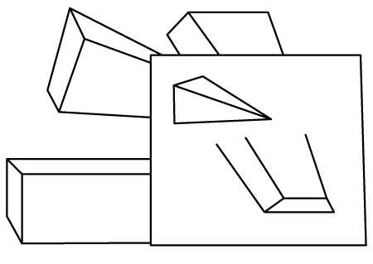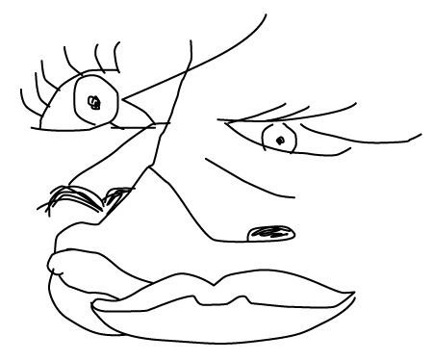
- The images above are examples of form. True or False

- Cubism was an objective style of art developed in Paris by Pablo Picasso.
True or False

- Principles of Design include value, space, and line. True or False

- Cubism uses geometry to express multiple view points of an object. True or False

Title Louisiana State Capitol Block Print
Time Frame Two 60-minute classes
Overview After investigating and studying the art and architecture of the Louisiana State Capitol, students create a linocut print of architectural details.

Standards Critical Analysis and Creative Expression

Arts Benchmarks
Express and justify aesthetic judgments about the created (built) environment. | VA-CA-M3
Select and apply media techniques, and technology to visually express and communicate. | VA-CE-M2

Foundation Skills Problem Solving, Linking and Generating Knowledge

Student Understandings

After exploring the architecture of the Louisiana State Capitol, students have an understanding of architectural details and their aesthetic attributes. Having created a series of linocut block prints using a split-fountain technique, students understand how printmaking techniques are used to create a work of art. After designing and creating a series of prints, students have an understanding of how art elements and principles are used to create art works.

Vocabulary

artist’s proof, split fountain, baren, frieze, bas relief, openwork

Materials and Equipment

access to Internet, books on the Louisiana State Capitol, pencils, sketchbook/learning logs, linocut blocks (such as EZ cut brand), assorted gouges, soft brayers, linocut ink (black and colors), barens, block print paper

Prior Knowledge

Students have a basic understanding of printmaking techniques and have visited the Louisiana State Capitol.

Sample Lesson

Day 1
Introduce the Louisiana State Capitol. Huey Long was the primary advocate for the building of a new state capitol and he wanted a tower, his only stipulation. The building design was completed in November 1930 by the New Orleans firm, Weiss, Dreyfous, and Seiferth. The building construction was completed in 14 months by the Fuller Company who had erected the Flatiron Building, one of the first skyscrapers. The dedication of the 34-story, 450-foot tower coincided with the inauguration of Governor Allen in 1932. The Chrysler Building and the Empire State Building were being constructed at the same time as the Louisiana State Capitol.

Our State Capitol is one of the last buildings in the country to integrate classical arts (sculpture and mural paintings) with futuristic architecture (the skyscraper). The sculpture and murals tell the story of our state, architecture as literature. Show images during this introduction via Internet or pictures. Explain that the building’s interior and exterior are covered with imagery of our state’s history. There is a bas-relief frieze at the top of the capitol’s base at the fifth floor level that depicts Louisiana history and life, de La Salle’s early explorations in 1682, wartime scenes (various battles), peacetime scenes (agriculture, fishing, etc.) and more. A frieze is a decorative horizontal band usually placed along the upper end of a wall, as well as, any sculptured or ornamental band in a building, or on furniture, pottery, etc. Bas-relief is a French term meaning "low-raised work." This art is known collectively as relief sculpture – meant to be seen primarily from one direction – as opposed to sculpture which is in the round or full round.

The tower’s top holds four corner figures in bas-relief symbolizing “the four dominating spirits of a free and enlightened people: Law, Science, Philosophy and Art.” A great lantern of light graces the highest point of the building.

On the interior, bronze openwork can be found in the form of various grill works, generally highlighting nature. Openwork is what many call any object or architectural construction produced in such a way that it shows a pattern of openings (perforations, piercings, gaps, holes), for decorative effect. Such works can be in cloth, metal, or wood. At the Capitol, this openwork adorns air vents, balconies, elevator doors and stairways (10 minutes).

Following the lecture, students use books and the Internet to further investigate the building’s exterior and interior architectural details. Encourage students to look at the openwork found in the capitol as it will lend itself nicely to the lino-printing process. In their sketchbook/learning logs (view literacy strategy descriptions), students list 10 architectural details that are aesthetically pleasing to them. Then, each student selects and sketches three architectural details and identifies their location on the building (20 minutes).

After students complete their sketches, review the following linocut techniques: transferring image to the block, gouging (cutting) techniques, and printing techniques (10 minutes).

Then, students transfer sketch to linocut block by placing their favorite detail drawing upside down on the block (drawing facing block) and rubbing the back of the drawing. This technique transfers much of the drawing onto the block. Students complete the transfer by touching up this drawing with pencil.

Students begin cutting the block, practicing safe cutting techniques by making certain that the hand holding the gouge always stays away from the block holding the drawing and that the gouge always points away from the body. Students should rotate the block often to safely cut the image. Remember that it is best if the carving blade stays parallel to the block.

When the image is completely carved, students pull an artist’s proof in black ink. Students begin by laying a small amount of ink in a line (about three inches) on a slick surface (8”x10” plexiglass). Using a soft brayer to roll out the ink, students should be certain not to roll the brayer back but rather pick it up after every pass. This insures that the ink is actually getting on the brayer in an appropriate fashion and not just being pushed back and forth. After a few pulls of the brayer on the slick surface, the ink makes a “sticky” sound. That’s the right amount to create a great print. If the ink is too thick, it will print poorly.

Next, students roll the ink on the carved block and then they should pick it up after each pass. Make one, two or three passes. Students very slightly moisten paper with a quick swipe of a sponge and place the paper on top of the block, pressing gently with their fingers (so the paper sticks to the ink). Then, students use a baren to press the image onto the paper and make small circular motions while pressing into the block. They pull a print by holding one corner of the paper and pulling the other corner up gently. Immediately after this pull, they create a “ghost” print by laying another slightly moistened piece of paper over the block without adding more ink.

These first prints or artist’s proofs visually inform the student as to whether more carving work is necessary. In printmaking, contrast, texture and pattern are very important. Students may draw on the ghost print to work out changes. Signing prints is always done in pencil and is placed directly under the print and to the right, making sure the signature does not land in the right margin (25 minutes).

Day 2
Open by reviewing printing techniques along with the introduction of the split fountain technique. This technique uses two colors of ink, either two primary colors, two warm colors or two cool colors to create a third color where the two colors meet. Complements are not used as they create brown at their mixing point.

Demonstrate the split fountain method by first laying down only a small line (about two inches) of each ink, side by side on the slick surface (see images below). When the ink is rolled out, a third color appears between the two original colors (see images below). This process may be used to pull a print of the carved block. Another print may also be created by using split fountain “under color.” First, ink up the smooth back of the block and print; then print the carved block in a solid color or another split fountain on top of the background color (see images below). Experimentation is encouraged as well as the introduction of colored papers (10 minutes).

Using their artist’s proofs, students now complete their carving of the block before they pull four split fountain prints of their architectural detail (45 minutes).

Upon completion of their prints, students respond to the linocut printing process by creating a process guide in their sketchbook/learning logs, delineating the steps taken to complete their prints. Students also reflect on the success of their printmaking experience in their sketchbook or learning logs (5 minutes).

Extension
Four student linocut blocks may be printed together or the entire class’s linocut blocks may be printed onto one sheet of paper to exhibit all selected architectural detail in one print. Also, have the students investigate Nebraska’s State Capitol of a similar design.

Sample Assessments

Formative
Observe, monitor and assist with activities throughout the lesson (list of architectural details, sketch of three details, lino print of one detail, process journal). Adjustments and suggestions are provided based on individual needs of students.

Summative
Assess the following:
Completion of students’ architectural details list (10) and sketch three of these details
Lino print of one architectural detail, two prints (artist’s proof in black ink)
Criteria for assessment include craftsmanship, neatness, and completion
Lino print using split fountain color scheme, four prints
Criteria for assessment include craftsmanship, neatness, and completion
Completion of students’ sketchbook/learning logs’ process guide, and responses to finished art work

Resources

Kubly, V. F. (1977). The Louisiana Capitol, Its art and architecture, Gretna, LA: Pelican Publishing.
The following websites contain information and images for this lesson:
www.artlex.com
http://www.capitol.org/guid_tour/home_guid.html

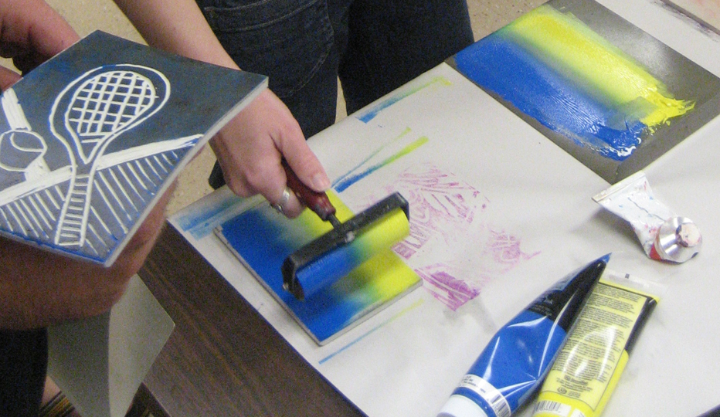
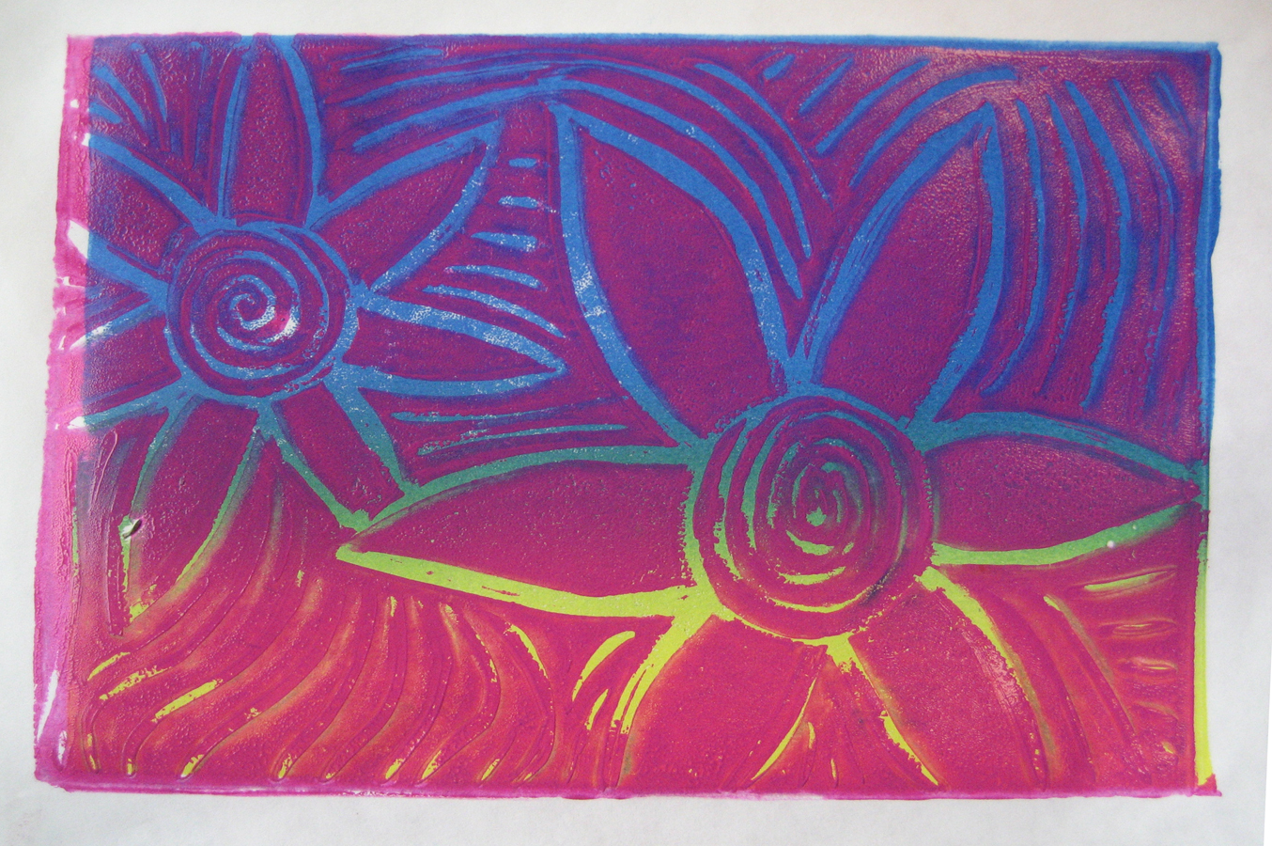
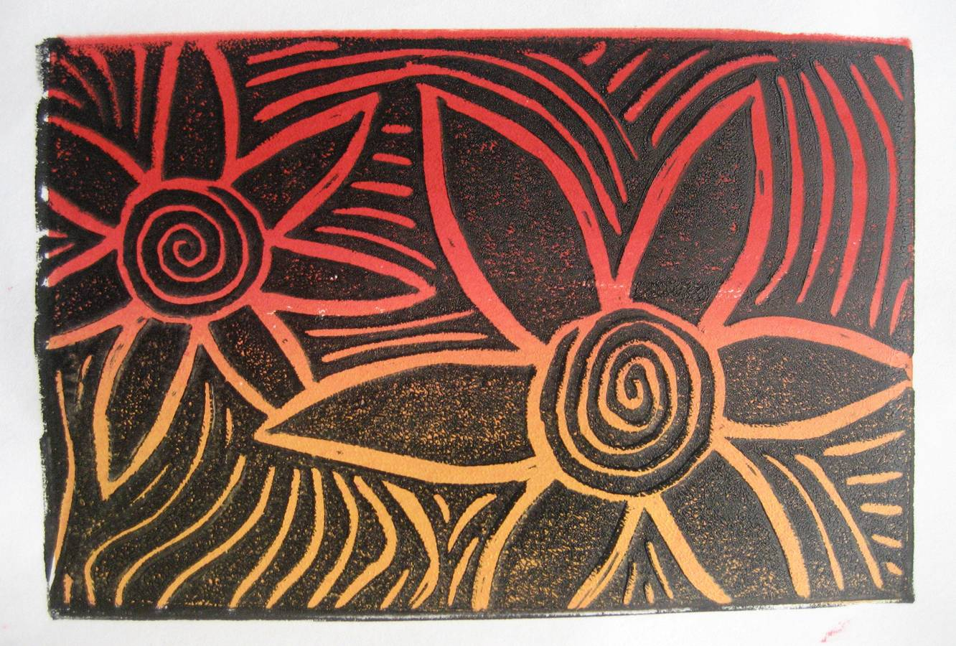
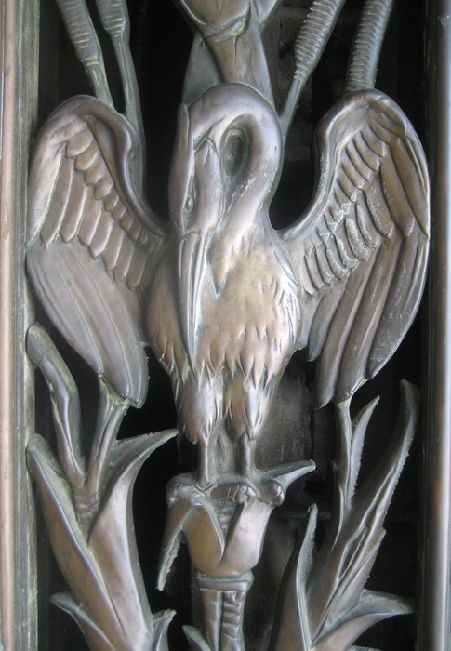
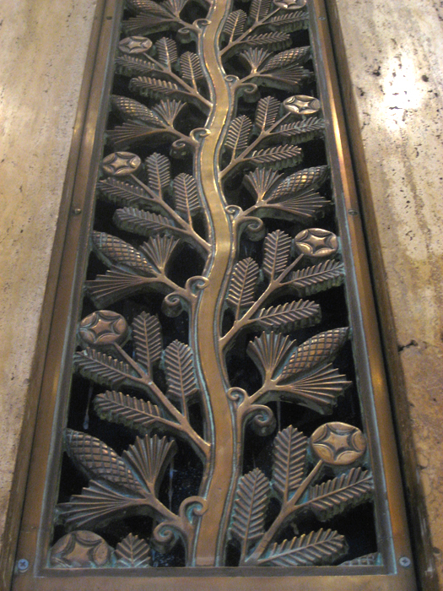
Title Surrealist Creations
Time Frame Five 60-minute classes
Overview Using the artwork of surrealists Salvador Dali and Jacqueline Lamba as inspiration, students create a drawing of a morphed object

Standards Creative Expression and Historical and Cultural Perspective

Arts Benchmarks
Identify and classify work of arts by their subject, style, culture and time period. | VA-HP-M1
Produce ideas for art productions while engaging in individual and group activities. | VA-CE-M5
Maintain a sketchbook or journal and develop a portfolio. | VA-CE-M7

Foundation Skills Problem Solving and Linking and Generating Knowledge

Student Understandings

Having viewed the works of surrealist artists, students identify surrealist artists’ works and classify surrealist stylistic characteristics. Students create a drawing of a landscape depicting the morphing of an everyday object. They understand the importance of preliminary preparation by sketching ideas in their sketchbook journals.

Vocabulary

Surrealism, metamorphosis

Materials and Equipment

Images of surrealists’ work including Dali’s The Persistence of Memory, Internet access, www.artlex.com, vocabulary self-awareness sheet, word grid, journal and ebony pencil, everyday objects, colored pencils and permanent marker (fine line)

Prior Knowledge

Students have a basic understanding of the following techniques and concepts - landscape, habitat, colored pencil techniques (blending, etc.), ebony pencil, foreground, middle ground, and background.

Sample Lesson

Day 1
Introduce the lesson by displaying the reproduction of Dali’s The Persistence of Memory. Ask students to complete the following in their sketchbooks: (10 minutes).
- list objects that they see
- describe main ideas represented in the work
- write at least three possible titles for Dali’s work

Next, assign students into pairs. Encourage students to share their written ideas with peers. Have students pairs present their ideas and one title to the class (10 minutes).

Then, reveal the actual title and read the following quote from Dali regarding this work from MOMA:
“Those limp watches are as soft as overripe cheese—indeed ‘the camembert of time,’ in Dali's phrase.” Publication excerpt: The Museum of Modern Art, MoMA Highlights, New York: The Museum of Modern Art, revised 2004, originally published 1999.

Frame questions regarding Dali’s The Persistence of Memory to prompt discussion:
What makes this picture look unreal?
How did the artist accomplish this effect? (man-made clocks morphing into melting cheese)?
If you could add a morphed object to this landscape, what would you add?

Next, students return to pairs and begin the vocabulary self-awareness sheet (view literacy strategy descriptions). Students rate their understanding of each word on the sheet with either a “+” (understand well), a “√” (limited understanding or unsure), or a “—” (don’t know). Then they provide a definition for each word using the online art dictionary (25minutes).

Close class by having students pair and share (5 minutes).

Day 2
Open by displaying a work of art by surrealist Jacqueline Lamba reviewing stylistic characteristics common to surrealist works. Students view additional works of Dali and other surrealists like Jacqueline Lamba. Encourage discussion by asking students to compare Lamda’s work with that of Dali. Each student is creating a surrealist drawing, and in order for them to do so, they will engage in further research into other surrealists (15 minutes).

Next, provide enough random, everyday objects for each student pair to have three objects; pairs use the object exploration grid and the modified word grid (view literacy strategy descriptions) to describe the object’s qualities (see ); now, find descriptions that are opposite of the actual qualities of the object and place them on the grid. Then, brainstorm the “What if ______ were like a ______?” question. (Example: What if the fork were like a stuffed animal?) (15 minutes)

After completing the grid, students select one object. They create thumbnail sketches in the rectangles formed by folding paper into quadrants. Using the information from the brainstorm grid, they create drawings representing the selected object in stages of metamorphosis. Each portion of the grid represents one step of the morphing process (25 minutes). Clean up (5 minutes).

Day 3
Open class by having students display their morphed drawings. Prompt student discussion by asking students to point out drawings which demonstrate morphing in very convincing ways. Refer to Dali’s work Persistence of Memory. Point out the ways he used morphed objects by placing them in an imaginary or dream-like landscape (5 minutes).

In their sketchbook, students use their exploratory sketches to create a colored pencil drawing of the morphed object in its imaginary habitat. Drawings should include foreground, middle ground and background (45 minutes).

At the end of this lesson, have the students clean up and revisit their vocabulary self awareness sheet to add any new understanding and/or make a journal entry about the process of creating this artwork (10 minutes).

Extension
Students write a poem about the drawing.

Sample Assessments

Formative
Check ongoing progress of brainstorming and preliminary drawings.

Summative
Assess:
Vocabulary self awareness sheet,
Object exploration grid,
Completion of preliminary drawing,
Completed art product to include the following criteria:
- One morphed object
- Creation of depth with the use of foreground, middle ground and background
- Use of surreal habitat for morphed object
- Use of colored pencil

Resources

This website is an online dictionary of art terms.
www.artlex.com
Surrealist Creations: Object quality grid sheet

Name_______________________________

Directions: Explore each object and record actual qualities as well as a description of opposite qualities
Object | Actual Qualities | Opposite qualities

Use each object in the question.
What if the ____________________(object) were like a _______________________?

Use each object in the question.
What if the ____________________(object) were like a _______________________?

Use each object in the question.
What if the ____________________(object) were like a _______________________?

Title Marcel Duchamp as Dadaist
Time Frame One 60-minute lesson
Overview Students view the works of Dada artist, Marcel Duchamp. They explore the question, “Why is this artwork considered art and valued by art historians today?” They create a Dadaist-inspired work of protest.

Standards Aesthetic Perception and Creative Expression

Arts Benchmarks
Discuss the question “What is art?” and express intuitive reactions and personal responses to various works. | VA-AP-M5
Maintain a sketchbook or journal and develop a portfolio. | VA-CE-M7

Foundation Skills Communication, Linking and Generating Knowledge

Student Understandings

Having viewed the works of Marcel Duchamp, students understand the ways artists challenge the meaning of art. They apply their knowledge of Dadaist works of art to create a work of protest using readymade images.

Vocabulary

Dada art, readymades

Materials and Equipment

Internet or reproductions of Marcel Duchamp’s works Bicycle Wheel, Fountain and L.H.O.O.Q., large paper, markers, glue, colored pencils, art journals and pencils

Prior Knowledge

Students should be familiar with different forms of contemporary protest and events surrounding World War I.

Sample Lesson

Day 1
Write the following question on the board: “If you were told to create art that never followed any rules, what would you create?” Individual students share ideas about what this might mean to an artist and what they might create (5 minutes).

During the next 15 minutes, lead a discussion about the following information concerning Marcel Duchamp and the Dada art movement. This information could include the following:
During World War I several artists left Europe for neutral Switzerland. They were angry and frustrated about the effects of war, and they wanted to express this anger and frustration. They came up with the idea to reject anything civilization had to offer, including art, because civilization was why we were in this mess. This group of artists and writers named themselves Dadaists, and their goal was to provoke a negative reaction by the public. Their one rule was not to follow any rules. Marcel Duchamp, a member of this group, created a series of readymades, using objects that were readily available and adding a controversial touch, a made-up signature, or an inappropriate phrase.

Next, show and discuss the works Bicycle Wheel, Fountain and L.H.O.O.Q. by Duchamp posing the following questions.
Did he achieve his goal? Explain why you think this.
Does this work have a sense of humor? Explain why you think this.
What do you think he was making fun of?
Why do we consider this art today?

Because Dadaism started as a form of protest, the students brainstorm contemporary and historical images which have caused or have been used as protest. (This might include the Olympic torch, the noose, the American flag, the peace sign…)

Working individually, students write a list in their journal of ideas that they might want to protest against. (This might include war, world hunger, discrimination, global warming…) Students select one of their ideas and create a work of art around that idea. They should look through magazines and newspapers to find “ready made” images they could incorporate into their work of art. Inspired by Dadaist approaches to art-making, they need to use this imagery in a new and challenging way. On a separate sheet of paper attached to the back of their work, each student should write what the work is protesting and why he/she used the images they did to communicate this protest (25 minutes).

Students display their work and explain it to the class (15 minutes).

Sample Assessments

Formative
Students respond to the question “What is art?” in their learning logs.
Students participate in the discussion of Duchamp’s work.
Check journals for a list of protest ideas.

Summative
Student’s presentation of his/her artwork for explanation of imagery used to depict protest.
The student’s work of art for the following criteria: the use of ready-made objects, depiction of a protest, and completion.

Resources

The following websites contain information and images to support this lesson:
http://arthistory.about.com/cs/arthistory10one/a/dada.htm
http://www.understandingduchamp.com/
Title Students as Art Critics and Creators: Exploring the works of Romare Bearden
Time Frame Four 60-minute classes
Overview Students view and respond to a work by Romare Bearden using new art vocabulary and then create a collage and use this vocabulary to present and explain their work to the class.

Standards Critical Analysis and Creative Expression

Arts Benchmarks
Critique works of art using expanded art vocabulary. | VA-CA-M4
Produce ideas for art productions while engaging in individual and group activities. | VA-CE-M5
Use the elements and Principles of Design and art vocabulary to visually express and describe individual ideas. | VA-CE-M3

Foundation Skills Communication, Problem Solving, Linking and Generating Knowledge

Student Understandings

After studying the works of Romare Bearden and providing opinions about his work, students have an understanding of the formal analysis process of art criticism. They also recognize that Bearden’s stylistic characteristics and techniques can be employed to create cut-paper collages. Students describe their own collages using the elements and principles of design.

Vocabulary

criteria, critique, analysis, interpretation, judgment, collage, composition, mixed media

Materials and Equipment

learning logs, Internet access or reproductions of Romare Bearden’s art work, magazines, large paper (18” x 12”) glue, scissors, paint, a variety of colored paper with patterns, photographs, markers, opinionnaire

Prior Knowledge

Students have a basic understanding of the art elements and principles.

Sample Lesson

Day 1
Begin by presenting Summertime (1967) by Romare Bearden. Summertime is a collage of paper and synthetic polymer paint on composition board (56” x 44”). A collage is an artistic creation made from a variety of media or materials such as newspaper, photographs, cloth, string, paint, charcoal, pencil, wallpaper, sand, almost any material that can be attached to a flat surface. Another term used for this collection of different materials is mixed media. Emphasize Bearden’s use of magazine, Xerox and photographic cut outs, a variety of papers and strong pattern (10 minutes).

Students work as a class to critique Summertime. Explain that a critique is a way of studying a work of art. A critique consists of four steps. First, students visually describe and identify all the images they can find in this work. This is the step known as description. One student makes a list on the board as the class discovers different images in the work. The second step is known as analysis. During this step, another list should be made by the class of statements on how Mr. Bearden uses the art elements (line, shape, color, texture, space) and principles (rhythm, variety, harmony, emphasis, proportion, movement, balance and unity) in this collage. This list is recorded again by a student on the board (15 minutes).

Students interpret this work by individually completing an opinionnaire (view literacy strategy descriptions). Remind students to use the information they collected as a group, which is written on the board, to support their ideas. Individual students share their answer statements about the meaning of Summertime with the class. They must take and defend a position, using images and information gathered from the artwork that supports their ideas (25 minutes).

After the students have completed the opinionnaire and shared their interpretations, the last step in the critique process is judgment. Students individually share why they like or dislike this work and support their opinions using expanded art vocabulary and the criteria previously established (10 minutes).

Day 2
Begin class by reviewing stylistic characteristics often found in Bearden’s work. These include his use of cut-out images, photographs, and Xerox images; he also incorporated strong patterns (5 minutes).

Pair students to discuss what summer means to them—the topic of the collages they create. The pairs brainstorm ideas about summertime. Students discuss how they will use elements and principles to communicate these ideas, recording their favorite ideas and drawing at least four quick sketches of these ideas in their art journals (10 minutes).

Students begin creating a collage representing summertime using some of Bearden’s techniques such as the incorporation of cut-out photographs, Xerox images, and patterns. Using 18” x 12” paper, glue, scissors, paint, markers, pencils, a variety of colored paper with patterns, magazines, photographs and markers, students focus on several art elements and principles in the making of the collage. The collage should communicate their ideas about summertime (35 minutes).

Inform the students that it is time to clean up. Before students leave, ask them to think about a descriptive statement they could write about summertime on the board tomorrow (10 minutes).
Day 3
As students enter the classroom, have them each write a statement about summertime on the board. The work of Romare Bearden, Summertime, should be displayed in the classroom. Read some of the statements highlighting words that provide imagery (5 minutes).

Consider playing summertime music in the background. Musical suggestions might include: Porgy and Bess’s Summertime, Nat King Cole’s Those Lazy Hazy Crazy Days of Summer, Loving Spoonful’s Summer in the City, Sly and the Family Stone’s Hot Fun in the Summertime and Chicago’s Saturday in the Park. As music plays, students continue to work on their collages (45 minutes).

Close the lesson by asking students to write a short description of their plan for tomorrows’ work on the back of their collage (10 minutes).

Day 4
Write and go over the questions from the handout on the board and remind students they need to be able to answer these questions about their completed work (5 minutes).

What was the main idea you were trying to communicate about summertime?
What art elements and principles did you use to help communicate this?
Why do you think that your use of elements/principles helps communicates this?
What was the most interesting/fun part of creating your collage?
What did you find the most frustrating/disappointing about creating your collage?
Students should complete their collage and display their work in the classroom/hallway.

Students continue to work on their collages (40 minutes). Once students have completed their collage, they clean up and complete the handout (15 minutes).

Sample Assessments

Formative
Check art journals for completed opinionnaire and ideas and sketches about their theme of summertime
Ongoing observation and monitoring of activities take place throughout the lesson. Adjustments and suggestions are provided based on individual needs of students.

Summative
Use the attached student self assessment to assess each student’s artwork.

Resources

The following websites contain information and images for this lesson:
http://www.beardenfoundation.org/artlife/beardensart/collage/artwork/summertime_i.shtml)
http://www.beardenfoundation.org/artlife/biography/biography.shtml
http://hirshhorn.si.edu/collection/search.asp?Artist=Bearden+Romare&hasImage=1
http://northbysouth.kenyon.edu/1998/art/pages/greenshade.htm

Students as Art Critics and Creators: Self-Assessment of Summertime Collage

Name________________________
Directions: Study your collage and answer the following questions fully.

What was the main idea you were trying to communicate about summertime?

What four principles and four elements did you use to help communicate your ideas about summertime?
1.

2.

3.

4.

How do you think the use of the above four elements/principles helped communicate your ideas?
1.

2.

3.

4.

What was the most interesting/fun part of creating your collage?

What did you find most frustrating/disappointing while creating your collage?
Title Sweet Seats
Time Frame Four 60-minute class periods
Overview Students discuss the role and types of chairs found in their lives. They design and create a chair using found materials, placing it in an environment they create on paper.

Standards Aesthetic Perception and Creative Expression

Arts Benchmarks
Describe the use and value of the visual arts in daily life, the workplace, and the community. | VA-AP-M6
Select and apply media, techniques and technology to visually express and communicate. | VA-CE-M2

Foundation Skills Problem Solving, Resource Access and Utilization

Student Understandings

Students discuss the role of a variety of different types of chairs in their lives. Students design their own chairs using available resources. They paint or draw an environment where the chair could be placed.

Vocabulary craft, function, stretcher, backrest, apron, arm, foot, leg, splat, assemblage
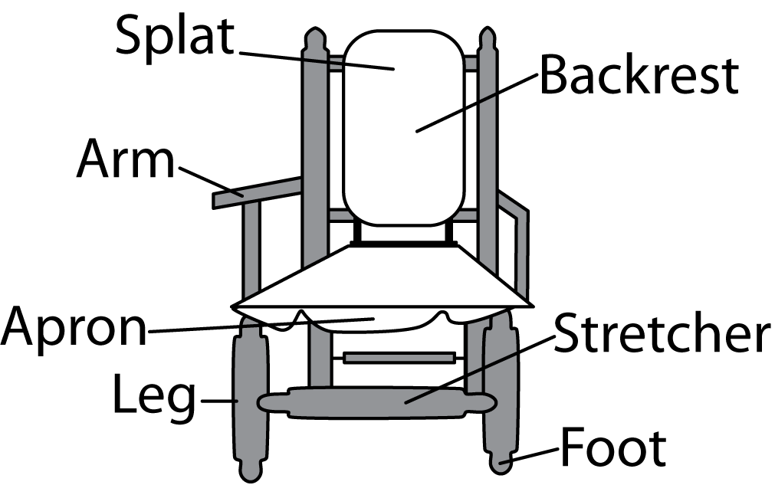

Materials and Equipment

Internet access, art journal, pencils, 12 x 18” white paper, colored pencils, watercolor paint, markers, wood glue, masking tape, white glue, hot glue, small saws, X-Acto knives, cutting boards, a wide variety of found objects to construct chairs from, such as twigs/sticks, raffia, yarn, wood scraps, bamboo, straw, cloth, cotton balls, foam, empty containers

Prior Knowledge

Students need to be aware of the different types of glue and which glue is best for which purpose.
Sample Lesson

Day 1
Lead a discussion of the role of chairs in students’ lives posing the following questions.
Describe the chairs you sit in on a daily basis.
How do chairs differ from each other? (Recliners, kitchen chairs, porch chairs, beach chairs, camping chairs, park chairs, office chairs, school chairs, etc.)
Why are these chairs different?
When selecting a chair to place in your room or home, what factors would you take into consideration?
How might a chair selected for your mother be different than a chair selected for your grandfather or your best friend?
What would make a chair a piece of art?

Define the vocabulary listed above using a chair in the classroom (or the chair drawn above). Students design and build chairs out of natural and found materials. Each chair must be 5-10 inches high and include a seat, a backrest and one other type of support. Review the rubric with the class so students know how their work is scored (15 minutes).

In their art journal, each student draws four sketches for a chair design. Attention should be paid to a background created for each chair and the materials from which they are to be made (35 minutes). They should consider the following:
What materials are needed to create the chair?
Who will sit in the chair?
Where will the chair be located?

The class brainstorms (view literacy strategy descriptions) materials they could use to make their chairs. Students make a list of materials they need to bring for their chair (10 minutes).

Day 2
Students share found materials they have brought to create their chairs. Review the rubric for the chair project. They respond to Part I and the teacher fills out Part II. Both parts are added together for the final grade. Demonstrate several ways students can bind materials together such as gluing and tying sticks together with raffia, yarn or string (15 minutes).

Students begin constructing their chairs or work on background for their chairs (35 minutes). They clean up and store chairs in a protected space. Remind students to continue to bring materials for chair construction (10 minutes).

Day 3
Students show any new materials they have brought for constructing their chairs (5 minutes). Students construct chairs or work on background drawing for their chair (35 minutes). They clean-up and store chairs in a protected space. Remind them to bring materials for chair construction (10 minutes).

Day 4
Students present their chairs during the second half of the class period. They complete questions on the handout which are part of their presentations (15 minutes). Students put finishing touches on their chairs and backgrounds (20 minutes).

Each student displays his/her chair and background. Each student responds to the following questions (30 minutes).
What is the title of your chair?
What is the environment you created for your chair?
Who would sit in your chair?
What support device did you use to construct your chair?
What problems did you have building your chair?

Sample Assessments

Formative
Check art journals for four different sketches of chair designs.
Check that each student brings in found materials for his/her chair construction
Observe and monitor activities throughout the lesson. Adjustments and suggestions are provided based on individual needs of students.

Summative
Each student completes the questionnaire Part 1 of the rubric and presents their chair to the class.
Assess the student’s work using Part 2 on the rubric.

Resources

Hayward, H. (Ed.). World furniture. New York: Crescent Books, 1965.

The following websites contain information and images for this lesson:
http://artsedge.kennedy-center.org/content/2181/chair.html
http://www.lib.washington.edu/Subject/drama/chair-image.html
http://artsedge.kennedy-center.org

*This lesson was inspired by a lesson presented by Heather Hogg, a student teacher at LSU Lab School in Baton Rouge.

Sweet Seats: Student/Teacher Assessment Rubric Name_____________________

Part I

Students respond to the following questions about their chair:

What is the title of your chair? (2 points) ____________________________________________

Explain the environment you created for your chair. (2 points) ___________________________ ________________________________________________________________________________________________________________________________________________________

Who would sit in your chair: Is it made specifically for someone? (1 point) ________________ ____________________________________________________________________________________________________________________________________________________________

What form of support device did you use other than the seat or the backrest for your chair? (1 point) ______________________________________________________________________________
What problems did you encounter during the making of this chair? If you made this chair again, what would you do differently? (1 point) _________________________________________________________________________________________________________________________________________________________________________________________________________________

Part II

The teacher will reflect on the following criteria and assign a point value for each item.

_____Student drew four sketches of different chair designs in their journal prior to construction. (8 points)

_____Student brought in outside materials such as sticks, twine, twist ties, bamboo, small boxes, etc. (3 points)

_____Student constructed a miniature chair (5-10 inches) which includes a seat, backrest and one other type of support such as arms, stretchers and/or apron. (10 points)

_____Student designed a background environment for the chair. (10 points)

_____Student wrote his/her name or initials on their chair. (2 points)

Comments:
Total __________ (40 possible points)
Title Monuments: Context and Creation
Time Frame Three 60-minute sessions
Overview The students view and compare images from the monument work of Wenda Gu. They use this research and their understanding of design elements and principles to examine motifs related to Wenda Gu’s monuments through a series of sketches.

Standards Critical Analysis and Creative Expression

Arts Benchmarks
Develop interpretations about works of art and give supporting reasons. | VA-CA-M5
Demonstrate art methods and techniques in visual representations based on research of imagery. | VA-CE-M1
Use the elements and Principles of Design and art vocabulary to visually express and describe individual ideas. | VA-CE-M3

Foundation Skills Communication, Linking and Generating Knowledge, Citizenship

Student Understandings

Having studied Wenda Gu’s monuments, students understand design and contextual criteria for successful site-specific monuments. Having created a written art review of these monuments, students understand the methods and techniques used to create works of art as well as the ways principles and Elements of Design are used to create art.

Vocabulary

monument, hybridization, juxtaposition, trans-nationalism

Materials and Equipment

images of the works of Wenda Gu, pencils, colored pencils, sketch books, pre-test/post test assessment measure, computer, printer

Prior Knowledge

Students have a beginning understanding of the following: composition, ground, form, texture, representational, positive space, negative space, foreground, background, middle ground, and can identify visual representations of these words. They understand basic techniques and skills associated with drawing.

Sample Lesson

Day 1
Begin by giving the pre/post-test assessment. Students complete the assessment (5 minutes).

Present printed handouts of information on Wenda Gu’s United Nations (UN) monument series (see resources.) Her UN Monument series strove to embrace the uniqueness of cultural and national identities and to honor heritage, culture and national histories while at the same time explore concepts of hybridization and trans-nationalism. Hybridization in art is a new art form created from at least two other original sources. In the case of Wenda Gu’s work, this means creating a work of art that represents at least two cultures from two different nations. Trans-nationalism is the interconnection of the cultures of at least two different nations or countries across national boundaries. The ultimate goal of Wenda Gu’s multi-year year, multi-national monument-making endeavor was unification through art, the ability to embrace the diversity and honor the uniqueness inherent in every nation’s culture. The UN Monument series began in 1992 and culminated in 2000. It involved 20 countries across five continents (15 minutes).

Next, present printed handouts of Wenda Gu’s United Nations - Africa Monument: The Praying Wall, a site specific installation (1997) and United Nations—USA Monument 1: Post Cmoellotniinaglpiostm (1995). Referring to the artworks, briefly introduce motifs characteristic of monuments. A monument can be a tomb, a stone, a building, or anything erected to honor or to remember the past. It can be erected to honor an individual person, a place or an event. Motifs characteristic of Wenda Gu’s monuments include the use of human organic materials, the incorporation of written texts from a variety of nations, use of texture to create perspective, and the juxtaposition of objects. Object juxtaposition is the placement of objects side by side for aesthetic effect. In the case of Wenda Gu’s monuments, it is the placement, side by side, of objects representing different nations. Emphasize examples of how positive space, negative space, ground, assemblage, foreground, background, and middle ground are used to create each of Wenda Gu’s monument compositions (10 minutes).

In groups of three, students continue viewing and comparing images of Wenda Gu’s United Nations - Africa Monument: The Praying Wall, a site specific installation (1997) and United Nations—USA Monument 1: Post Cmoellotniinaglpiostm (1995). Using their sketchbooks, students record and consider the following questions: 1) Which aspects of history did the artist choose to memorialize? 2) How many written texts did the artist use to create the composition and which nations were the writings from? 3) How did the artist use texture to create perspective? 4) How did the artist incorporate texts into the monuments? 5) How did the artist incorporate positive space, negative space and ground in the monuments? 6) How did the artist use foreground, background, and middle ground to create the monument? 7) How did the artist juxtapose objects in the monument? 8) What are Wenda Gu’s monuments communicating? Give supporting reasons. Students write their responses to these questions in their sketchbooks (20 minutes). Close by having a spokesperson present his/her group’s findings to the class (10 minutes).

Day 2
Using their sketchbooks, students reflect on questions and answers from the previous class period. Using sketchbooks and handouts as resources, students complete the exercise to further examine motifs characteristic of Wenda Gu’s monuments. The exercise provides students with the opportunity to produce a series of sketches. This assists students by enabling them to record and display their comprehension using two methods of communication, written text and corresponding visual representations. Using two methods, written text and corresponding visual representations, reinforces targeted concepts, vocabulary words, and, allows students to self-assess changes in their personal comprehension throughout the course of the lesson (50 minutes). Students clean up (5 minutes).

Day 3
Open class by explaining that today students are acting as art critics, and they will be writing a review of Wenda Gu’s work. To do so, students translate the questions they recorded and responded to in their sketchbooks on Day 2 and the written descriptions of Wenda Gu’s trans-national monuments from their exercise into a written review of selected works. Art reviews should be at least one page long (typed) and are scored using the following criteria: 1) Acceptable grammar, 2) Spelling, 3) Punctuation, and 4) Representation of an understanding of stylistic characteristics unique to each of Wenda Gu’s works (5 minutes).

Students write art reviews (50 minutes).

Close by having students complete the pre/post-test assessment (5 minutes).

Sample Assessments

Formative
Monitor student performance throughout the art-making process and assist students with individual needs.
Assess group presentations to see if students completed group tasks.
Check to see if students have explored the use of space, texture, form and perspective in written definitions and in sketches.
Check to see if students have explored stylistic characteristics of monuments in sketches.

Summative
Evaluate the following:
Pre/post-test for completion and accuracy;
Changes in scores between the pre-test and the post-test and a comparison of these changes;
Completion and accuracy of writing exercise (both written and visual representations);
Art reviews for: 1) Grammar, 2) Spelling, 3) Punctuation, and 4) Understanding of stylistic characteristics unique to each of Wenda Gu’s works and 5) Completion

Resources

The websites listed below offer detailed information on Wenda Gu’s site-specific monuments and opportunities to view his work:
http://www.wendagu.com/home.html
http://www.artbeatus.com/pres_wendagu.html
Monuments: Context and Creation Name ____________________

Describe and sketch what you see:

Wenda Gu’s United Nations Monument Series I:

Write a description of the art work by answering the following questions:  What is the title of the work?  How many nations are represented in the monument and which nations are they?  How does Wenda Gu use texture?  How does Wenda Gu use space?  How does Wenda Gu use written text? | Create three thumbnail sketches of textures and juxtaposing objects you see in Wenda Gu’s composition:  Focusing on form and space, create a thumbnail sketch of the whole composition:
Wenda Gu’s United Nations Monument Series II:

Write a description of the art work by answering the following questions:  What is the title of the work?  How many nations are represented in the monument and which nations are they?  How does Wenda Gu use texture?  How does Wenda Gu use space?  How does Wenda Gu use written text? | Create three thumbnail sketches of textures and juxtaposing objects you see in Wenda Gu’s composition:  Focusing on form and space, create a thumbnail sketch of the whole composition:

Monuments: Context and Creation: Pre/ Post Assessment

Please circle the correct answer. Name__________________________

- Elements of Design include perspective. True or False

- Principles of Design include line and form. True or False

- Artists often use symbols to communicate information about ways of life and cultural values. True or False

- A monument can be a tomb, a stone, a building, or anything erected to honor or remember the past. True or False

- Symbols can be used to communicate what is unique about a person, place or an event.
True or False

- Texture is a design principle. True or False

- Monuments are permanent structures. True or False

Title Architectural Aesthetics
Time Frame One 60-minute class
Overview Students investigate and compare two contemporary pieces of architecture, Iberville Building (Baton Rouge, Louisiana) and Peter B. Lewis Building (Cleveland, Ohio) to build awareness of differing tastes in the architectural world.

Standards Aesthetic Perception and Creative Expression

Arts Benchmarks
Recognize that concepts of beauty differ by culture and that taste varies from person to person. | VA-AP-M2
Maintain a sketchbook or journal and develop a portfolio. | VA-CE-M7

Foundation Skills Communication, Problem Solving, Resource Access and Utilization

Student Understandings

Having investigated two contemporary pieces of architecture, Iberville Building, (Baton Rouge, Louisiana) and Peter B. Lewis Building (Cleveland, Ohio) students recognize how beauty differs from one architect to another. Students understand architectural terminology. Students understand how building can be considered sculpture.

Vocabulary

façade, plan, site, taste, fenestration

Materials and Equipment

Internet access or printed images, sketchbook/journal, pencil

Prior Knowledge
Students have a basic understanding of the elements of art (color, value, line, shape, form, texture and space) and Principles of Design (movement, unity, variety, balance, emphasis, contrast, proportion, and pattern), and contour line drawing.

Sample Lesson

Introduce students to two contemporary pieces of architecture, Iberville Building, (Baton Rouge, Louisiana) and Peter Lewis Building (Cleveland, Ohio). The Iberville Building was created for the State of Louisiana and the other building was for Case Western Reserve University. Architecture is often thought of as a living sculpture in which humans interact (5 minutes).
Students view images of the above architecture via the Internet and/or printed images, continuing to think about them as sculpture. They create two sketches of each building in their sketchbook/journal, one overall contour line drawing and one contour drawing of a detail that interests them. The drawings are to be labeled with the name of each building. Students then describe their first impression of each building in one sentence. (15 minutes)

Students are now introduced to some architectural vocabulary: plan, site plan, façade and fenestration as well as taste (definitions from www.artlex.com).
Plan - In architecture, such a drawing or diagram of the parts of a building — either it's a floor plan, a roof plan, or it's a horizontal cross-section of a building at some other level.
A site plan represents an environment within which architectural or artistic designs may be located.
Façade - The front or face of a building. The façade accents the entrance of a building and usually prepares the visitor for the architectural style found inside. Also, any other sides of a building when they are emphasized architecturally.
Fenestration - The design and arrangement of windows in architecture. Architects sometimes refer to the windows of a building as the glazing. (pr. fə-nə-STRAY-shən)
Taste - A personal preference or liking and the capacity to tell what is aesthetically excellent or appropriate.

These definitions, along with added information about the specific buildings (found on their websites), help students with continued activities. The following informational narratives may be read aloud or provided to students.

Peter Lewis Building
Frank Gehry-designed the Peter B. Lewis Building. The building reflects the spirit of Weatherhead’s innovative approach and clearly places it in the vanguard of business education. It redefines the way a business school should look, just as Weatherhead redefines the way management education should be taught.
In 1965, in one of the first leveraged buyouts in history, Peter B. Lewis took control of his family's 100-employee Cleveland insurance company. His radical idea: insure drivers no other company would touch. Forty years later, he is Chairman of the Progressive Corporate, the nation's third largest auto insurer. In 1999, Mr. Lewis donated $36.9 million to the school for the building that bears his name.
Decentralized design:
Faculty offices, classrooms and meeting areas are distributed on every floor to encourage informal interaction and complement the school’s learner-centered curriculums:
One oval, two-tiered classroom has white board around the perimeter so that students may lead discussions.
Four large classrooms tiered and acoustically designed to ensure that every student is seen and heard by the rest of the class.
Classrooms designed to enable learning in large and small groups.
Meeting rooms:
Students have access to 12 dedicated team meeting rooms in addition to open meeting areas and a student lounge.
Technology:
Some classrooms have systems for multimedia and video conferencing with schools and organizations worldwide.
Every seat has power and data connections to CWRUnet, the University’s fiber-optic network, and the Internet (Case University, 2008).

Iberville Building
Conceived as one of the brother buildings by the Capitol Park Interpretive Master Plan, the Iberville building, while housing the Department of Social Services, forms one half of the new Capitol park gateway. The 270,000 s.f., 9-story office building is designed in cooperation with its adjacent gateway brother, the Bienville building, to complete a group of four buildings facing the Louisiana state capitol. The gateway concept draws from history in that the exploring brothers, Iberville and Bienville discovered a gulf route to the mouth of the Mississippi River, the gate to Louisiana. The buildings both incorporate a third floor roof terrace facing the capitol and a nine story linear tower element. The elevator shafts are positioned so that exiting the cab provides a profound direct view of the W.P.A. art deco design of the Louisiana state capitol and its expansive formal gardens. The majority of the buildings (including the Iberville) within the capitol park complex reference the forms and details of the WPA/art deco influence. Primary materials include pre-cast concrete panels, glass curtain walls and aluminum wall panels. To contribute in the marking of the gateway, the tower is detailed with seven protruding curtain elements, serving as illuminated lanterns (10 minutes) (Holly & Smith, 2008).

Next, in groups of three, students discuss and compare the two buildings/sculptures.
Using a form of split-page notetaking (view literacy strategy descriptions) and the above information, student groups investigate the buildings to build awareness of differing tastes in the architectural world. Did the narratives assist in your understanding of the architecture? In your opinion, did the building usage match the form? What are some of the sculptural elements evident in both pieces of architecture? Through this process, they also form opinions of their own (20 minutes).

In closing, several student volunteers share their taste or opinion of the buildings with the whole class. At the end of this share time, students write if their opinions have changed or not, reflecting on a specific reason that may have come from another student’s shared response (10 minutes).

Sample Assessments

Formative
Ongoing observation and monitoring of activities (sketching, split page note taking in sketchbook/journal, and discussion) take place throughout the lesson. Adjustments and suggestions are provided based on individual needs of students.

Resources

Information and images for this lesson may be found at the following websites:
http://weatherhead.case.edu/lewis/
www.artlex.com
http://www.hollyandsmith.com/portfolio/iberville-state-office-building
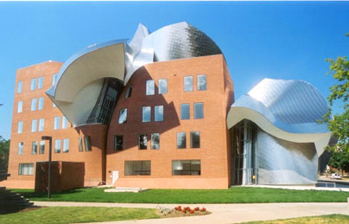
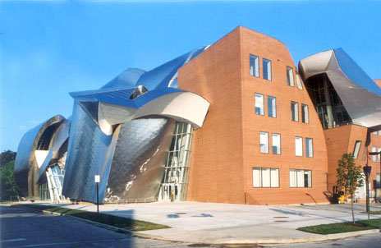
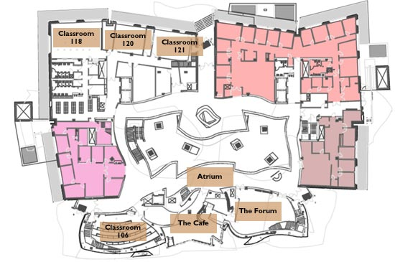
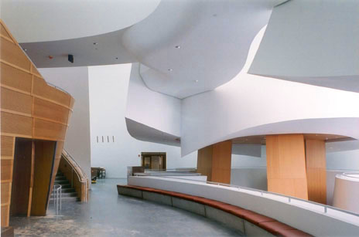
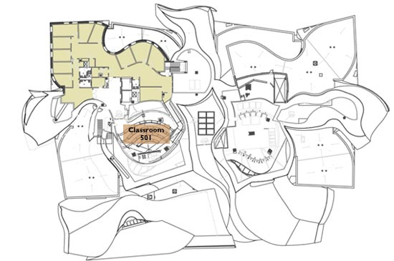
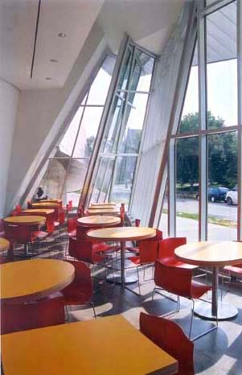
Peter Lewis Building, Cleveland, Ohio
Weatherhead School of Management - Case Western Reserve University
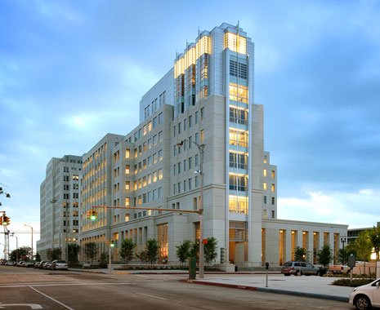


Iberville Building, Baton Rouge, Louisiana
Department of Social Services
Capitol Park Complex

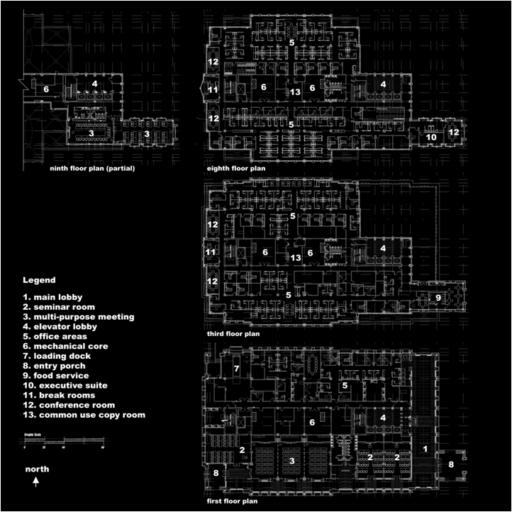
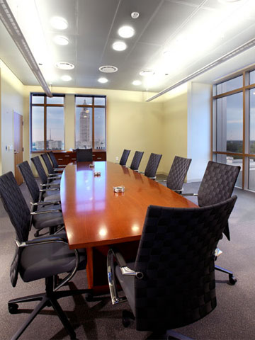
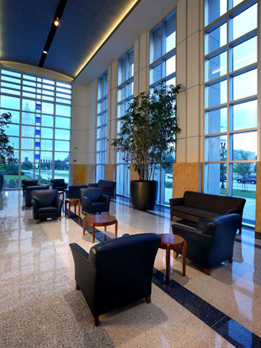

Name __________________________
Split-page notetaking

Investigate and compare two contemporary pieces of architecture, Iberville Building, (Baton Rouge, Louisiana) and Peter B. Lewis Building (Cleveland, Ohio). Use at least two of the Elements of Art (color, value, line, shape, form, texture and space) and Principles of Design (movement, unity, variety, balance, emphasis, contrast, proportion, and pattern) in each of your descriptions.

Architecture  Client  Location | Iberville Building  State of Louisiana  Baton Rouge, Louisiana | Peter B. Lewis Building  Case Western Reserve University  Cleveland, Ohio
Plan –
a drawing or diagram of the parts of a building — either it's a floor plan, a roof plan, or it's a horizontal cross-section of a building at some other level.
Façade –
The front or face of a building. The façade accents the entrance of a building and usually prepares the visitor for the architectural style found inside.
Fenestration –
The design and arrangement of windows in architecture.
Taste - A personal preference or liking. And, the capacity to tell what is aesthetically excellent or appropriate.

Group members: ________________________________ and _______________________________
GLOSSARY

abstraction – A style of artwork that is nonrepresentational of naturally occurring forms.
action painting – Abstract style of painting where the painting is “drizzled” or thrown on the canvas.
additive sculpture – The areas added to a sculptural form.
aesthetics – a particular theory or conception of beauty or art : a particular taste for or approach to what is pleasing to the senses.
analysis – Study of the use of elements in a work of art.
animation – Two-dimensional or graphic images that are made to appear as if they are moving.
apron – A decorative support piece located below the seat. This piece is fixed to the legs of a chair at the corner where the legs join the seat.
archeology – The study of ancient cultures through the examination of artifacts such as art.
architecture – Art and science of designing and constructing buildings.
arm – A support, used as a rest for a person’s arms when they are seated in a chair.
artifacts – Found objects created by human beings.
artist’s proof – Trial prints or proofs made from a print process for the artist to check for any changes needed to be made before the edition is run.
assemblage – A sculptural composition consisting of an arrangement of miscellaneous objects or found materials.
asymmetric – Artwork that looks balanced when the parts are arranged differently on each side.
atmospheric perspective – Visual effect achieved to give the illusion of distance.
avant-garde – A style representing the pushing of boundaries in a given field.
background – The part of the scene or picture that seems far from the viewer.
backrest – A support for a person’s back that can be leaned against while sitting.
baren – A printing tool used to apply pressure evenly.
bas relief – Sculpture in which the figure/design projects only a little from the background.
basketry – The craft of basket weaving.
bisqueware – Unglazed clay sculpture.
block print – The act, art, or practice of impressing letters, characters, or figures on paper, cloth, or other material
brayer – Roller used to ink a printing plate.
buttress – A solid structure made to support a wall.
cell – One frame in a work of animation.
clay prep – The act of getting the clay ready by making sure it is of the same consistency.
coil-built – Rolling the clay into a cylinder.
collage – Artwork where a piece of paper or other objects or materials are glued to a flat surface.
color – Element of art referring to the hues found in nature to enhance or distort a visual image.
color field – Abstract painting style where color is emphasized.
color scheme – A planned combination of colors.
color wheel – A chart of colors specifically arranged showing primary and secondary colors.
commercial art – Art that is created for specific purposes.
communicate – The act of expressing feelings, meanings, and thoughts.
composition – Arranging objects/subjects so they have well-ordered relationships.
contrapposto – An Italian term referring to the twisting of a figure’s proportions to suggest movement or relaxation.
craft – Decorative objects that have a practical purpose.
credit line – A line of text that acknowledges the artist.
criteria – Standards used to make a judgment or assessment.
cross-hatch – Using short lines that cross each other at angles or horizontal/perpendicular to give an area a shaded or contour effect.
critique – Assessment of a creative work with comments on good and bad qualities.
Cubism – Style where forms of nature are reorganized with geometric elements.
Dada art – A style that was a reaction against all established traditions of logic and art.
de Stijl – A style associated with the use of rectangular forms and primary colors.
decomposition – The breaking down of materials.
design – To plan or arrange parts of an artwork or object in a particular way.
dichromatic – Having two colors.
distempera – Paint pigment in an animal glue or gelatin.
document – To record findings.
earthworks – Describes mounds of dirt that are constructed for a purpose.
ecology – The study of the relationship between living organisms and their environment.
elements – The elements of visual art include line, shape, form, texture, and color.
etching – The process of creating etched designs.
façade – The front of a building.
fine art – Refers to the decorative arts of dance, music, theatre, and the visual arts.
flipbook – A small book containing a series of images that create the illusion of movement.
flying buttress – A supportive structure that stands apart from a wall.
foot – The base of the chair leg that rests on the floor.
forced perspective – A technique that employs illusion to make an object appear different that it actually is.
foreground – The part of the scene or picture that seems near the viewer.
form – Element of art that gives body to a work of art and moves it from the realm of pure design.
fragmentation – An object that is broken into pieces.
frame – A structure that surrounds a work of art.
frieze – A decorative horizontal band usually placed along the upper end of a wall.
geometric – Using simple mathematical forms in design and decoration.
gestural abstraction – The artist’s desire to focus on the act of painting, the physical gestures involved, and the spontaneity of design this kinetic approach to painting produces.
graphic design – Artistic and professional disciplines that focus on visual communication.
greenware – Unfired clay ware.
hand building – Clay working methods including pinch, slab and coil methods.
harmony – A principle of design where elements complement each other.
hatching – Using short lines that give an area a shaded or contour effect.
hybridization – A new art form created from at least two other original sources.
idea – A mental image that reflects reality.
illusion – A mythical perception of reality.
imagination – A mental image or idea; the ability to deal creatively with reality.
impermanence – Art that is designed not to last or be around for long periods of time.
impression – A printed copy; the pressing of a plate on paper.
inflatable – Being able to be filled with a gas.
installation art – A style of art that challenges the traditional boundaries of the visual arts.
intaglio – A carving made by cutting a hollowed-out design in an object.
interpretation – An attribution of a particular meaning or significance to something.
invention – A thing that has been created that did not previously exist.
judgment – An opinion formed after consideration.
juxtaposition – Objects of contrast in relation to each other, usually in close proximity.
kiln – An insulated box used to fire pottery.
kinetic – Relating to, caused by, or producing motion.
landscape – A selected site of environment as a painting inspiration.
layout – The way component parts are arranged.
leather hard – A description of clay ware which is partially dry and is tough enough to handle, but not ready to fire.
leg – The support of the chair which lifts the seat off of the floor.
line – Element of art that has one dimension and is the path of a moving point.
logo – A word, letter, or symbol usually designed for a company/corporation or individual.
masterworks – Artworks that have been admired for a long time.
medium – The tools used for visual expression or communication.
megalith – A large stone forming part of a prehistoric structure.
message – A lesson, moral, or important idea that is communicated in a work of art.
metamorphosis – An object that changes shapes.
mezzotints – An engraving process that involves scraping and burnishing the roughened surface of a metal plate.
middle ground – The area between the foreground and the background.
minimal – A style of art emphasizing a simplification of form and color.
mixed media – A combination of two or more media.
model – Person or thing that serves as a pattern for an artist.
mola – A patterned piece of clothing created from layering fabrics.
monochromatic – One color only with its tints, shades, and tones.
monument – A memorial stone or a building erected in remembrance of a person or event
motif – A repeated design, shape, or pattern.
mound builders – People who created earthworks.
multiple viewpoints – A founding principle of Cubism
narrative – The telling of a story in art.
nave – The long central hall of a cross-shaped church.
negative space – Areas of a surface that are empty or unoccupied by definite shapes or form.
niche – (small box with a scene inside)
openwork - any object or architectural construction produced in such a way that it shows a pattern of openings for decorative effect.
orthogonal line – Lines that move to the vanishing point.
overlapping – One element of art (line, shape, color) that covers part of another element.
paint binders – Substance which makes the paint stick to whatever it is on.
pattern – A choice of lines, colors or shapes that are repeated over and over in a planned way.
permanence – An object that will exist in the same form for a long time.
perspective – A way of creating the illusion of space or depth on a two-dimensional surface.
pigment – A powdered substance mixed with a liquid in which it is relatively insoluble.
plane – The use of design elements to create a flat surface.
plasticity – The condition of a material that is soft enough to be molded.
point-of-view – The position in which the object or person is depicted.
Pop Art – Style of art, which focused on familiar images such as comic strips and supermarket products in an honest and open manner.
positive space – Surface occupied by definite forms or shapes, quite often the subject of the study.
posterity – The act of leaving something for future generations.
principles of design – Include concepts such as balance, contrast, emphasis, rhythm, reception, variety, proportion, unity, and harmony.
proportion – The harmonious relationship of one part to another or the whole.
public art – Art created for a public audience.
realism – The representation of objects and people in a composition exactly as they appear.
recess – An indented or hollowed-out space.
reductivism – A composition containing greatly reduced or simplistic forms, bare minimum of elements and principles to create a composition.
relief – The elevation of figures or shapes from a flat surface.
retablo – A painting typically done on a word carving.
rhythm – A principle of design referring to the arrangement of parts of an artwork that seem to have movement or repetition.
rose window – A circular window composed of patterned tracery arranged in petal-like formation.
sand painting – Ceremonial design made of colored sands on a flat surface; the art of creating such designs.
scoring – A notch cut onto a surface.
self-portrait – An image created to visually represent how the artist views himself or herself.
sequence – The order in which frames or cells are ordered.
shape – Element of art that is created when a line meets or crosses itself and encloses a space.
silhouette – An outline of a person or object where the details are filled in with a dark color.
slip – Liquid clay used for decorating/casting/ attaching pieces of clay.
space – Element of art referring to the interval between shapes or other units of design.
splat – The central upright panel located between the uprights of a chair back, serving as a back rest. It is often pierced or shaped.
split fountain – Putting more than one ink in a printing fountain to achieve special color affects.
still life – A group of objects arranged in a manner pleasing to the eye.
stipple – To draw or paint in dots or short touches.
stretcher – The crosspiece that connects braces and strengthens the legs of a chair.
subtractive sculpture – The areas removed from a sculptural form.
Surrealism – A style of art where artists experimented with fantasy and weird psychological effects, with the dream world and the grotesque, with extravagant symbolism.
symbolize – To represent something by means of a symbol.
symmetrical – Artwork that looks balanced when the parts are arranged similarly on each side.
symmetry – Parts of a design that are arranged the same way on both sides of an imaginary middle line.
tableau vivant – A scene presented by costumed actors who remain silent and motionless on a stage, as if in a picture.
tempera – An opaque water-based paint.
Terra Cotta – Clay-based unglazed ceramics.
tessera – Small piece of stone or glass used in making a mosaic.
texture – Element of art referring to the quality of a surface. Can be felt or illusionary.
theme – A distinct and unifying idea, the message or emotion that the artist is conveying.
three-dimensional – Forms having height, weight, and depth.
thumbnail – A small sketch or image of a composition.
tracery – Decorative ribs in windows.
transcend – To go beyond a specified limit.
trans-nationalism – The cultural interconnection of two or more different nations or countries across national boundaries.
two-dimensional – Artwork that is made on a flat surface and is measured in only two ways, height and width.
underglaze – Coloring or decoration applied to ceramics before glazing.
unity – Principle of design where the quality of having all the parts look as if they belong together.
value – The lightness or darkness of a color.
variety – Having different kinds of colors, lines, and shapes, etc.
warp – The threads that run vertically in a tapestry.
wedging – Preparing clay by kneading, to remove air pockets and to create a uniform consistency.
weft – The threads that run horizontally in a tapestry.
VISUAL ARTS
CREATIVE EXPRESSION
Standard: Students develop creative expression through the application of knowledge, ideas, communication skills, organizational abilities, and imagination.
 | K–4 | 5–8 | 9–12
Benchmark 1 | Explore and identify imagery from a variety of sources and create visual representations  (2, 3) | Demonstrate art methods and techniques in visual representations based on research of imagery  (2, 3) | Produce works of art that successfully convey a central theme based on imagery, ideas, feelings, and memories  (1, 2, 3)
Benchmark 2 | Explore and discuss techniques and technologies for visual expression and communication  (1, 2, 3) | Select and apply media, techniques, and technology to visually express and communicate  (1, 2, 3) | Apply a variety of media techniques, technologies, and processes for visual expression and communication  (1, 2, 3)
Benchmark 3 | Use art vocabulary and the elements and principles of design to convey the language of art (create and discuss own artwork)  (1, 2, 3) | Use the elements and principles of design and art vocabulary to visually express and describe individual ideas  (1, 2) | Use the elements and principles of design for individual expression while exploring compositional problems  (1, 2)
Benchmark 4 | Experiment to create various art forms, including art forms from other cultures  (2, 3, 4) | Develop skills in creating various art forms, including art forms from other cultures  (2, 3, 4) | Produce a visual representation of ideas derived through the study of various cultures and art forms  (2, 3, 4)
Benchmark 5 | Draw on imagination, individual experience, and group activities to generate ideas for visual expression  (1, 4, 5) | Produce ideas for art productions while engaging in individual and group activities  (1, 2, 5) | Produce imaginative works of art generated from individual and group ideas  (1, 2, 5)
Benchmark 6 | Identify relationships among visual arts, other arts, and disciplines outside the arts  (1, 4) | Understand and visually express relationships among visual arts, other arts, and disciplines outside the arts  (1, 2, 4) | Produce works of art that describe and connect art with other disciplines  (1, 2, 4)
Benchmark 7 | Maintain a sketchbook or journal, or develop a portfolio  (1, 2, 3) | Maintain a sketchbook or journal and develop a portfolio  (1, 2, 3) | Maintain a sketchbook or journal and develop a portfolio  (1, 2, 3)

VISUAL ARTS
AESTHETIC PERCEPTION
Standard: Students develop aesthetic perception through the knowledge of art forms and respect for their commonalities and differences.
 | K–4 | 5–8 | 9–12
Benchmark 1 | Use elements and principles of design and basic art vocabulary for expressing responses to the work of others  (1, 4, 5) | Use elements and principles of design and expanded art vocabulary for responding to the aesthetic qualities of various works  (1, 4) | Use advanced art/design vocabulary for responding to the aesthetic qualities of various works  (1, 4)
Benchmark 2 | Recognize and respond to concepts of beauty and taste in the ideas and creations of others through the study of visual arts  (1, 4, 5) | Recognize that concepts of beauty differ by culture and that taste varies from person to person  (1, 4, 5) | Distinguish unique characteristics of art as it reflects concepts of beauty and quality of life in various cultures  (1, 4, 5)
Benchmark 3 | Explore the beauty in nature and discern images and sensory qualities found in nature and art  (1, 2) | Perceive the aesthetic value and influence of organic forms and the natural environment as reflected in works of art  (1, 2, 4) | Use analogies, metaphors, and other descriptors to describe interrelationships in works of art and nature  (1, 2, 4)
Benchmark 4 | Recognize that there are many possibilities and choices in the processes for designing and producing visual arts  (2, 3, 4) | Demonstrate awareness of various new ideas, possibilities, options, and situations pertaining to the art world  (1, 4) | Compare and contrast multiple possibilities and options available for artistic expression  (1, 4)
Benchmark 5 | Participate in guided inquiry into the basic question “What is art?” and share personal feelings or preferences about various works  (1, 2, 4) | Discuss the question “What is art?” and express intuitive reactions and personal responses to various works  (1, 4) | Question/weigh evidence and information, examine intuitive reactions, and articulate personal attitudes toward visual work  (1, 2, 5)
Benchmark 6 | Identify where and how the visual arts are used in daily life and in the community  (1, 2, 4) | Describe the use and value of the visual arts in daily life, the workplace, and the community  (1, 2, 4) | Integrate knowledge of the visual arts in the total environment to understand the arts within a community  (2, 4, 5)
VISUAL ARTS
HISTORICAL AND CULTURAL PERSPECTIVE
Standard: Students develop historical and cultural perspective by recognizing and understanding that the arts throughout history are a record of human experience with a past, present, and future.

 | K–4 | 5–8 | 9–12
Benchmark 1 | Identify the subject, basic style, and culture represented by various works of art  (2, 4) | Identify and classify works of art by their subject, style, culture, and time period  (2, 4) | Analyze specific styles and periods of art in relation to prevailing cultural, social, political, and economic conditions  (2, 4, 5)
Benchmark 2 | Recognize universal symbols and how works of art communicate a universal language  (1, 4, 5) | Understand how works of art cross geographical, political, and historical boundaries  (2, 4) | Analyze how works of art cross geographical, political, and historical boundaries  (2, 4)
Benchmark 3 | Identify art images and themes from the past and present and discuss historical differences  (1, 2, 4) | Understand the meaning and significance of ideas, themes, and messages in works of art from the past and present  (2, 4) | Compare and contrast ways art has been used to communicate ideas, themes, and messages throughout history  (1, 2, 4)
Benchmark 4 | Identify media used in works of art throughout history and recognize the importance of available resources  (2, 3, 4) | Distinguish media and techniques used to create works of art throughout history  (2, 3, 4) | Analyze materials, technologies, media, and processes of the visual arts throughout history  (2, 3, 4)
Benchmark 5 | Recognize professions in the visual arts and the role and status of the artist in various cultures and time periods  (2, 4) | Describe and compare careers in visual arts and the role and status of the artist in various cultures and time periods  (1, 2, 4) | Investigate and assess roles, careers, and career opportunities in the visual arts  (2, 4)
Benchmark 6 | Recognize great artists and works of art that have shaped the history of art  (2, 4) | Identify major works of great and influential artists and recognize their achievements  (4, 5) | Identify representative visual artists of various cultures and compare their lives, careers, works, and influence  (1, 4)
VISUAL ARTS
CRITICAL ANALYSIS
Standard: Students make informed verbal and written observations about the arts by developing skills for critical analysis through the study of and exposure to the arts.
 | K–4 | 5–8 | 9–12
Benchmark 1 | View works of art and express observations about how the elements and principles of design are used in the works  (1, 4) | View works of art and analyze how artists use design elements and principles to achieve an aesthetic effect  (2, 3, 4) | Apply knowledge of design elements and principles to analyze, compare, or contrast the composition of various works of art  (2, 4)
Benchmark 2 | Identify images, colors, and other art elements that have specific meanings in cultural contexts  (1, 4) | Analyze and interpret art images for their symbolic meaning, purpose, and value in place and time  (2, 4) | Compare and contrast symbolism as used in works of visual art from different cultures and time periods  (1, 4)
Benchmark 3 | Express and explain aesthetic judgments about the created (built) environment  (1, 2, 4) | Express and justify aesthetic judgments about the created (built) environment  (1, 2, 4) | Critique the design of structures or areas in the created (built) environment based on aesthetic criteria  (1, 2, 4)
Benchmark 4 | Express and explain opinions about visual works of others using basic art vocabulary  (1, 4) | Critique works of art using expanded art vocabulary  (1, 4) | Critique works of art using advanced art vocabulary  (1, 4)
Benchmark 5 | Express interpretations about works of art and give supporting reasons  (1, 4) | Develop interpretations about works of art and give supporting reasons  (1, 4) | Develop and justify personal interpretations of works of art based on information from inside and outside the work  (1, 2, 4)

LOUISIANA CONTENT STANDARDS
FOUNDATION SKILLS

The Louisiana Content Standards Task Force developed the following foundation skills that should apply to all students in all disciplines.
1. Communication: A process by which information is exchanged and a concept of “meaning” is created and shared between individuals through a common system of symbols, signs, or behavior. Students should be able to communicate clearly, fluently, strategically, technologically, critically, and creatively in society and in a variety of workplaces. This process can best be accomplished through use of the following skills: reading, writing, speaking, listening, viewing, and visually representing.
2. Problem Solving: The identification of an obstacle or challenge and the subsequent application of knowledge and thinking processes, which include reasoning, decision making, and inquiry in order to reach a solution using multiple pathways, even when no routine path is apparent.
3. Resource Access and Utilization: The process of identifying, locating, selecting, and using resource tools to help in analyzing, synthesizing, and communicating information. The identification and employment of appropriate tools, techniques, and technologies are essential to all learning processes. These resource tools include pen, pencil, and paper; audio/video materials, word processors, computers, interactive devices, telecommunication, and other emerging technologies.
- Linking and Generating Knowledge: The effective use of cognitive processes to generate and link knowledge across the disciplines and in a variety of contexts. In order to engage in the principles of continual improvement, students must be able to transfer and elaborate on these processes. Transfer refers to the ability to apply a strategy or content knowledge effectively in a setting or context other than that in which it was originally learned. Elaboration refers to monitoring, adjusting, and expanding strategies into other contexts.
- Citizenship: The application of the understanding of the ideals, rights, and responsibilities of active participation in a democratic republic that includes working respectfully and productively together for the benefit of the individual and the community; being accountable for one’s own choices and actions and understanding their impact on oneself and others; knowing one’s civil, constitutional, and statutory rights; and mentoring others to become productive citizens and lifelong learners.

Note: These foundation skills are listed numerically in parentheses after each benchmark.

