Adopt-A-Family School Uniform Request Form
Complete this form using word, save, and email to
adoptafamily@cableone.net.

School name:
Address:
Your name:
School Phone: Principle Name:
Your Cell phone:
Note: Your principle may be contacted to verify your request via school phone

Where will you buy your uniforms: (Goal is 2 shirts & pants for $50)

Store phone number:
Store Mailing Address:
Store Email Address:

(The goal of our program is to help the students in school who have no school uniform. Please only use this program as a last resource)

First Name | Grade | Pants Option: SEE OPTIONS BELOW | Shirts Option: SEE OPTIONS BELOW | Gender
JR. GIRLS: 0-1-3-5-7-9-11-13-15-17-19-21 BOYS: 4-5-6-7-8-10-12-14-16-18-20
GIRLS: 4-5-6X-7-8-10-12-14-16 MENS: 32-30 / 34-30 / 36-30 / 38-30 / 40-30

Note: Once approved we will mail the check directly to the uniform store. Make sure you work with the uniform store to get your order correctly. We want orders filled and uniforms distributed to student within 7 days of payment received if possible.

Rules of Grant Program;

1. We allocate $50 per student. If approved, you understand that a check will be issued in the school name to the uniform store. When you pick up your uniforms you will be handed a $50 “cash register” receipt for each student from the uniform shop.

2. You agree to spend the funds for school uniforms only in $50 increments ($50 per student) and return the $50 receipts to Adopt-A-Family.

3. Please have each student that receives their new uniforms write a general thank you note to the donors. Please have them put some effort into doing a nice note. These notes are sent back to the donors.

3. Each receipt should be attached to the upper left corner of the thank you note from the student and written on an 8x11 piece of paper. Please no post cards or construction paper. (its hard to mail to donors) I CAN ONLY ACCEPT CASH REGISTER RECEIPT from the uniform shop. No HAND WRITTEN RECEIPTS will be accepted. School purchases should be tax free from the uniform vendor.

4. VERY IMPORTANT: Please make one copy of the receipt / thank you note before sending them to me with the originals. I do not have access to a copy machine for free.

5. These thank you notes are sent back to each donor to show them what their donation was used for. It is very important to spend these funds as directed because the results are audited by a law firm each year.

6. Please mail the receipts and thank you notes to P.O. Box 457, Long Beach MS 39560. I suggest you use tracking because packets have been lost in the past.

6. All receipts and student thank you notes are due back to the program before the Thanksgiving break. If you cannot meet this deadline please email me for permission to extend the date. Schools that do not meet this deadline will not be allowed to request funds next year.

Please sign by typing your Name and Title:

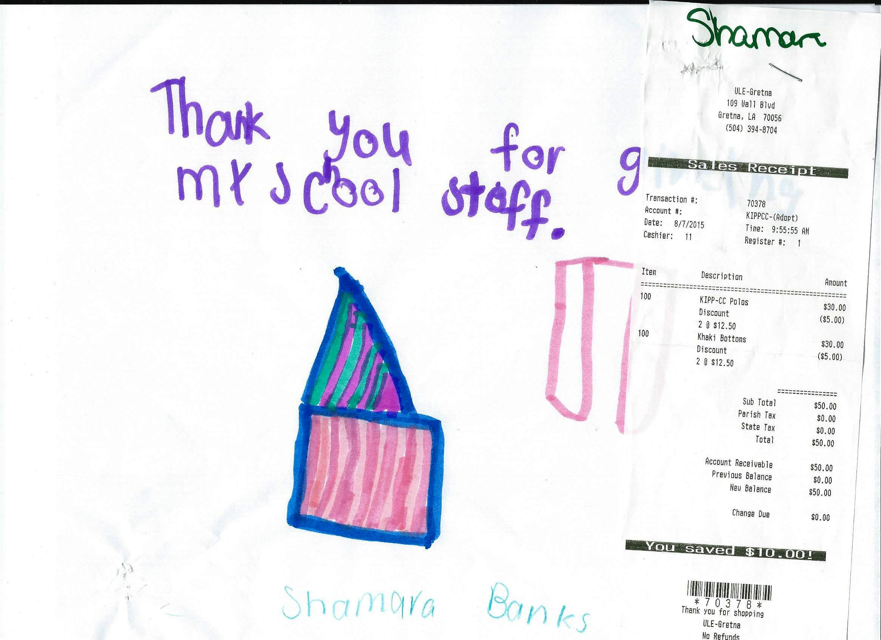
Dear Counselors: Please follow these instructions before you send me the Thank you notes / Receipts.
PLEASE REMEMBER 8X11 PAPER ONLY…NO CARDS OR CONSTRUCTION PAPER
1. Take the original thank you note from the students and attached the original receipt to one corner of the thank you note (see above)
2. Write the students first name on the top of the receipt.
3. Place the original thank you note / original receipt on the copying machine and make me one copy.
4. Place the copies in one stack and originals in another stack…..please do not attach the copy to the original thank you notes.
5. Place both the stack of originals and the stack of copies in a envelope and mail to P.O. Box 457, Long Beach, MS 39560

(You do not have to reveal the students full name….first name is ok)

