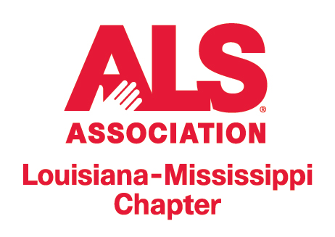


“The Luckiest Man” Essay Contest

Legendary New York Yankee Lou Gehrig was diagnosed with ALS in the prime of his record-setting baseball career. Through it all, he presented a face of courage, perseverance and humility. 2014 marked the 75th anniversary of Gehrig’s famous farewell speech at Yankee Stadium, in which he referred to himself as “The Luckiest Man” on the face of the Earth.

Eligibility: Open to all Louisiana 8th Grade Students

Requirements:
▪ 500 words or less
▪ Typed, 10-point Times New Roman
▪ Essays will be judged on spelling, grammar, content and how well the student answers the question, “Why did Lou Gehrig consider himself ‘The Luckiest
Man?’” The winning essays will highlight both Gehrig and ALS.
▪ All entries should include Student Name, Teacher’s Name and School Name and should be accompanied by the School Participation Form.

Prize levels:
1st prize – $100
2nd prize – $50
3rd prize – $25

Winners will be presented at the Louisiana State Capitol on ALS Awareness Day on May 7.

Deadline for entries: Friday, March 27, 2015

Questions? Call Sarah Paretti at (225) 343-9880, ext. 4 or e-mail sarah.paretti@alsalams.org

Submit entries by mail or e-mail to:

The ALS Association Louisiana-Mississippi Chapter
ATTN: “The Luckiest Man” Essay Contest
P.O. Box 66825
Baton Rouge, LA 70896-6825

E-mail to sarah.paretti@alsalams.org

