Local Literacy Plan for
(School/System)
(Lead Contact/Principal)
(Superintendent)
(Completion Date)

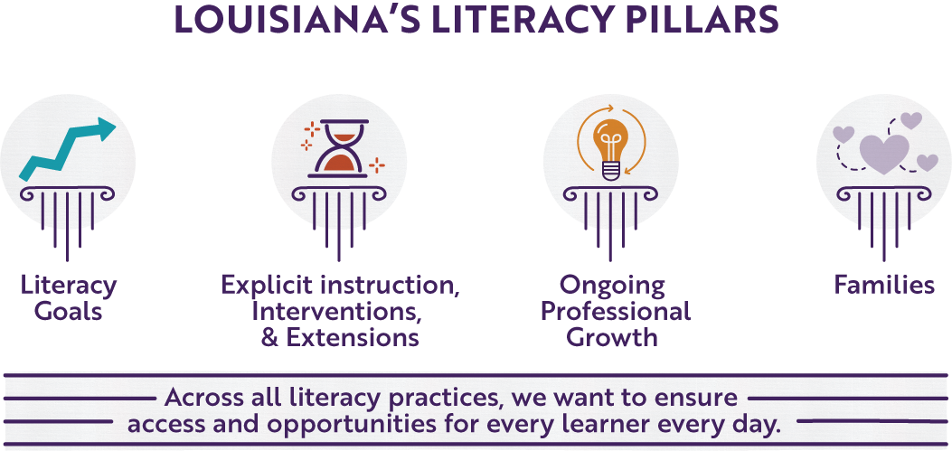

Section 1A: Literacy Vision and Mission Statement
- What is the school/system’s focus and mindset around literacy?
- What is the primary, overarching goal and expected or intended outcomes for the school(s) around literacy?
- Are the vision and mission statements inclusive of all leaders, teachers, students, and families?
Literacy Vision
Literacy Mission Statement

Section 1B: Literacy Goals
- What are the overall literacy goals?
- What are the student-focused leading and lagging goals, including individual subgroups?
- What teacher-focused goals lead to students meeting their goals?
- What are the program-focused goals for creating structures that help students and teachers succeed?
- How is the plan to measure these goals?

Goal 1 (Student-Focused)
Goal 2 (Teacher-Focused)
Goal 3 (Program-Focused)

Section 2: Explicit Instruction, Intervention and Extension
Louisiana’s Tiered Pathways for Literacy Support (TPLS) Framework guides implementation of healthy Tier I core instruction and extension, as well as effective Tier II and Tier III interventions.
While acceleration, intervention, and special education services are essential, they cannot replace
coherent literacy instruction using high-quality instructional materials (HQIM). Healthy Tier I instruction for all students is the best prevention measure against overloading the intervention system. This section is designed to support Tiers I, II, and III instruction.
Tier I | - Are Tier I instruction and small-group support consistently delivered by a classroom teacher trained in the effective implementation of approved HQIM?  - Strong Tier I instruction should result in at least 80% student mastery in overall class assessment data.  - Are curriculum-based assessments from HQIM used consistently to evaluate the effectiveness of Tier I core instruction?  - Is the Instructional Leadership Team (ILT) trained in the implementation and evaluation of the HQIM?  - Is there a regular walkthrough schedule to determine support around Tier I?  - Is the ILT responding to data to support a healthy Tier I?  - Are teachers and leaders effectively trained in unit and lesson preparation (K-2 Skills Unit, K-2 Skill Lesson, K-2 Knowledge Unit, K-2 Knowledge Lesson, 3-12 Unit Preparation, 3-12 Lesson Preparation)  - What data and resources are being used to support extension?
Amount of time spent on daily literacy skills instruction and how it is used
English Language Arts textbooks and instructional materials used
Tier II | - Is the Tier II intervention being provided by a classroom teacher/tutor or other extensively trained literacy educator using approved HQIM?  - Are curriculum-based measures and assessments from HQIM consistently used with integrity to reflect the effectiveness of the Tier II intervention?  - Does the skill of the intervention and the progress monitoring tool align with the identified needs of the student based on current literacy assessment data?  - Do student schedules ensure they are not pulled from Tier I core instruction to receive Tier II intervention?  - Has progress monitoring of Tier II intervention occurred bi-weekly or weekly, depending on the needs of the student as indicated by assessment data?
Tier II plan, including the amount of time
List of available interventions and their descriptions
Tier III | - Is the Tier III intervention being provided by a literacy staff member who possesses deep conceptual knowledge and specialized skills in reading instruction and has been fully trained in the adopted Tier III curriculum?  - Are curriculum-based measures and assessments from HQIM consistently used with integrity to reflect the effectiveness of the Tier III intervention?  - Does the skill of the intervention and the progress monitoring tool align with the identified needs of the student based on current literacy assessment data?  - Do student schedules ensure they are not pulled from Tier I core instruction to receive Tier III intervention?  - Is progress monitoring of Tier III interventions occurring at least on a weekly basis to track student progress and adjust interventions as needed?
Tier III plan, including the amount of time
List of available interventions and their descriptions

Action Plan
Goal | Timeline | Action Steps | Person(s) Responsible | Resources | Monitoring Evidence of Teacher and Student Success
1 | August -September | Create first cycle of ILT and TC around unit and lesson preparation | ILT Team/Instructional coach | 3-12 Unit Preparation  3-12 Lesson Preparation | -teacher unit preparation documents will demonstrate teacher understanding of skills and knowledge unpacked from HQIM assessments, rubrics, exemplars and texts  -lesson annotations demonstrate understanding of lesson and activity purpose, mastery expectations for that day’s lesson, what parts of the lesson will be explicitly modeled, and student differentiation  -95% of observed students are engaged in and demonstrating learning through reading, speaking, listening, or writing tasks that are explicitly aligned to the lesson’s learning objective and the unit’s identified knowledge and skills. Evidence: Student exit tickets, daily formative assessments, and walkthrough data  -A measurable increase in performance from section diagnostics to culminating writing tasks, with at least a 10% increase in students meeting or exceeding proficiency. Evidence: Section diagnostic data, culminating student work

Section 3A: Professional Learning: Partners (if applicable)
- Have teachers received initial implementation and launch training on their HQIM?
- Is there ongoing professional learning around the different components/assessments within the HQIM? How is the leadership evaluating the effectiveness of the PL?
- Are teachers trained in the Science of Reading, reading interventions, and content/disciplinary literacy as applicable by grade level?
- Are coaching days provided by the Louisiana Professional Learning Partners?
- Have the Louisiana Professional Learning Partners been evaluated based on the ELA Criteria using the efficacy indicators?
Potential Professional Learning Planning
Month/Date  (When can PL be scheduled throughout the school year?) |  | Topics  (What topics are most needed and should be covered and/or prioritized?) | Attendees  (Who would benefit most from this PL? Consider also who can redeliver to other teachers/faculty.)

Section 3B: Professional Learning: Instructional Leadership Teams (ILT) and Teacher Collaboration (TC)
- What is the ILT/TC long-range plan to support literacy?
- Is the ILT/TC long-range plan chunked into cycles that lead to the success of yearly goals?
- How/when is the effectiveness of cycles monitored?
- Is HQIM embedded in the cycles and long-range plans?
- How do the LER indicators support HQIM implementation during cycles in ILT and TC?
- Are ILT members trained to support literacy?
Potential Cycle Topic |  | Goal for Cycle | How is the success of the cycle monitored?

Section 4: Family Engagement Around Literacy
- To improve family engagement around literacy, what is the plan to:
  - include families in focus groups and other discussions with teachers, students, and leaders around:
    - school literacy priorities and programs aligned to the school’s mission?
    - family access to interpret literacy data (screener and LEAP) and resources available?
  - using communication and methods that accommodate all families?
  - providing ongoing support and communication to families regarding the progress of their child’s IASP?
  - providing family-friendly professional learning regarding literacy knowledge and grade-level student expectations?
- How can community partners:
  - engage families and strengthen the connections between school and community?
  - invest in sustained literacy efforts in the school and community that extend beyond the school day?
  - expand access to literacy resources?
- What resources and tools are shared with families and community partners to enhance literacy?
Month/Date | Activity | Accessibility Opportunities | Community  Partners

Section 5: Alignment to Other Initiatives
To successfully implement, communicate, and monitor this literacy plan, what is the plan to:
- Identify which district or school initiatives most directly support literacy goals, including:
  - School improvement plan
  - Early childhood programs
  - Cross-curricular initiatives
  - Community programs
  - System-wide priorities across schools
- Determine which initiatives should be prioritized, integrated, or streamlined to ensure sustainable implementation of literacy goals.
- Align initiatives to ILT priorities, walkthrough look-fors, and teacher collaboration cycle goals?
Initiative Alignment
Other Programs/Initiatives | Connection to Literacy | Monitoring Plan/  Evidence of Success

Section 6: Communicating the Plan
To ensure clear communication and strong implementation of this literacy plan, what is the plan to:
- Define clear, non-negotiable implementation expectations for schools, including the role of school-based literacy teams and alignment with ILT and teacher collaboration structures.
- Clarify the roles and responsibilities of district leaders, school leaders, instructional coaches, and teachers in implementing and monitoring the plan.
- Communicate the plan to families and community members in clear, accessible ways, including the plan’s goals, expectations, and how they can support student literacy.
- Provide regular, transparent updates on progress, including both student literacy outcomes and implementation progress.
- Establish consistent structures for monitoring implementation at the school level (e.g., quarterly reporting, benchmark meetings).
Communication Plan
Stakeholder Group | Plan for Communicating | Timeline

