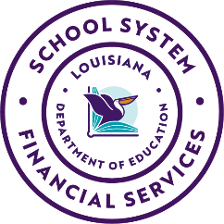
Statement of Affirmation
Annual Operating Budget FY 2026- 2027

The charter school listed below is implementing Board-approved internal control procedures to ensure the financial data contained in the report is truthful. I hereby certify that to the best of my knowledge and belief, the data reported in the attached Annual Operating Budget (Actual data for FY2025- 2026 and Budgeted data for FY2026- 2027) constitutes a true and full report of revenues and expenditures, both budgeted and actual. Additionally, I certify that the budget complies with LA Revised Statute 39:1305E, which requires that the total of proposed expenditures shall not exceed the total of estimated funds available for the fiscal year.

Charter School Name

School Principal
(print or type name)

Signature
(School Principal) (Date)

Board President
(print or type name)

Signature
(Board President) (Date)

Board Approval Date__________________________________________
(If the Annual Operating Budget submitted by August 1st is not adopted in accordance with the Louisiana Local Government Budget Act, submittal of the budget adopted in accordance with the Louisiana Local Government Budget Act is required no later than September 30, 2026.)

Scan and submit this completed form via email to CharterFinanceHelpdesk@la.gov
by August 1, 2026.

