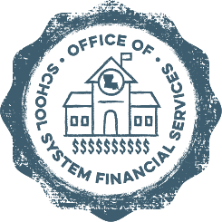

**Statement of Affirmation**

**First Quarter Financial Report FY 2025-2026**

The charter school listed below is implementing Board-approved internal control procedures to assure the financial data contained in the report is truthful. I hereby certify that to the best of my knowledge and belief, the data reported in the attached First Quarter Financial Report for FY 2025-2026 constitutes a true and full report of revenues and expenditures, both budgeted and actual. Additionally, I certify that the budget is in compliance with LA Revised Statute 39:1305E, which requires that the total of proposed expenditures shall not exceed the total of estimated funds available for the fiscal year.

Charter School Name

School Principal

(print or type name)

Signature

(School Principal) (Date)

Board President

(print or type name)

Signature

(Board President) (Date)

Scan and submit this completed form via email to LDOE at [CharterFinanceHelpdesk@la.gov](mailto:CharterFinanceHelpdesk@la.gov)

by **October 31, 2025.**